Graf Park

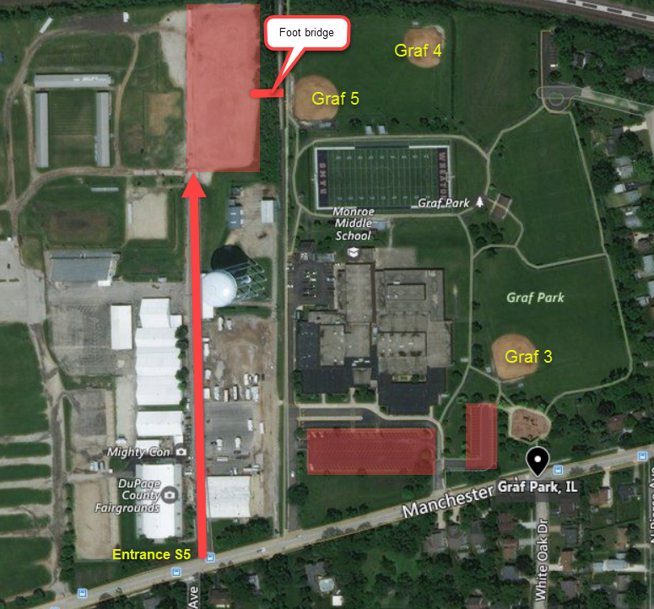
If you are playing at Graf 3, the easiest parking will be in the lots in front of Monroe Middle School.

If you are playing at Graf 4 or Graf 5, the easiest lot will be in the back of the DuPage County Fairgrounds. Please use Entrance S5, which is on Manchester Road.

Central Athletic Center

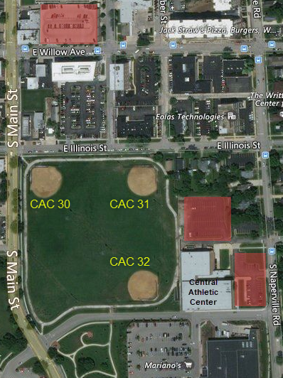

There is limited street parking along Main Street and Illinois Street. Park at your own risk if you choose street parking close CAC 30 or 31!!

There are two lots next to Central Athletic Center available for parking. In addition, there is a public parking structure on Willow Ave., 1 block north of the fields.

The DuPage Medical Group lot on Illinois Street is NOT available for tournament parking. We have been told that DMG will tow cars that they determine are parked for the tournament.

Wheaton Warrenville South High School
1993 Tiger Trail, Wheaton IL 60189

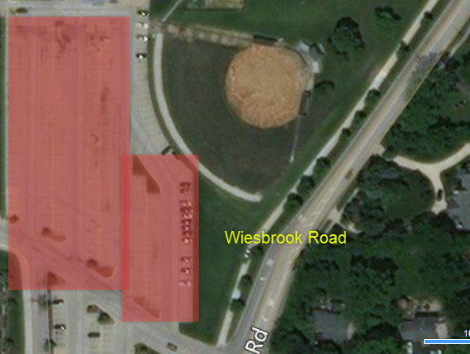

The entrance to Wheaton Warrenville South’s main parking lot is on Wiesbrook Road. Please be careful parking along the right field fence as home runs will reach the parking lot.

Wheaton North High School
1 Falcon Way, Wheaton IL 60187

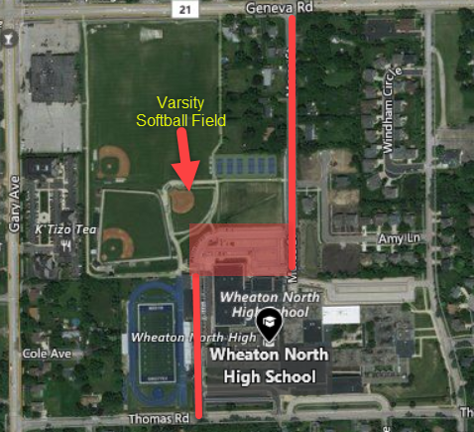

There are two parking lot entrances for Wheaton North. From the North, off of Morse Avenue, and from the South off of Thomas Road.

