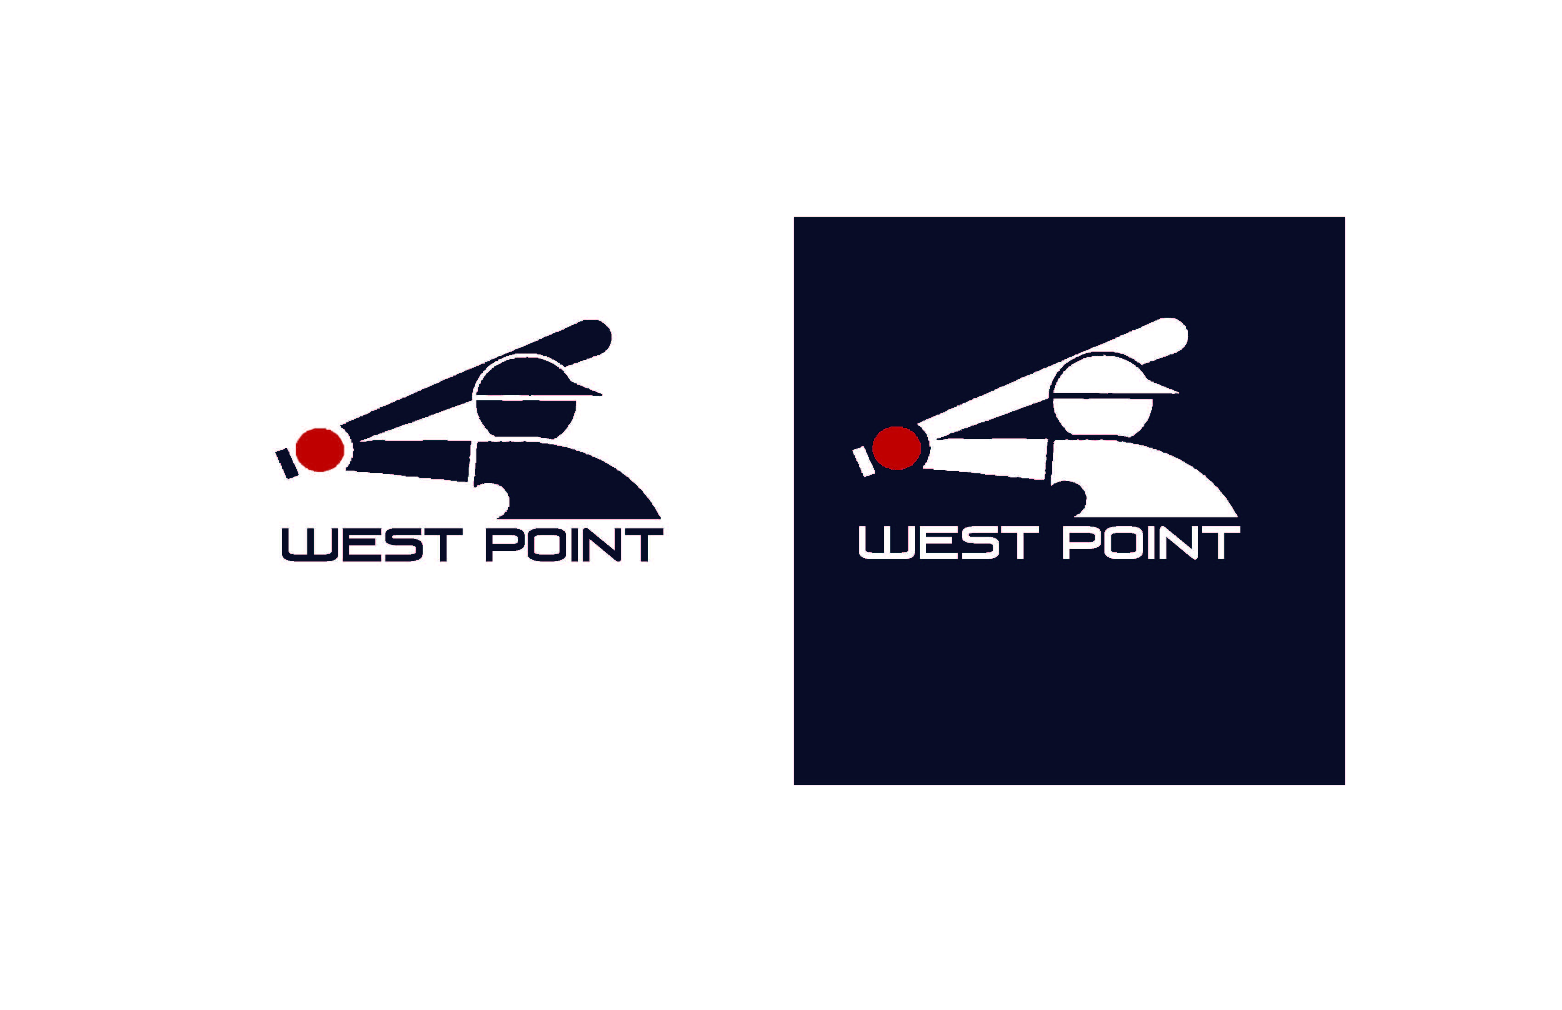

WEST POINT CITY RECREATION
2025 T-ball Rules
PLAY WILL BE GOVERNED BY THE OFFICIAL LITTLE LEAGUE RULEBOOK WITH THE FOLLOWING MODIFICATIONS:

Game Format
- Games will be 50 minutes.
- Running clock
- Score will not be kept.
- First team listed is home team and will starts in the field on defense.
- Coaches are responsible for starting and stopping the games on time.
- All players will bat each inning.
- There is no limit to the number of outs or runs scored each inning.
Players
- Each team roster shall consist of 10 players maximum
- All players will play defensively each inning. Rotate players through the season so they can learn different positions.
Rules of Play
- Players will get 5 swings to hit the ball off the tee.
- Coaches will be in the field with their team on defensive. The batting team coach will put balls on the tee and assist the batter, while acting as the ‘catcher”
- Coaches that are in the field with their team will encourage the fielders to make the play for an out, but the runners will be able to continue to run the bases if they get out.
Sportsmanship Philosophy
- West Point City Recreation is dedicated to providing quality recreational sports programs in the spirit of sportsmanship and fellowship for all of our families, friends and neighbors. It is expected that all players, coaches, parents, and spectators will strongly adhere to all rules of play and etiquette involving the program.
- Cheering for your team and cheering for the opposing team is encouraged. Cheering against another team or player will not be tolerated (this includes chants). Coaches are responsible for the sportsmanship of their team and fans.

