Roster eligibility breakdown:
Men’s Division (40-90): A player must be of the age in their age group or turning that age during the softball year. Oct 1st to Dec 31st of the following year.
Women’s Division (40-90): A player must be of the age in their age group or turning that age during the softball year. Oct 1st to Dec 31st of the following year.
Age Restrictions
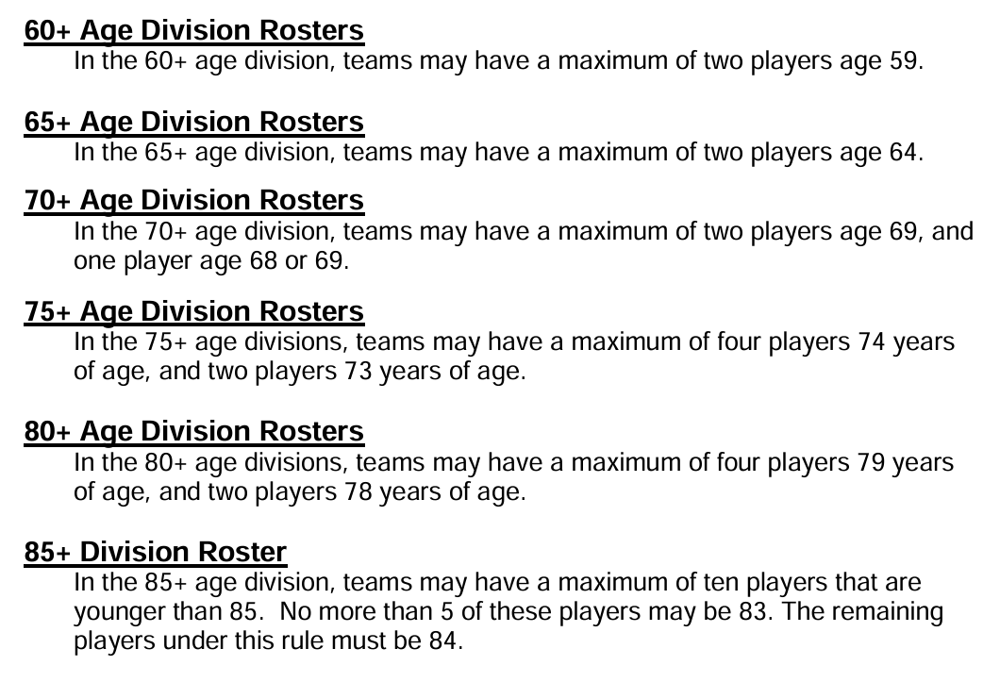

SPECIAL DIVISION RULES:
In the 65-80 men’s divisions and up and 50 to 70 women’s divisions eleven defensive players shall constitute a team. In the 85 men's division twelve defensive players shall constitute a team (Teams may elect to start and play with 10 defensive players with no penalty). TPSSA rules for re-entry and extra players will apply. Roster eligibility for, 75-, 80- and 85-men’s teams is. In the 70 Division the roster may include up to three 69-year-old players. In the 75 Division the roster may include up to five 73- and 74-year-old players with a maximum of two 73s. And in the 80 Division the roster may include up to seven 78 and/or 79-year-old players.

2027 (October 1st, 2026) new rule additions:
Men’s 65-90: No border restrictions.
Men’s 40-90: You are allowed 2 out of area players. Out of area is defined as non-touching states.
Women’s 40-90: No border restrictions.

