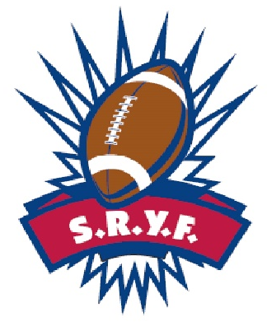
DECLARATION OF COMPLIANCE
OF AB 1-YOUTH ATHLETICS:
CALIFORNIA YOUTH FOOTBALL ACT

SEASON YEAR: Click or tap here to enter text.
ASSOCIATION NAME:Click or tap here to enter text.
I, Click or tap here to enter text. as the representative for Click or tap here to enter text.(Association Name hereafter referred to as association), declare has complied with the mandates listed in AB 1-YOUTH ATHLETICS: CA Youth Football Act as specified in Section 124240 to Chapter 4 of Part 2 of Division 106 of the Health and Safety Code.
Our association understands that failure to abide by the mandates could have varying results depending on the seriousness of the allegations with sanctions imposed at a conference level or by local and/or state government level, if deemed applicable. The association understand this declaration will be posted on either or both the association or conference website for public review.
I declare penalty under perjury under the law of the State of California that the information on this form is true and correct.
Date:Click or tap to enter a date.
Signature:___________________________
Print Name:Click or tap here to enter text.

