

Youth Basketball Rules 2015:

- Eligibility

  - RPAR youth basketball is for all boys and girls ages 5-16.

    - 5-6 year old league
    - 7-9 year old league
    - 10-12 year old league
    - 12-16 year old league

  - Any boy or girl participating must be 5 years old by September 1st of the current year. Participant turning 16 before September 1st of the current year will not be allowed to play.

  - Each child will be entered into our Active Network software and teams will be evenly and randomly distributed based on age and gender only.

- Equipment

  - Uniforms will consist of:

    - No hard sole shoes.
    - Jersey with number on back. Approved numbers are 1-9 digits or no number over 5 if double digit. No team will have any players with the same number.
    - Shorts of individual choosing.

  - All players must be in uniform by the beginning of the 2nd game of the season or lose the privilege of playing until they have the required uniform.

  - Basketballs, a set of rules, equipment and other materials required to play basketball games will be the responsibility of RPAR.

  - RPAR will provide a Book Keeper, Clock Keeper and Referees.

- Players and Playing Time

  - Each player present at the game must play an equivalent of two (2) complete quarters or the game will be forfeited by the team violating this rule. The only exceptions to this rule are:

    - Players who do not come to practice
    - Disciplinary problems
    - Illness
    - Injury
    - Player fouls out

  - Every game will start with a review of sportsmanship and the basic rules. Every game will end with both teams meeting at center court for a team handshake. Also, after the game, parents meet at center court to create a tunnel for all players from both teams to run through while parents cheer them on! See last page.

  - Each team will be allowed four 30-second timeouts per game. One extra timeout will be given for overtime.

  - Clock stops for injuries, technical fouls, final one minute of the second period, and the final one minutes of the fourth period. If there is a difference of 20 points or more, the clock will continue to run.

    - Jump Ball: Teams will alternate possessions in all situations.
    - Floor Violations: (traveling, double dribble, backcourt, fouls, etc) will be called.
    - Rule Interpretation: Will be based on high school rules. Officials will meet with each coach prior to the game to discuss rule interpretations. Protest will not be honored. The decision on the court will be final.

  - Two minutes for 1st overtime, if the score remains tied then a second overtime will go on till we have a winner.

  - Forfeited Games: Each game will start at the scheduled time with 5 players from each team. If either team is not available to start the game at the scheduled time, they will forfeit the game or the score will be recorded as 2-0. If a team knows prior to the day of the game that forfeiture is imminent, the coach should inform the RPAR Recreation Coordinator.

  - Playing Time: RPAR is in favor of equal playing time for all youth participants. The purpose of the rules concerning playing time is to insure each player has the opportunity to obtain equal playing time on the court as reasonably as possible and to instill the concept of total team participation to all players. The playing time rules are also used to equalize any advantage.

    - Starting a game: a team must have 5 eligible players to start a game; however, it needs only 1 player to finish a game.
    - Failure to comply with playing time rules:
1st time- verbal warning from Recreation Coordinator
2nd time- will be submitted to a forfeit
3rd time- grounds for expulsion for coach and team from the league

- General Rules

  - All coaches will be responsible for their players and parents conduct at all times i.e. before, during, and after every game and practice. Only the coach has the authority to consult with a referee. Abusive language will not be tolerated. Any type of fighting or instigation (taunting) will cause the guilty party to leave the game and possibly not be allowed to attend future games. Any player that fights will be suspended for a game.

  - Coaches must remain in the coaching box at all times with the exception of a time out or injury. Coaching boxes are for coaches only.

  - No team may schedule more than 3 participation sessions per week with no sessions longer than 1 ½ hours. This goes into effect beginning the week the rosters are handed out. A scheduled game or practice is considered 1 session.

  - Zone or man-to-man defense is allowed.

    - No defensive team can apply full court press when it leads the opposing team by 20 points.

  - Fouls:

    - A player shall be removed from the game after committing his or her 5th personal foul (personal and technical fouls are combined).
    - Bonus situation (1&1) on the 7th team foul and each non-shooting fouls will be a 1&1.
    - A player shall be removed from the game after the 2 technical foul (unsportsmanlike conduct).
    - A player may be ejected from the game for an intentional foul.
    - If a coach or player receives 2 technical fouls in a game, he/she will be ejected from the game and must leave the gym (Note: Refusal to leave will constitute a forfeit).
    - Defense: When one team gains possession of the ball, the opposing team must immediately go to their defensive end of the court. The defense may not defend the ball until the ball carrier is within 15 feet of the goal.
* 5-6 and 7-9 year old leagues see addendum

RPAR has zero tolerance for unsportsmanlike behavior from coaches, players, and spectators. We would encourage all coaches to let a member of RPAR staff know if such behavior is occurring in our basketball program.
5 & 6 Year Old League

Quarter Length: 6 minutes
Player Playing Time: 12 minutes
Goal Height: 8’
Basketball Size: Junior 27.5”
Defense: Man to man or Zone defense, no full court press
Court: Cross Court
Score: Scores will be recorded and posted on www.quickscores.com/ruston
Clock: Running clock, except for time outs and the last one minute of the
4th quarter
7 - 9 Year Old League

Quarter Length: 6 minutes
Player Playing Time: 12 minutes
Goal Height: 8’
Basketball Size: Junior ball 27.5”
Defense: Man to man or Zone defense, no full court press
Court: Full Court
Score: Scores will be recorded and posted on www.quickscores.com/ruston
Clock: Clock will stop for timeouts, fouls, out of bounds, injuries, and floor violations
10 - 11 Year Old League

Quarter Length: 7 minutes
Player Playing Time: 14 minutes
Goal Height: 10’
Basketball Size: Intermediate 28.5”
Defense: Man to man or Zone defense, Full or Half court press allowed
Court: Full Court
Score: Scores will be recorded and posted on www.quickscores.com/ruston
Clock: Clock will stop for timeouts, fouls, out of bounds, injuries, and floor violations
12– 16 Year Old League

Quarter Length: 8 minutes
Player Playing Time: 16 minutes
Goal Height: 10’
Basketball Size: Regulation
Defense: Man to man or Zone defense, Full or Half court press allowed
Court: Full Court
Score: Scores will be recorded and posted on www.quickscores.com/ruston
Clock: Clock will stop for timeouts, fouls, out of bounds, injuries, and floor violations.

Parent Cheering Tunnel
Rule 3B
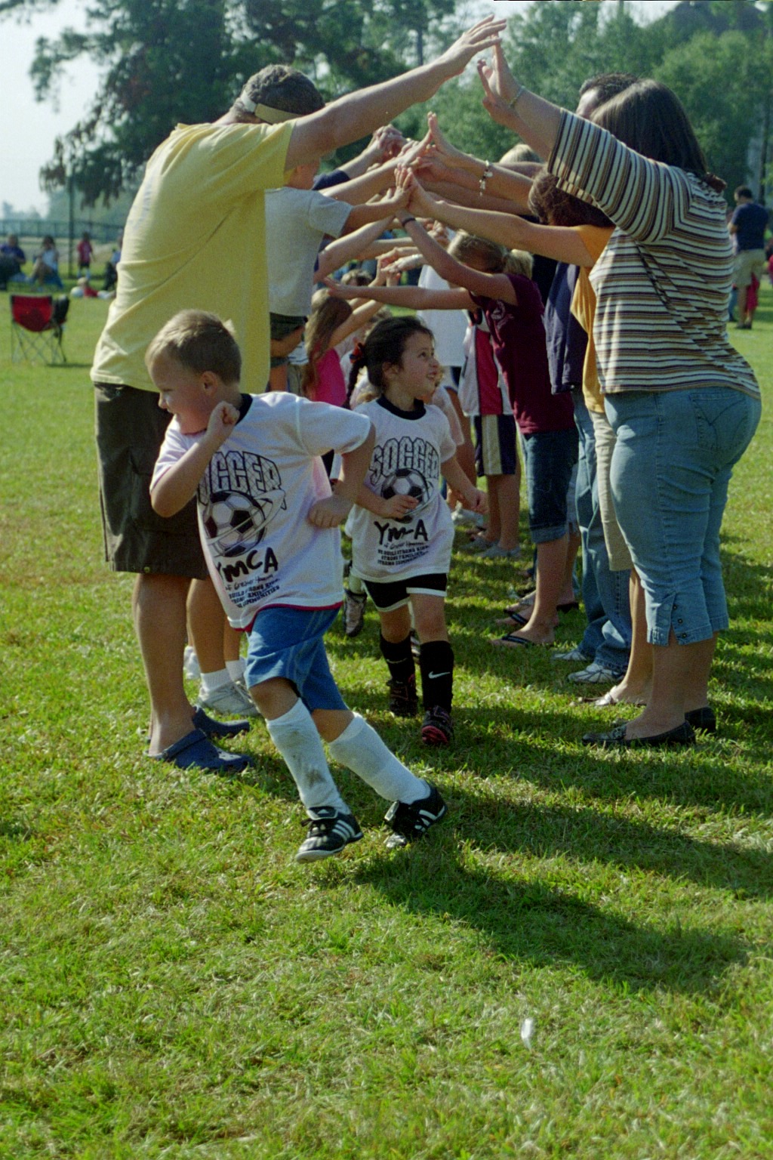

After every game, parents meet at center court to create a tunnel for all players from both teams to run through, while parents cheer them on!

