2025 Flag Football
1st through 12th Grades Rules



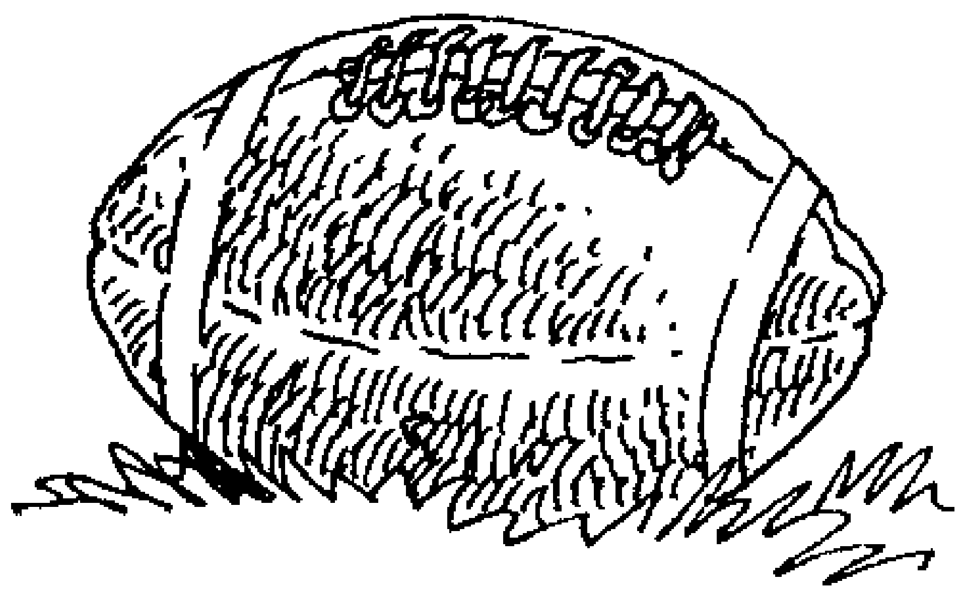

Pleasant Grove Recreation
547 S. Locust Ave.
Pleasant Grove, UT 84062
785-6172 / rec.plgrove.org
Pleasant Grove Recreation
Flag Football Rules

THE FIELD

The dimension of the field is approximately 45 yards long for 1st - 6th grades and 80 yards long for 7th - 12th grades. The width of the field is approximately 25 yards for 1st – 6th grades and 35 for 7th – 9th. Each field is divided laterally into equal halves within which the offensive team has 4 downs to cross into the next half.
.

THE GAME

DOWNS – Each team shall have 4 downs in which to gain entry into the next half, upon which another 4 downs shall be awarded. If penalties or poor play causes the offense to lose ground into a rear half, the forward half or goal line remains the amount to gain. The offense must then pass through the half in which the penalty occurred and cross into the next half in order to achieve a first down or touchdown. On changes of possession, however, when a penalty sends the ball into a rear half, the offense has 4 downs to make it back into the half in which the penalty occurred in order to achieve a first down.

A down is declared when the person having the ball is tackled (knee touches ground, flag is pulled or merely loses flag) and no penalty is called. If a penalty is called and accepted, the down remains the same (some exceptions) and yardage walked off.

DEAD BALL – Dead ball is declared any time the ball touches the ground after touching an offensive player. The offense always keeps possession. Exceptions to the dead ball rule are:
- When the ball touches the ground during the snap, before the designated rusher gets to the quarterback in which case only the quarterback may pick the ball up and continue play.
- On a scrimmage kick, if the ball touches the ground before a punt attempt, the ball may be picked up and punted.

SCORING – Touchdowns count 6 points; point after 1 point from, safety is 2 points and the ball.
Note: A player scoring the touchdown must raise his arms so the nearest official can deflag the player. If the player is not deflagged with one pull and the official determines the flag belt has been secured illegally, the touchdown is disallowed. PENALTY: loss of down.

TIMING – The game shall consist of two 20 minute halves. Halftime will be 3 minutes long.
OUT OF BOUNDS – A player is considered out of bounds as soon as he steps on the perimeter lines.
THE LINE OF SCRIMMAGE (LOS) – The scrimmage line is an imaginary line that runs the width of the field at the front tip of the football.
POINT OF INFRACTION (POI) – That point at which a violation of the rules occurred and often the point from which the penalty is enforced. Hiding the Flag, Pass interference, Illegal Runs, Tackles or Blocks are examples.

THE EQUIPMENT

SHOES – All players must wear shoes. Most turf shoes and soft rubber cleat shoes, (no metal), that are approved for soccer and/ or little league baseball are legal. Players wearing illegal shoes are ineligible to play until problem is resolved.

FLAGS – All players shall wear a flag belt with 3 flags; a flag shall be positioned just to the rear of each hip, and one down the back. The belt must be worn outside the uniform shirt, and may not be hidden, or the flags be secured in any way that would prohibit access, or from being pulled.

PENALTY – HIDING THE FLAG: Blown dead at first tackle attempt

UNIFORM SHIRTS – All players are supplied with a uniform shirt from the Recreation Department. Uniform shirts must be worn on the outside of any jacket or sweatshirt. It is recommended that all upper body clothing be tucked in, but is not required as long as opposing players have access to the belt and flags.

WATCHES, JEWELRY, CASTS, ETC – All watches and jewelry must be removed prior to start of game. Players shall not wear anything dangerous to themselves or other players, such as watches, rings, hats, earrings, casts, etc. Wrapping of casts is not acceptable. The Referee or Supervisor will be the judge to determine other dangerous items.

THE PLAYERS

NUMBER OF PLAYERS – 9 players shall constitute a team playing on the field at any one time in 1st – 4th grades, 7 players for 5th – 9th grades and 6 players in 10th – 12th. However, the team will not forfeit if fewer than 9, 7 or 6 players are at the game. More than the amount agreed upon players on the field at one time is a violation.

PENALTY – ILLEGAL PARTICIPATION: 5 STEPS/ LOS.

THE KICKING GAME

THE KICKOFF

WHO – Team captains shall meet with the referees at the first of the game to decide who will kick and who will receive.

HOW & WHERE – The kickoff shall be a place kick. The offense shall line up at the designated spot for each grade line using the width of the field if desired. The defense can line up on their half of the field.

RECEIVING THE KICKOFF – The kicked ball may be caught (before or after touching the ground) and returned.
However, if the ball touched the ground after being touched by the receiving team, it becomes dead, and is
marked at that spot. Any kick going beyond the goal line, which is not advanced by the receiver back across that line, will be placed at the first quarter line.
RECEIVING TEAM – The Receiving team may not throw a forward pass, however, the receiver / runner may lateral the ball at any time.

PENALTY – ILLEGAL PASS ON KICKOFF: DEADBALL @ POI.

OUT-OF-BOUNDS – Once the ball is kicked, the ball shall belong to the receiving team, regardless of the outcome. The receiving team will take possession 2 yards behind the closest down field forward mark unless it is in the front half of the field.

PENALTY – KICK OUT-OF-BOUNDS: 2 yards behind the nearest forward mark unless it is in the front half
of the field.

OFFSIDES ON KICKOFF – Breaking the LOS before the ball is put into play with a kick will result in an off sides penalty.

PENALTY – OFFSIDES: 5 STEPS/ LOS.

THE SCRIMMAGE KICK (PUNT)

ANNOUNCES INTENTION TO KICK – A team must announce its intention to kick. If a kick is not intended, no announcement need be made. All players on the LOS and every member of the kicking team, except the kicker, may not move off the line or in any other direction until the ball is kicked.

RECEIVING THE SCRIMMAGE KICK – Receiving team may not attempt to block the kick, even from their side of line. If this is attempted, kicking team may elect to re-kick. The kicked ball may be caught and returned. However, if the ball touches the ground before being caught by the receiving team, it becomes dead, and is marked at that spot. The kicked ball will be the possession of the receiving team: (A) Where the ball touches the ground (B) at the point it goes out-of-bounds (C) Where the receiver, after catching the ball on the fly, is tackled.

THE PASSING AND RUNNING GAME

OFFSIDES – Neither the offense, nor the defense may in any way cross the LOS until the ball is put into play, either by kicking or hiking.

PENALTY – OFFSIDES: 5 STEPS/ LOS.

OFFENSIVE FORMATION – Any offensive formation is legal as long as: (A) The ball is hiked (between the legs or from the side) to someone behind the line of scrimmage (B) There is at least 1 player on the line of scrimmage at the snap of the ball. (Players are considered on the LOS if they are within two yards of that line)

PENALTY – ILLEGAL FORMATION: 5 STEPS/ LOS.

RUSHING

Designated Rushers – An Official will stand 10 steps from the line of scrimmage into the defense and act as a marker for all defensive players who want to rush the quarterback. NO defensive player can rush the quarterback unless he/she starts behind the official at 10 steps down field. Any defensive player can rush the ball when the ball is handed off and in possession of an offensive player who did not receive the ball from the center.

PENALTY – ILLEGAL RUSH: 5 STEPS/ LOS-REPLAY DOWN

ROUGHING THE PASSER – Defensive players rushing the quarterback may not make any contact with the quarterback’s upper body or arm as he releases the ball for a pass. Pulling the flag is the preferred method of stopping the pass.

PENALTY – ROUGHING THE PASSER: 10 STEPS/ LOS-REPLAY DOWN

PASSING

EVERYONE ELIGIBLE – All players are eligible to receive or throw passes.

ONE FORWARD PASS – Only one forward pass may be thrown during a play. Any pass thrown after ball carrier crosses the line of scrimmage is an illegal pass.

PENALTY – ILLEGAL PASS: 5 STEPS/ LOS and LOSS OF DOWN.

LATERALS – Any pass thrown or tossed backwards is called a lateral. Any lateral which touches the ground shall be dead and that spot becomes the new LOS.

DEFENDING THE PASS – The defense may not hold, trip, or in any way interfere with, or impede the pass receiver in his attempt to catch a thrown ball.

PENALTY – DEFENSIVE INTERFERENCE: 10 STEPS/ LOS and REPLAY DOWN

OFFENSIVE PASS INTERFERENCE – The offense may not hold, trip, or in any way interfere with a defensive player in his attempt to catch thrown ball.

PENALTY – OFFENSIVE INTERFERENCE: 10 STEPS/ LOS and LOSS OF DOWN.

RUNNING

BALL CARRIER MAY – Ball carrier may jump or spin in a controlled manner. Ball carrier may not jump or spin in a way that the official views as dangerous to himself or any other person.
(Jumping into defenders or spinning 2 times consecutively may be considered dangerous)

PENALTY – ILLEGAL RUN: 5 STEPS/ POI and LOSS OF DOWN.

BALL CARRIER MAY NOT – Ball carrier may not stiff-arm, guard his flag to avoid a tackle, jump over other players, or run through tacklers. (Ball carrier must attempt to run around defenders to avoid head on collisions)

PENALTY – ILLEGAL RUN: 5 STEPS/ POI and LOSS OF DOWN.

BALL CARRIER MAY NOT – intentionally fumble a ball forward in order to take advantage of field position or achieve a first down. In the case of an intentional forward fumble, the ball will be spotted at the point of release.

BALL CARRIER MAY NOT – Ball carrier may not dive with ball to gain field advantage. Ball will be placed where dive was initiated.

NO CENTER SNEAK – The player who snaps the ball to the quarterback must hike between his legs and turn around to receive the handoff in order to carry the ball. (The center is still eligible as a receiver)

PENALTY – ILLEGAL PLAY: REPLAY THE DOWN.

QUICK SNAP TO MAN IN MOTION - This play is legal as long as the man in motion is at least 3 yards behind the LOS at the point he receives the ball.

PENALTY – ILLEGAL PLAY: REPLAY THE DOWN.

TACKLING

PULLING THE FLAG – Tackling is the process of pulling the flag of the ball carrier. The tackler may not hold, pull down, or run through the ball carrier himself in order to pull the flag, nor may he deliberately trip the ball carrier, or intentionally push him out of bounds. The defense may not deliberately pull the flag of any player not in possession of the ball, or knock the ball out of the ball carriers hands. Once the flag has been pulled, it must be immediately dropped to the ground. Flags swung around in the air can be unsafe.

PENALTY – ILLEGAL TACKLE: 10 STEPS/ POI. (IF UNSAFE OR FLAGRANT: 10 YARDS/ POSSIBLE EJECTION)

LOST FLAG – A player is considered tackled if he has lost his belt, and has possession of the ball.

DROPPED BALL – Is a dead ball, (not a fumble), with one exception. If the ball is dropped by a quarterback during the initial snap and before the rusher can pull the flag, the quarterback can pick up the ball once and continue the play.

UNFAIR CIRCUMSTANCE CLAUSE – If the defense makes an attempt to pull the flag of a ball carrier but is unsuccessful because of some unfair circumstance, the official may blow the play dead and spot the ball at that point.

SPOTTING THE BALL - The ball will be spotted at the location of the ball carrier’s torso when tackled. The ball will not necessarily be spotted where the flags fall on the field.

BLOCKING

OFFENSE – Players may not run over, push, shoulder, hold, trip, or in any deliberate way impede the defense except by being an obstacle, stationary, or moving, which the defense must run around in order to gain access to the ball carrier.

PENALTY – ILLEGAL BLOCK: 5 STEPS/ LOS IF BLOCK OCCURRED BEHIND LOS, OR 5 STEPS POI and LOSS OF DOWN IF INFRACTION OCCURRED BEYOND LOS.
Referee may impose harsher penalty if he feels the infraction was flagrant or dangerous.

DEFENSE – The defensive players must run around the offensive player in order to gain access to the ball carrier. Elbows may not be raised from the body with forearms or hands aimed toward the opponent when contact is made. They may not run over, push, shoulder, hold, trip, or in any deliberate way remove the offensive player from his station, even if that player is moving.

PENALTY – ILLEGAL BLOCK: 5 STEPS/LOS OR 5 STEPS/POI IF INFRACTION OCCURRED BEYOND LOS.
Referee may impose harsher penalty if he feels the infraction was flagrant or dangerous.

GENERAL INFORMATION AND PENALTIES

SPORTSMANSHIP – Players or coaches shall not swear, scream, fight, spike the ball, complain about the referee’s judgment, deliberately deter the official in his attempt to officiate the game, or in any manner show unsportsmanlike conduct.
PENALTY – UNSPORTSMANLIKE CONDUCT: 10 STEPS/LOS ASSESSED AT END OF PLAY. A more severe penalty may be assessed at the referee’s discretion depending on severity of offense. Ejection from the game or from the field is within the power of the official.

OFFICIAL – The official shall have the right to rule on anything not specifically covered in the rules. Judgment calls are not to be questioned or protested. Improper application of the rules by the official may be questioned by the coach if done in prudent gentlemanlike manner. The official is in charge of the game; his ruling shall be final. There will be a field supervisor at each location to assist with official/coach questions.

INADVERTENT WHISTLE – If the referee blows his whistle by mistake the ball shall be placed at the spot of the ball when the whistle was inadvertently blown and the down counted, or the down may be replayed at the discretion of the offensive team.

WIN/ LOSS – There will be win/ loss records kept during the season for 5th – 12th Grade. We will end the season with a tournament.

COACHING – Coaches will be allowed to coach on the field for the entire season in the 1st - 2rd grade leagues. 3rd – 4th grade offensive coach is allowed to stay on the field for the season. Coaches will not be allowed on the field of play for the 5th - 12th grade teams.

PENALTY SUMMARY

INFRACTION | PENALTY
Unsportsmanlike conduct | 10 Steps/LOS assessed at end of play
Offensive Interference Defensive Interference | 10 Steps/LOS and Loss of Down
(Pass interference) | 10 Steps/LOS and Replay the down
Roughing the Passer | 10 Steps/LOS and Replay the down
Hiding the flag | Blown dead at first tackle attempt
Offsides | 5 Steps/LOS and Replay the down
Illegal Participation | 5 Steps/LOS and Replay the down
Illegal Rush | 5 Steps/LOS and Replay the down
Illegal Formation | 5 Steps/LOS and Replay the down
Illegal Pass | 5 Steps/LOS and Loss of Down
Illegal Tackle | 10 Steps/POI
Illegal Run | 5 Steps/POI and Loss of Down
Illegal Pass on Kickoff | Dead Ball @ POI
Illegal Block-Offense | 5 Steps/LOS if occurred behind LOS  5 Steps/POI and Loss of Down if infraction occurred beyond LOS
Illegal Block-Defense | 5 Steps/LOS if occurred behind LOS  5 Steps/POI if occurred beyond LOS
Kickoff Out-of Bounds | Ball placed 2 yards behind first down marker
Illegal Play | Replay the down

Official may assess 10 step penalty if he felt that any above infraction was flagrant or occurred in a dangerous manner. When an infraction occurs, the offended team usually has the choice to accept result of play or assess the penalty for that infraction.

