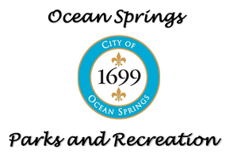
Adult Basketball League

Liability Waiver

Name: ________________________________________________________________________________
Address: _______________________________________________________________________________
City: ____________________________________ State: ___________ Zip: __________________
Phone: __________________________________ Email: ___________________________________
DOB: ___________________________________ Team: ___________________________________

Waiver Statement: The undersigned states that he/she understands that the City of Ocean Springs Parks and Recreation are not and shall not be responsible for or liable for any illness, or injury to person or damage to property resulting from the program in which the undersigned is enrolling or being enrolled or from his/her participating in said program, and the participant and the undersigned, if the participant is a minor or under other legal disability, hereby forever releases and holds harmless the said City of Ocean Springs Parks and Recreation, its employees, agents and representatives from any and all claims of any kind that the participant, or the undersigned or their respective heirs, executors, administrators, or assigns may have or claim to have resulting from participation in said program.

