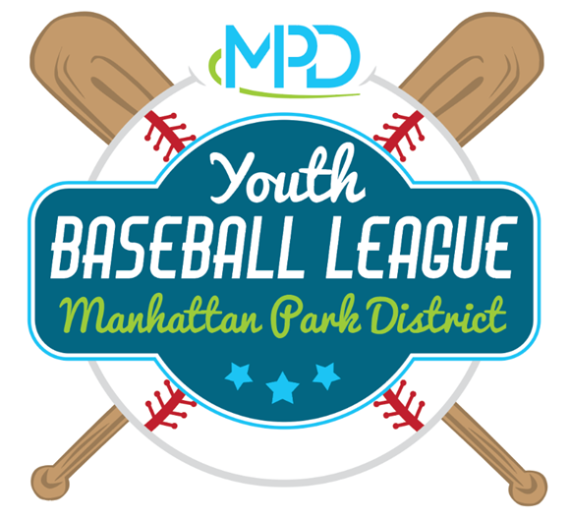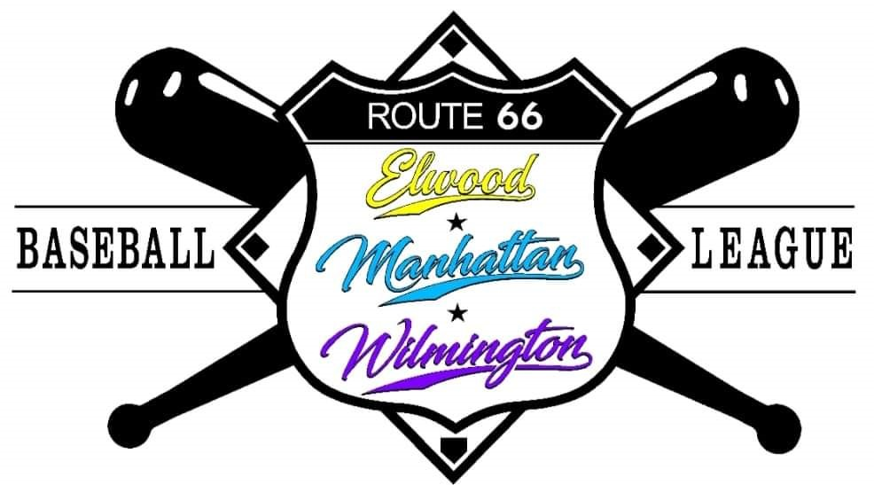

Manhattan Park District
Youth Baseball & T-Ball Parent Manual

Welcome to Manhattan Park District’s Youth T-Ball and Baseball program! We believe the role of youth sports is to encourage children of all ages and skill levels to participate, learn and most importantly, have fun. It is our mission to create a safe, low-pressure and family-friendly environment in order to ensure that everyone has the best experience possible.

General Policies
Rules and League Participation
Depending on the season, Manhattan Park District (MPD) baseball teams will play in the Route 66 League (MPD, Wilmington, Elwood) or with the Lincoln-Way League (Mokena, Elwood, Frankfort & Frankfort Square teams). Both leagues follow PONY league age divisions and game rules. Please note that both leagues will have customized rules adjustments for each season that will supersede the PONY League rules in specific cases. A link to season specific rules for each season will be posted on the MPD Athletics page.
MPD T-Ball will also follow PONY League rules and may participate in either the Route 66 League, the Lincon-Way League, or play completely in-house.

Registration
Each participant needs to register online (rectrac.manhattanparks.org) prior to the registration cutoff date. Late registrations will be placed on a waitlist and are not guaranteed a spot in the league unless notified by MPD. MPD will make every effort to place all players, but it some circumstances it may not be possible due to full rosters.
Having trouble registering online? Contact the Hansen Community Center (815-478-3324) or stop by in person to register.

In-Game Injuries / Medical Emergencies
At registration all participants are asked if ADA (Americans with Disabilities Act) accommodations are needed for your player. Please indicate these needs at registration.
Please notify MPD if your child has any other pre-existing medical conditions that may affect their ability to play, or that may present in an emergency during practice or play. (Allergies, medications, physical impairments, etc.).
In the event of an on-field injury, first aid kits are located in the field boxes at the MPD Athletic Field Complex, as well as in the Baseball equipment bags. Coaches and parents will be responsible for administering first aid and/or calling 9-1-1 if necessary.

Weather
In the case of inclement weather, the safety of all our participants, officials and spectators are our primary concern. MPD will contact your coach if a field is determined to be unplayable and your game is cancelled as a result. The coach is responsible for notifying all players and the opposing team’s coach of a cancelled practice or game. If the field is determined to be playable by MPD, but the weather is not safe to play, game officials and/or coaches will have the responsibility of cancelling or postponing the game if they believe the weather warrants such an action.
If thunder or lightning can be seen or heard at the field being played on, the game must immediately be cancelled or postponed for a 30-minute reevaluation period. Game time limits are still in effect for delayed games.

Rainouts, Cancellations and Rescheduling
If a game is cancelled due to weather or other unforeseeable circumstances, the game will be rescheduled by team coaches in coordination with the opposing teams’ coaches. Coaches will inform MPD of the new date/time and will be responsible for informing their teams. Special considerations may be taken into consideration when rescheduling games.
Requests by head coaches to reschedule for other reasons will not be honored. If a coach is unable to attend a game or practice, the assistant coach will assume the role. If neither head coach or assistant are available, a 3rd team parent will step in to fill the role for the day or the game will be forfeited.

Uniforms
Jerseys and a baseball cap will be provided prior to the first games of the season. Please indicate your players uniform size at registration. Uniforms may have sponsor logos also printed on them. No other advertising is allowed on team uniforms.
Players will need to complete their uniform with baseball pants (Grey preferred but not required), baseball socks and appropriate shoes. No metal cleats are allowed.
Absolutely no jewelry may not be worn on the field.

Team Selection Process
Shortly after the registration cut-off date, MPD will hold a one-day player evaluation session for youth baseball players. These are not ‘try-outs’, but rather a skill session that will be used as a tool to help ensure even teams are created.
Carpool/neighborhood requests are accepted and considered, but there is NO GUARANTEE that requests will be honored.
T-Ball teams do not have a player evaluation date. Teams are created taking into account the total numbers of players registered, number of volunteer coaches and carpool/neighborhood requests.
Once rosters are created and assigned, no changes can be made.

Practices and Regular Season Games
Team practices at all levels will begin prior to the start of game play. Team practice dates/times are determined by the team’s volunteer coach.
T-Ball League regular seasons typically consist of 8-10 games, typically played on Saturdays at Manhattan Park District Athletic Complex on Smith Rd. The number of games, game schedule and location may vary depending on the league and season.
Youth Baseball League regular seasons typically consist of a 10-15 game schedule. Teams typically will have 1 practice per week and can expect to play 1-2 games per week on average. Games may take place on weekday evenings or weekends. HOME games and practices take place at Round Barn Farm or Central Park fields. AWAY games will be held at neighboring community fields.

End of Season
T-Ball does not typically play a post-season. Participation medals will be dispersed to coaches prior to the end of the season. After the last game/practice of the season, the season is over.
Youth Baseball League teams (Pinto, Mustang, Bronco and older) typically participate in a single elimination playoff bracket, depending on the season.

Volunteering Procedure
Our program relies on our volunteer parent coaches to teach and lead practices and games, but there are many other ways interested parents can be involved. Head coach, assistant head coaches, team parents, scorekeepers, and evaluation date coaches are always needed. Other team parents not assigned volunteer coaching positions are encouraged to speak with their teams coach if they’d like to be involved in any other ways. All volunteer coaches are required to submit a volunteer application and background check before they are able to volunteer. Please indicate at registration your desire to volunteer as a parent coach, or contact MPD for more information.

Volunteer/Spectator Code of Conduct
All volunteers and spectators present at games or practices are expected to demonstrate appropriate behavior at all times. The following guidelines are designed to provide safe and enjoyable activities for all participants.

Volunteers / Spectators shall:
- Show respect to all participants, staff and officials.
- Do their best to provide and maintain a safe playing environment for all participants.
- Refrain from using abusive or foul language towards ANYBODY in attendance.
- Refrain from causing emotional or bodily harm to self, other participants, staff or officials.
- Show respect for equipment, supplies and facilities.

Coaches Code of Conduct
All coaches are expected to adhere to the following coach specific guidelines in addition to the Volunteer/Spectator guidelines listed above.

As a Volunteer Coach I pledge to:
- Place emotional and physical well-being of all participants ahead of a personal desire to win.
- Treat each player as an individual, understanding the large range of emotional and physical development occurring at this stage.
- Lead by example in demonstrating fair play and sportsmanship to all players.
- Review and practice basic first aid needed to treat injuries.
- Educate themself on league rules and teach those rules to all players.
- Do their best to organize practices that are fun and challenging for all players.
- Take direction from league supervisor.

Players Code of Conduct
Like our parents and spectators, we expect participating players in our programs to adhere to a standard code of ethics.

- I will demonstrate and encourage traits of good sportsmanship from fellow players, coaches, officials and spectators.
- I will do my best to listen and learn from my coaches.
- I will treat fellow players, coaches, officials and spectators with respect regardless of their race, sex, creed or abilities. I expect to treated the same.
- I will alert parents or coaches if the game stops being fun for any reason.
- I will place my schoolwork ahead of my athletics.
- I will have fun!

Ultimately, we want everyone to understand and keep in mind that this is a recreational youth sports program. The players are children, who are learning and growing at various paces. The umpires are often young adults (or children), who are learning and growing at various paces. Your volunteer coaches may be new to the role or the sport, and are learning and growing at various paces.
We are all here to learn, grow and most importantly have fun playing a game we all love so much. Please act accordingly.

Failure to adhere to any of these guidelines may result in disciplinary action or dismissal from the program.

Disciplinary Procedures
A positive approach will be used regarding discipline. MPD reserves the right to dismiss a volunteer/spectator/coach whose behavior is not consistent with expectations listed above. If a participant/volunteer/spectator/coach exhibits inappropriate actions or behaviors, the following guidelines will be followed:

Step 1: Verbal Warning
Participant/Volunteer/Spectator/Coach will be contacted by phone, email or in person letting them know that this action and/or behavior will not be tolerated

Step 2: Game Suspension
The Participant/Volunteer/Spectator/Coach has continued to display this action and/or behavior which will result in being asked to sit out for the next game. The Youth Athletic Supervisor and the Participant/Volunteer/Spectator/Coach will have a sit-down meeting before rejoining.

Step 3: League Expulsion
The Participant/Volunteer/Spectator/Coach will be expelled from the league if they receive a third warning.

Complaint Procedure
For complaints or disagreements with a coach or umpire’s on-field decisions or rulings, MPD asks parents to follow the ’24-hour rule’. This rule allows for a 24-hour ‘cool down’ period to pass before contacting the Athletic Coordinator to get involved.

In cases that pose immediate physical or psychological harm to a player or anyone in attendance at a game or practice, please report behaviors to MPD as soon as possible.

Important Dates to Remember – Spring 2022
These are tentative dates and may change after a preseason league manager’s meeting.

Registration Deadline – Tuesday, March 1st.

Player Evaluations – Monday, March 14th. Location TBD

Practice Start Date – Week of April 4th

Games Start Date – Monday, April 25th. First games may be any day during the week.

6 weeks of games. 2 games per week. 12 games total.

Game End Date – Sunday, June 12th

Playoffs – Monday June 13th through Sunday June 26th

Picture Day - TBD

*Picture Day Date - TBD

