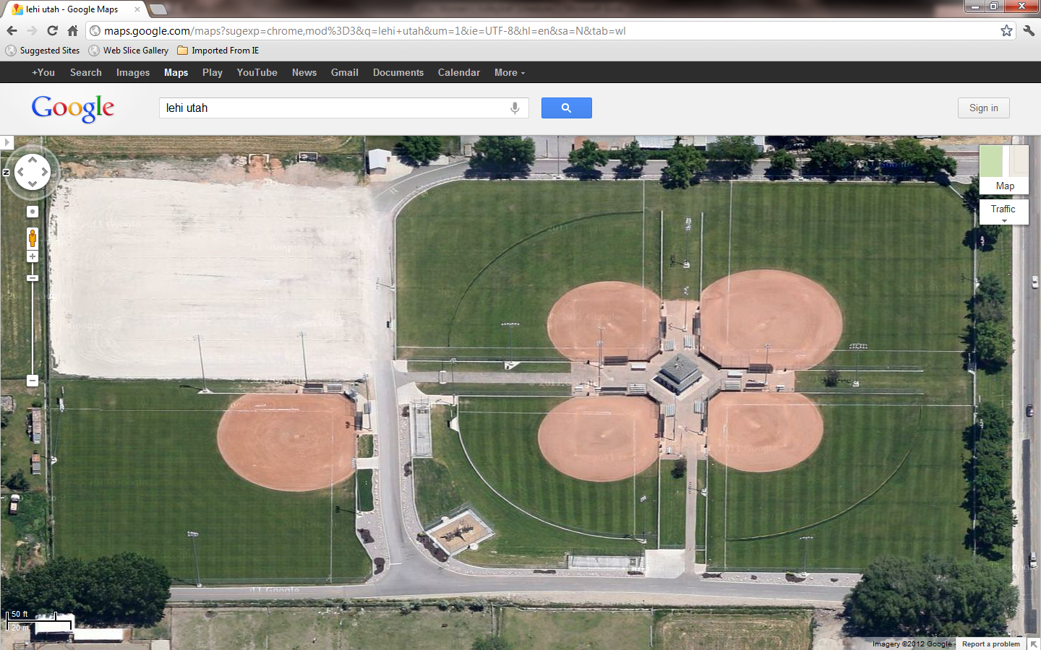

FIELD 1

FIELD 5

FIELD 2

FIELD 3

NO PARKING

LEHI MAIN ST.

LEHI CITY VETERANS BALLPARK (850 W. Main St.)

**FIELD D**

FIELD 2

**FIELD A**

**FIELD C**

**FIELD B**

FIELD 3

FIELD 5

**RESTROOMSS**

LEHI MAIN ST.

LEHI CITY VETERANS BALLPARK (850 W. Main St.)