2026 GRPA STATE TOURNAMENT PACKET
CLASS C 8U Girls
March 6th and 7th
Dear Basketball Teams:
On behalf of White County Recreation Department, we would like to welcome each team and its spectators to the 2025 GRPA Class C 8U Girls Basketball State Tournament held at the Yonah Preserve Recreation Center.
If we can be of any assistance to you and your team, please contact our department. As a reminder, no tobacco use of any kind (cigarettes, cigars, chewing tobacco, vapes, etc.) or alcohol is allowed inside the gyms or on facility grounds, including parking lots. The Zero Tolerance Policy is in effect at all times. For your safety, security will be present during the tournament.
Good Luck to you all!
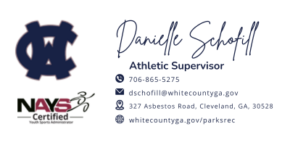
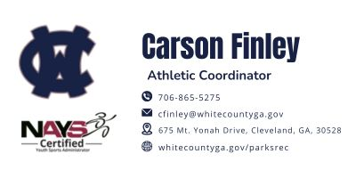
Game Site Information:
- Yonah Preserve Recreation Center
- 675 Mt. Yonah Drive, Cleveland, GA, 30528
- Office Number - (706) 865-5275
- Carson Finley – Tournament Director – cfinley@whitecountyga.gov
- Danielle Schofill – Athletic Supervisor – dschofill@whitecountga.gov
- Kim McEntire – Park Director – kmcentire@whitecountyga.gov

ROSTERS: Coaches or Staff Representatives should bring their copy of their GRPA Official Roster and birth verifications. If you are coming straight to state, all four copies of the roster are to be submitted upon arrival. All rosters must be typed and in alphabetical order. All players must be present at team roster check-in prior to their first game of the tournament. Any player arriving after team check in MUST check in with tournament staff prior to participating in tournament.
Entry Fee: $305.00 (Please make check payable to White County Recreation Department)
Officials: 2-3 GHSA High School approved officials per game.
Jerseys: Governed by GRPA State Athletic Manual
Awards: Governed by GRPA State Athletic Manual
Rules: GHSA Rules & GRPA Rules (2025 GRPA Manual, pages 71-74
Bench: Only 3 Coaches & 10 Players listed on official roster may be on the bench. No one at the Score table (Your Bookkeeper must be on the bench as a part of your 3 coaches).
Forfeit: Game time listed is the forfeit time.
Admission: There will be an admission fee each day. Cash Only!!!
- Adults - $8.00
- Students - $4.00
- Children 5 & Under AND Adults 61 & Over - No charge.
Tournament Brackets:
Brackets will be updated throughout the tournament at: www.quickscores.com/grpa
The Team listed on top of the bracket will be the home team and they will wear “White”. Exception-The host team will always be the home team.
Local Lodging and Dining Information
Lodging | Restaurants
https://helenga.org/lodging/ | https://helenga.org/dining/

GRPA SPORTSMANSHIP STATEMENT
“The Georgia Recreation and Park Association and its member agencies have made a commitment to promote good sportsmanship by athletes, coaches, and spectators at all GRPA sanctioned events. Profanity, degrading remarks, and intimidating actions directed at officials or competitors will not be tolerated and are grounds for removal from the event site. Spectators are not allowed to enter the competition area during warm-ups or while the contest is being conducted. Thank you for your cooperation in the promotion of good sportsmanship at today’s event.”

