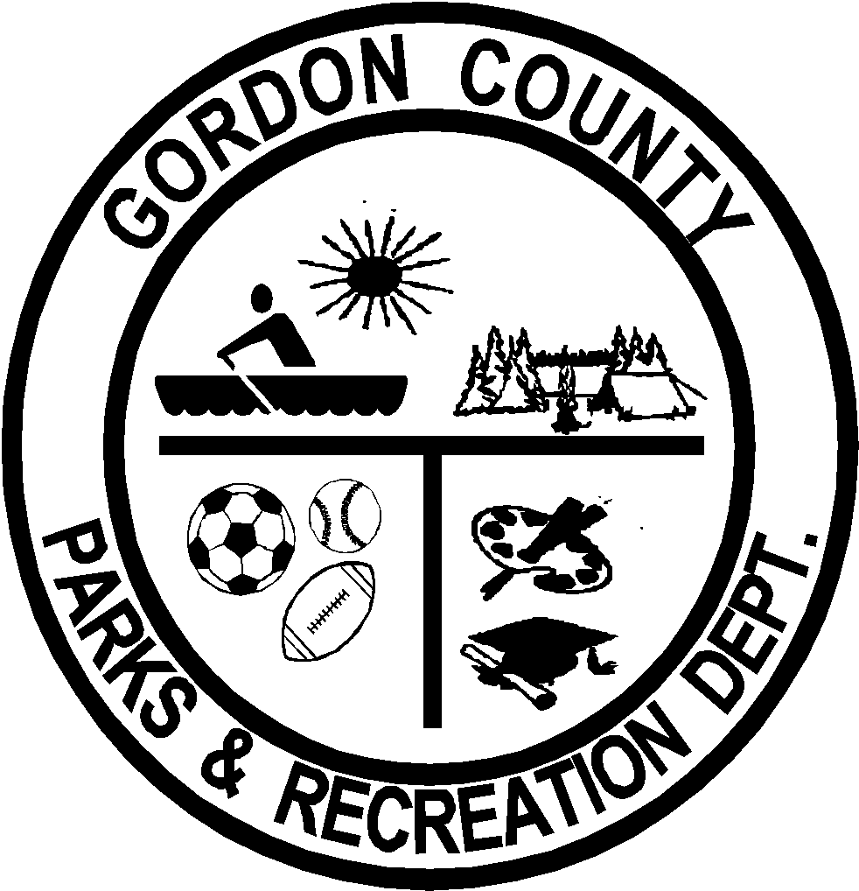
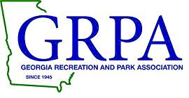

2023 GRPA State Basketball Tournament

Class B 8U Boys

March 3-4

Gordon County Parks & Recreation

Calhoun, GA

On behalf of the Gordon County Parks & Recreation Department, I would like to welcome you to Calhoun/Gordon County. We are honored to have been selected by the Georgia Recreation Park Association to host the 2023 GRPA Class B 8U Boys Basketball State Tournament. All games will be played at the Sonoraville Recreation Complex, located at 7494 Fairmount Highway SE, Calhoun, GA 30701.

Teams are required to check in with the tournament director at least one hour prior to their first game. Rosters will be checked and players identified at that time. Game officials will meet GHSA certifications.

There are numerous restaurants and hotels within 10 minutes of the host site. There is also a premium outlet mall located just minutes away featuring Nike, along with many other national brands. Bucees is also a popular local attraction located right off of exit 310 on I75 North.

Congratulations on representing your respective GRPA District. If there is anything we can do to assist you during your stay, please do not hesitate to call us. You can reach our office at 706-602-4435.

Sincerely,

Craig Sparks, Director Gordon County Parks & Recreation

2022
GRPA Class B 10U Girls
Basketball Tournament
March 3-4

Tournament Host: Gordon County Parks & Recreation

Tournament Site: Sonoraville Recreation Complex 7494 Fairmount Highway SE Calhoun, Georgia 30701
706-602-4435

Tournament Directors: Craig Sparks, Director csparks@gordoncounty.org
David Mitchell, Assistant Director
david.mitchell@gordoncounty.org

Format: Pool Play then Single Elimination.

Bracket: www.quickscores.com/grpa

Trophies: Team and individual trophies will be presented to the tournament champion and runner-up teams.

GRPA Rosters: Official GRPA rosters typed and signed by the agency director; along with acceptable birth records (see GRPA Athletic Manual). All players must be present at team/roster check in prior to the first game of the tournament.

Entry Fee: $205.00 per team is due along with roster at check-in. Make check payable to: Gordon County Parks & Recreation.

Uniforms: All team players must have matching jerseys with factory type legal numbers only on front and back (see GRPA Athletic Manual).

Concessions: A full line of concessions will be available.

Admission: All spectators will be required to pay:
Adults - $5.00
55 & Over - $2.00
17 & Under - $2.00
5 & Under - Free

LODGING

Holiday Inn Express
135 Hampton Drive
Calhoun, GA 30701
706-629-2018

La Quinta Inn by Wyndham
150 Cracker Barrel Dr.
Calhoun, GA 30701
706-629-2559

Baymont by Wyndham
125 Hampton Dr.
Calhoun, GA 30701
706-629-8566

Comfort Inn & Suites
1033 Fairmount Hwy SE
Calhoun, GA 30701
706-625-6500

Fairfield Inn & Suites
1002 Hwy 53 East
Calhoun, GA 30701
706-629-8002

Rodeway Inn
1007 Hwy 53 East SE
Calhoun, GA 30701
706-383-8600

Red Roof Inn & Suites
189 Jameson St.
Calhoun, GA 30701
706-629-8133

