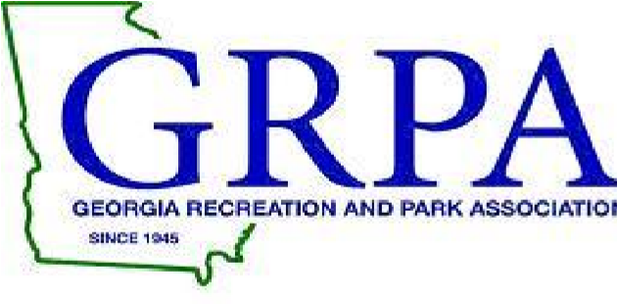
2023 GRPA STATE BASKETBAL
14 UNDER GIRLS – B/C STATE
MARCH 3-4, 2023

TOURNAMENT HOST: City of Riverdale Recreation Department

TOURNMAENT SITE: Riverdale Town Center
7210 Church Street
Riverdale, GA 30274

TOURNAMENT DIRECTOR : Alan Dotson
adotson@riverdaleg.gov
Office: 770-909-5304
Cell: 404-821-8320

ENTRY FEE: $205.00 – Payable to: City of Riverdale

ROSTERS: Coaches or Staff Representatives should bring their copy of their GRPA
Official Roster and birth verifications. All players must be verified
before competing in his/her first game.

OFFICIALS: 2 approved officials pool play / 3 officials single elimination

JERSEYS: Governed by GRPA State Athletic Manual (See pages 73-74)

AWARDS: Governed by GRPA State Athletic Manual.

ADMISSION: Adults: $5.00; Children $2.00 (5-18); Senior Citizens – 55 and up $2.00
TOURNAMENT BRACKETS: Brackets will be updated throughout tournament at www.grpa.org @ or www.quickscores.com (search GRPA Tournaments)

LODGING/RESTAURANTS:

Country Inn & Suites by Radisson, Atlanta Airport South, GA

5100 W Fayetteville Rd, College Park, GA 30349
(678) 369-916

Drury Inn & Suites Atlanta Morrow
6520 S Lee Street
Morrow, GA 30260
P: 770-960-0500
F: 678-724-4426

Business Name | Address
WAFFLE HOUSE | 6544 HWY 85
Fin and Feathers | 6340 Highway 85
PIZZA HUT | 7131 HWY 85
RIVERDALE DWARF HOUSE | 6549 HWY 85
NEW CITY BUFFET | 7165 HWY 85 #B
POPEYES CHICKEN & BISCUIT | 6717 HWY 85
Los Amigos Restaurant | 286 Highway 138 # I-J
ANNIE LAURA's Kitchen | 6814 HWY 85
The Juicy Crawfish | 7038 HWY 85
ANTHONY PIZZA | 6518 HWY 85 #A
KFC Kentucky Fried Chicken | 6892 HWY 85
Hotlanta Wings | 6761 Highway 85
This is It BBQ and Seafood | 6560 Highway 85
PANDA EXPRESS | 7105 HWY 85
Chipotle Mexican Grill | 7086 HWY 85
American Deli | 6401 Hwy 85 #B
J&J Fish and Chicken | 6746 HIGHWAY 85
KRISPY KREME DOUGHNUT | 6689 HWY 85
FIVE STAR SEAFOOD | 555 HWY 138 # B
BOJANGLES | 6922 HWY 85

