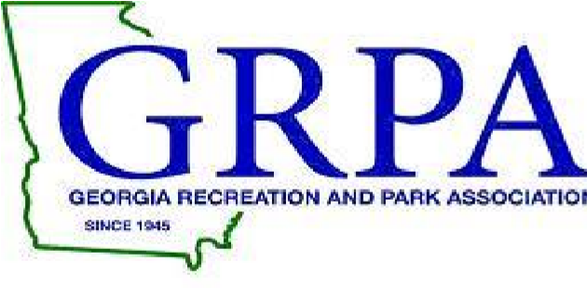
2023 GRPA STATE BASKETBAL
7-8 GIRLS – A/B STATE 9-10 GIRLS – CLASS B STATE
MARCH 3-4, 2023

TOURNAMENT HOST: Calhoun Recreation Department

TOURNMAENT SITES: Calhoun Middle School Calhoun High School
399 South River St. 355 South River St
Calhoun, Ga. 30701 Calhoun, Ga. 30701

TOURNAMENT DIRECTOR: Laura Carter
lcarter@calnet-ga.net
Office: 706-629-0177
Cell: 678-986-3662

ENTRY FEE: $205.00 – Payable to: Calhoun Recreation Department

ROSTERS: Coaches or Staff Representatives should bring their copy of their GRPA
Official Roster and birth verifications. All players must be verified
before competing in his/her first game.

OFFICIALS: Cherokee Basketball Officials Association – 2 approved
officials per game.

JERSEYS: Governed by GRPA State Athletic Manual (See pages 73-74)

AWARDS: Governed by GRPA State Athletic Manual.

ADMISSION: Adults: $5.00; Children $2.00 (5-18); Senior Citizens – 55 and up $2.00
TOURNAMENT BRACKETS: Brackets will be updated throughout tournament at www.grpa.org

LODGING/RESTAURANTS: Fairfield Inn and Suites - $169.00/night
Contact John Andrews – 828-280-6146 – for team block rate

Holiday Inn Express and Suites - $200.00/night
Contact – Vince Locke – 404-56-6990

Comfort Inn and Suites - $221.20/night
Contact – Jessica Mills – 470-315-0340

Baymont Inn and Suites - $109.00/night
Contact – Sam Patel – 423-667-7272

