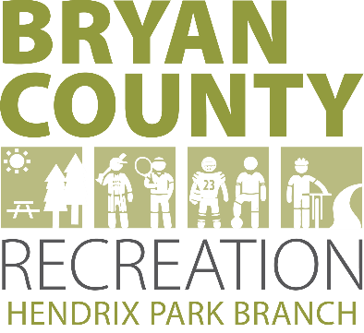
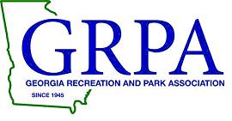

2022 GRPA
Class C 8U Girls
State Basketball Tournament

March 4-5, 2022

North Bryan County Recreation Department
Hendrix Park Gym
3960 Wilma Edwards Rd
Ellabell, GA 31308
912-858-4640

Mailing Address:
P.O. Box 430
Pembroke, GA 31321

Department Staff
- Dr. Samose Mays, Director Mandy Toole, Athleltic Director Acacia Davis, Administrative Assistant
Brianna Campbell, Athletic Coordinator Quayvis Hardy, Athletic Coordinator
Amber Harper, Athletic Coordinator Richard Chavis, Maintenance

Welcome

The North Bryan County Recreation Department would like to welcome all of the coaches, players and families to the 2022 GRPA Class C 8U Girls State Basketball Tournament. We are proud to be the State Host agency for this year’s event. All State tournament games will be played at the Hendrix Park Gym.
Teams will be requested to check in 90 mins prior to their first game to verify rosters and players. All officials will be GHSA certified and there will be a minimum of 3 per game.
Please reach out to our Department with any questions and concerns your may have concerning the 8U Girls State Basketball Tournament! We look forward to hosting your teams and making this a great game experience for your players!

Mandy Toole
Athletic Director & Tournament Director

- Game Sites: North Bryan County Recreation Department Gym (Hendrix Park)
3960 Wilma Edwards Rd, Ellabell, GA 31308
912-858-4640, Fax 912-858-4641

Contact Information:
Mandy Toole: Email: mtoole@bryan-county.org
Phone: (912) 858-4640
Cell: (912) 658-5953
Acacia Davis: Email: acaciae@bryan-county.org
Phone: (912) 858-4640
Cell: (912) 429-7453
Web page: www.bryancountyga.org

- Admission: $5.00: Adults (18 – 54 years of age)
$2.00: Children (17 years of age and under) and Seniors (55yrs of age and older)
Please assist as much as possible in letting your fans know that we cannot accept any bills larger than a $20.00 to ensure adequate funds on hand for event.

    - Entry Fee: $205.00 (Make check payable to North Bryan County Recreation Department). Fees are to be paid before the first game. The $5 fee is to cover Quick Scores charges.

- Rosters: Coaches or Staff Representatives should bring their copy of their GRPA Official Roster. If you are coming straight to State all FOUR Copies of the Roster are to be submitted upon arrival. All rosters must be typed and in alphabetical order or the agency will be fined $40.00 (see GRPA Manual). All adult and youth players must be present at team roster check-in prior to the first game of the tournament. The tournament director will visually cross check each player with the names on the roster. If a player is not present at team check-in, that player must check in with the tournament director prior to playing in the tournament.

    - Officials: Georgia High School Officials- Scheduled by Alijah Johnson.

    - Jerseys: Matching Jerseys with numbers on Front and Back. Mandatory uniforms shall be matching jerseys with factory type legal numbers only on front and back described in the Georgia High School Association Rule Book. Legal numbers consist of 0, 00 (0 and 00 can not be used on same team) 1-5, 10-15, 20-25, 30-35, 40-45 and 50-55. It is legal for players to wear matching color or white t-shirts only under game jerseys.
a. No other youth sports organization patches will be allowed on uniforms in GRPA tournaments. Penalty – Illegal Equipment
b. Emblem/Logo/Picture Placement: GRPA waives the GHSA and NFHSA penalties for logos and clipart placement on basketball uniforms. No technical foul will be administered.

- Awards: 1st and 2nd Team and 1st and 2nd Individual Awards

General Notes of Interest:
- 8 and under Girls divisions play 6 minute quarters. Overtime will be 3 minutes. Five minute half-time in all games.
- Time outs : 3- 60 second , 2 – 30 second plus one additional time out per OT
- No more than 3 team personnel members including 2- coach and 1- scorer (MAX 3 Total) are allowed on the team bench.
- Jump Balls will be used to begin games.
- Mercy Rule - Beginning in the third quarter, if requested by the losing team’s coach, or any time in the fourth quarter a team gains a 20-point lead the clock will run continuously for the balance of the game except during timeouts and injuries. If not elected in the third quarter it automatically occurs in the fourth quarter when a 20-point lead occurs. If the losing team gets within ten points, the clock will return to regulation.
- Youth coaches must be certified by one of the following certifications:
* NYSCA, * ACEP, * GHSA, * Simply the Best, * Excellence Plus

- Certified Youth Coach Or a Full-Time Recreation Staff member must be in attendance with the team during all games. Failure to have a certified coach or a Full-Time Staff member is a $100.00 fine paid to the GRPA (page 31 of the GRPA Manual).

- Game Time: A team must have at least 4 players in all divisions to
start a game. A team can continue with four players except in the case of an ejection.

- Tournament Director: Mandy Toole

- Rules: GRPA Manual pages 66 – 69 and GHSA 2022 Basketball Manual.

- Audio/Visual: Use of audio or visual recording devices, including a cell phone, is not permitted in changing areas, or rest rooms. The use of audio or visual recording devices is not allowed in resolution of protested matters.

- Mandatory Meeting: Teams MUST be checked in at least 30 minutes prior
to the team’s first game on Friday to cover any rules or other information concerning the tournament as well as verify rosters.

- There will be a full concession for spectators which include hamburgers, hotdogs, fries, chicken fingers, nachos and various candies, popcorn and drinks. All Concession staff will be required to maintain their PPE procedures including gloves and masks at all times.

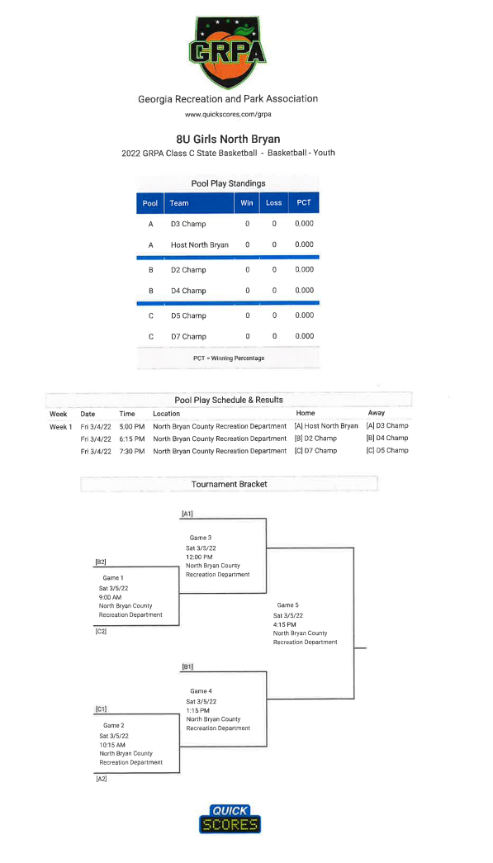

Lodging:
No immediate hotels near the park but the nearest areas are Statesboro, Pooler Parkway, I-95 (Pooler Exit and/or Savannah Exit).

Restaurants:
Pembroke, GA (10 miles from Hendrix Park)
- Dairy Queen, McDonalds, China #1, Subway, Higgins Place, Johnnie’s Grill, Stoner’s Pizza

Pooler, GA (22 miles from Hendrix Park)
- Wide variety of fast food: McDonalds, Chick fil-A, Arbys, Sonic, Zaxby’s, Wendy’s and more
- Wide Variety of eat-in establishments: IHOP, Jalepenos, Olive Garden, Longhorns, Carey Hilliards, and many more.

Statesboro, GA (29.3 miles from Hendrix Park)
- Wide variety of fast food: Wendy’s, Zaxby’s, Arby’s, Krystals, KFC, Taco Bell, and many more
- Wide Variety of eat-in establishments: El Sombrero, Ole Times Buffet, Applebees, IHOP, Longhorns, Cracker Barrel and many more.

GRPA SPORTSMANSHIP STATEMENT
“The Georgia Recreation and Park Association and its member agencies
have made a commitment to promote good sportsmanship by athletes,
coaches, and spectators at all GRPA sanctioned events. Profanity,
degrading remarks, and intimidating actions directed at officials or
competitors will not be tolerated, and are grounds for removal from the
event site. Spectators are not allowed to enter the competition area during
warm-ups or while the contest is being conducted. Thank you for your
cooperation in the promotion of good sportsmanship at today’s event.”
Hendrix Park
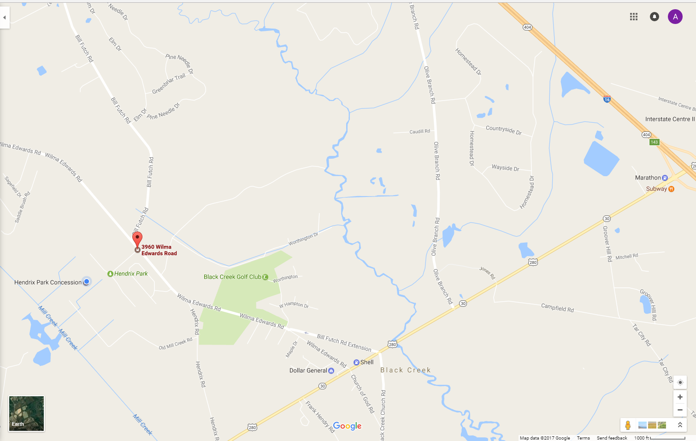

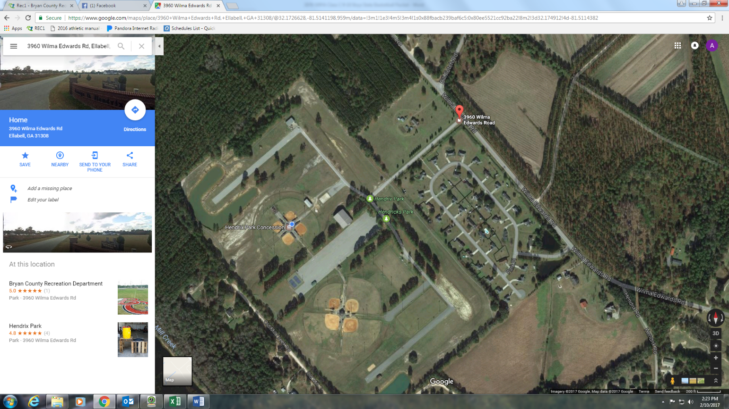

Gym

Directions to North Bryan County Recreation Department Hendrix Park
3960 Wilma Edwards Rd, Ellabell, GA 31308
Main Office Phone: (912) 858-4640 Fax: (912) 858-4641

From the WEST on I-16: Take Exit 143 off of I-16 East bound. Take a right off of the exit on US Hwy 280 towards Pembroke. Travel 2.2 miles then turn right onto Wilma Edwards Rd. Travel 1.4 miles and Hendrix Park will be on your left.

From the EAST on I-16: Take Exit 143 off of I-16 West bound. Take a left off of the exit on US Hwy 280 towards Pembroke. Travel 2.2 miles then turn right onto Wilma Edwards Rd. Travel 1.4 miles and Hendrix Park will be on your left.

From I-95 SOUTH: On I-95 North, take Exit 99B to merge onto I-16 W towards Macon. Travel 14.8 miles and take Exit 143 onto US Hwy 280 towards Pembroke. Travel 2.2 miles then turn right onto Wilma Edwards Rd. Travel 1.4 miles and Hendrix Park will be on your left.

From I-95 NORTH: On I-95 South, take Exit 99B to merge onto I-16 W towards Macon. Travel 14.8 miles and take Exit 143 onto US Hwy 280 towards Pembroke. Travel 2.2 miles then turn right onto Wilma Edwards Rd. Travel 1.4 miles and Hendrix Park will be on your left.

