

**2021 GRPA 12U Major Baseball**

**State Tournament**



**June 22nd – June 26th, 2021**

**Tift County Recreation E.B. Hamilton Complex**

**3199 E.B. Hamilton Drive Tifton GA 31794**

**Complex Phone – 229- 382-1403 or 229-382-1449**

The Tift County Recreation Department would like to welcome all of the coaches, players and families to the 2021 GRPA 12 Under Major Baseball Tournament. We are proud to be the Host agency for this year’s event. All tournament games will be played at the E.B. Hamilton Complex located at 3199 EB Hamilton Drive in Tifton GA. Our amenities include LED scoreboards, public address system, home and visitor dugout areas, concessions, bleacher seating and hospitality area for GRPA Coaches and GRPA Staff .

Prior to the beginning of the tournament, host staff will conduct a pre-tournament coach/staff meeting in the press box. Issues such as registration procedures, facility amenities, GRPA rules, sportsmanship and a question and answer session will be held. Game officials will be in attendance to answer any rule interpretations. All officials will be GHSA certified.

Tifton/Tift County offers a vast array of restaurants, shopping and over 1,500 hotel/motel rooms within a 3 mile radius of the host site. I have included a tourism brochure, and a map of the area to help you navigate around Tifton. We hope you have a great stay, and if you have any problems contact our office at 382-3262.

Jeff Howard

Tournament Director

**2021 GRPA**

**12 & Under Major Baseball Tournament**

* **Game Sites: Tift County Recreation E.B. Hamilton Complex**

**3199 E.B. Hamilton Drive Tifton GA 31794**

**Complex Phone – 229- 382-1403 or 229-382-1449**

**Office - 229-382-3262, Fax 229-382-7246,**

**Weather-Rain Line: 229-528-9292 (Voice Message Distribution)**

[recreation@tiftcounty.org](mailto:recreation@tiftcounty.org)

**Contact Information:**

Jeff Howard: Email:[jeff.howard@tiftcounty.org](mailto:jeff.howard@tiftcounty.org), www.tiftcounty.org

**Phone: (229-382-3262)**

**Cell: (229)-392-2256**

**General Notes of Interest*:***

* Baseball – Age Control Date is September 1. Maximum Roster Limit is 15. Maximum team personnel -3 coaches including scorekeeper and 1 Batboy are allowed on the team bench.
* Baseball Youth coaches must be certified by one of the following certifications:

NYSCA, ACEP, GHSA, HIGHER GROUND, SIMPLY THE BEST, DOYLE, MVP, ASA VIP, or EXCELLENCE PLUS

* Certified Youth Coach or a Full-Time Recreation Staff member must be in attendance with the team during all games. Failure to have a certified coach or a Full-Time Staff member is a $100.00 fine paid to the GRPA.
* **Game Time: Game Time is Forfeit Time –** A team can continue with minimum number of players except in the case of an ejection.
* **Tournament Director:** Jeff Howard
* **Protest Committee:** Jeff Howard, Tim Petrea – substitute will be a member of the GRPA SAC if Present and Head Official.
* **Mandatory Meeting:** A team meeting will be held for checked **in at least 30 minutes’ prior**

**to the team’s first game** to cover any rules or other information concerning the tournament. Penalty of $25 will be assessed if a coach or staff representative does not attend

this meeting.

* There will be a hospitality area for coaches, officials, and staff members. There will be a full concession for spectators.
* **Admission:** Adults $5.00 (18 years of age and older)

Children $2.00 (Under 18)

Adults 55 and Over $2.00

* + **Please assist as much as possible in letting your fans know that we cannot accept any bills larger than a 20.00 to ensure adequate funds are on hand for event.**

**RULE CHANGES 2021 ATHLETIC MANUAL**

**The athletic manual is available online at** www.grpa.org **under the “Athletics” tab.**

**All page # references are from the 2020 Athletic Manual**

**ALL SPORTS**

• RC #3 - Middle School/9th Grade athletes that are 14 years of age or younger are eligible to

participate in GRPA athletics. No participant that is on a Junior Varsity, B-Team or any other

sub-varsity high school sports eligibility roster, except summer sports, is eligible to participate in

GRPA Athletics provided all other GRPA eligibility requirements are met.

• RC #17 - A motion was made that if the committee finds any discrepancies or conflicts due to

the rule changes that they can be allowed to be changed at the next SAC Meeting in October.

• RC #14A - A motion was made to increase the state host fee $25 for all youth team sports.

• RC #15 - A motion was made to add a $50 fine, payable to the GRPA Office, for ejection of

youth or adult coach or adult player this must be noted on the tournament report form.

• RC #16 - A motion was made that any team that pulls players off the field/court be assessed the full forfeit fee $375 with normal distribution of the fee.

• RC #18 - A motion was made to allow rule changes with any SAC Committee or National

Governing Body to be considered to be changed in October.

**BASKETBALL**

• Page 77, Article III, Section A, 3a. - Add: upon entry into the game.

**GIRLS FLAG FOOTBALL**

• RC – A motion made to offer girls flag football in 2021. Host will be bid on at the President’s

Assembly.

**FOOTBALL**

• Game Balls – All game balls for each team that will be used for the game must be inspected by

officials prior to the game and marked by officials. Use of any other ball that is not marked

appropriately will be considered illegal equipment. If the illegal equipment (game ball) is:

o DISCOVERED PRIOR TO THE NEXT DOWN/PLAY, the down/play should be

REPLAYED and the team flagged for unsportsmanlike conduct with a 15 yard penalty

assessed (if the coach/team defers to the result of the play, the penalty will be assessed on

the next down) and the illegal equipment removed from the game.

o Is discovered after the play but NOT BEFORE the next down/snap/play the team will be

assessed an unsportsmanlike conduct penalty of 15 yards and the illegal ball/equipment

removed from the game. The result of the play stands and will not be replayed if

discovered after the next play/down has occurred.

o Any and all subsequent offenses, dealing with illegal equipment regarding the ball, by the

offending team will be assessed a 15 yard unsportsmanlike penalty and the coach ejected

from the game. NOTE: THE SIT OUT RULE WILL BE IN EFFECT.

**GRPA Athletic Manual**

**TRACK & FIELD**

• A motion was made in track and field for the softball throw to change the size of the softball to

an 11” softball. Ages 7, 8, 9, and 10.

**SOCCER**

• A motion was made for all classes and all divisions – 12U and above allowed to head the ball.

**PICKLEBALL**

• RC #7B - A motion was made to change the age control date for Pickleball to December 31st of

the tournament year.

• RC #12 - A motion was made to allow the pickleball tournament host to use

pickleballtournament.com. The host is allowed to charge a $2.00 fee per registered athlete for the

use of pickleballtournament.com. There will be no open registration.

**TCRD TOURNAMENT POLICY**

**Recreational Facilities**

* ALCOHOLIC BEVERAGES ARE PROHIBITED IN ALL AREAS.
* CLASS CONTAINERS ARE PROHIBITED IN ALL AREAS.
* PETS, SKATES OF ANY KIND, SKATEBOARDS, AND BICYCLES ARE PROHIBITED IN ALL AREAS.
* NO PEPPER GAMES BETWEEN DUGOUTS.
* NO BALL-TOSS DRILLS ON FIELD FENCE.
* WARM-UP IS AVAILABLE IN OUTFIELD GRASS. PRACTICE AREAS ARE AVAILABLE NEAR GAME FIELDS. NO WARM-UP IS ALLOWED IN THE ALLEY WAYS BETWEEN FIELDS.
* Water is provided in the dugouts.
* TEAM SEATING: Top line of bracket is home and uses the FIRST BASE DUGOUT , unless a team is playing back to back games.
* LINEUPS: Scorekeepers provide forms. A copy should be turned into scorekeeper at least 15 minutes prior to scheduled game time. Give original copy to umpire, second copy to scorer, third copy to opposing team/manager. The fourth copy is for your records. Give all substitutions to plate umpire.
* COIN TOSS: Coin toss for home team is fifteen minutes prior to scheduled game time.
* RUN RULE and Completed Game: A game shall be considered complete after five (5) innings with eight (8) runs, four (4) innings with twelve (12) runs or three (3) innings with fifteen (15) runs ahead or two (2) innings with twenty (20) runs ahead including championship game or if-needed championship game.
* A two hour time limit will be used 12 & Under Major in all games except for

championship and if games.

International Tie-breaker: After the regulation game or time limit has expired the

International tie-breaker will be used. The last scheduled batter will be placed on second

base. This will continue until a winner is determined. Refer to ASA rule 5, Section 11.

* **GAME TIME: *Game time is forfeit time – Exception for GRPA events see GRPA Rule***. Please be prepared to play at your scheduled time. The decision of the TOURNAMENT COMMITTEE will be final. ***Double Check Shorthanded Exception Rule prior to calling game a forfeit. – Rule 1 Section C -Special Provisions - 1.Shorthanded Rule- page 95.***
* **PROOF OF AGE:** Tournaments involving State and National organizations will be conducted in accordance with their specific rules.
* **UNIFORMS:** Tournaments involving State and National organizations will be conducted in accordance with their specific rules. Otherwise matching shirts with numbers and caps will be enforced.
* **PROTEST:** Please study all rules, especially pitching, equipment, appeals and protest procedures. A PROTEST COMMITTEE will handle all protests. ($50.00 protest fee-refundable if protest is upheld.)
* **HUSTLE:** One minute is the maximum time allowed between innings (Rule 6, section7). This will be enforced. Encourage all your players to hustle on and off the field.
* ***Bats must comply with current ASA/GRPA/NFHS or*** ***tournament governing body’s rules and regulations***.
* Teams and spectators are out guests. Please let us know if we can be of service to you.
* Enjoy your stay with us and please come again.

**ASBOLUTELY NO SMOKING INSIDE COMPLEX.**

**GRPA Pre-Tournament**

**Coach/Staff Meeting Topics**

1. **Welcome to Tifton –** Tournament Director
2. **Bench** – Top of bracket home 3rd base dugout (left side).
3. **Roster Check-in Prior to Game –**
4. **Hospitality Area –** Coaches & staff only
5. **Sportsmanship –** Positive cheering, shake hands after game, etc. (see GRPA Sportsmanship Policy)
6. **Coaches/ Team Personnel –** Only 3/1 Batboy allowed in team Dugout must be listed on roster
7. **Officials –** Question and answer session
8. **Admission for Adults $5, $2 For Students, and $2 for seniors (55 and over).**
9. **Shorthanded Rule – p 95**

**GRPA SPORTSMANSHIP STATEMENT**

*“The Georgia Recreation and Park Association and its member agencies*

*have made a commitment to promote good sportsmanship by athletes,*

*coaches, and spectators at all GRPA sanctioned events. Profanity,*

*degrading remarks, and intimidating actions directed at officials or*

*competitors will not be tolerated, and are grounds for removal from the*

*event site. Spectators are not allowed to enter the competition area during*

*warm-ups or while the contest is being conducted. Thank you for your*

*cooperation in the promotion of good sportsmanship at today’s event.”*

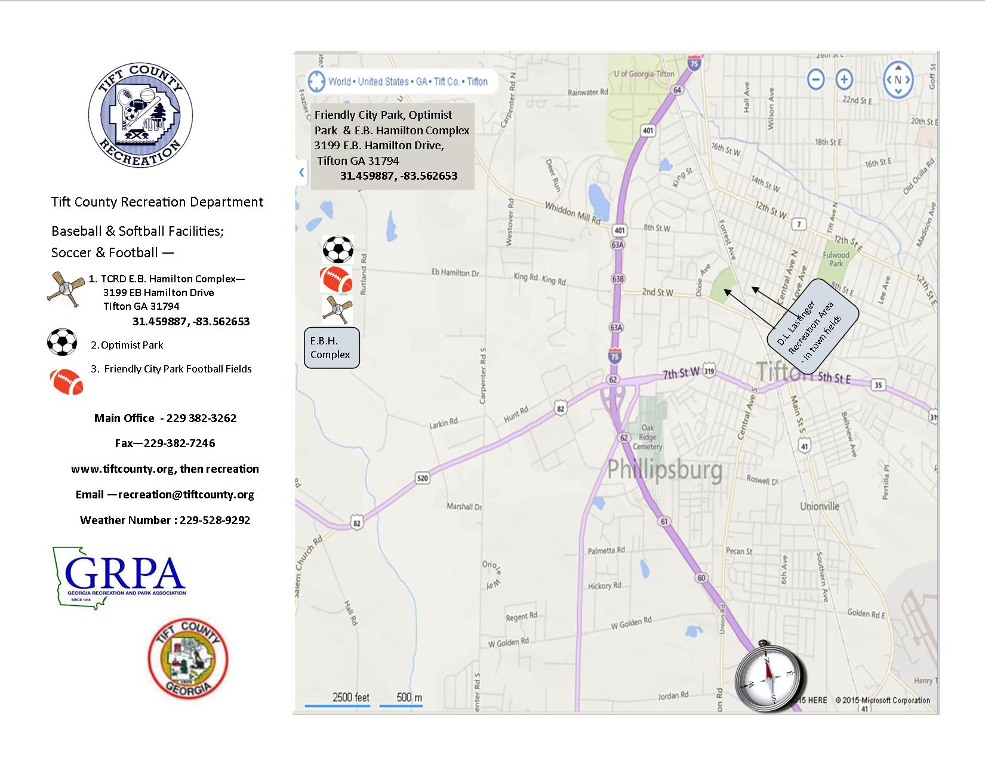

**TCRD DIRECTIONS CONTINUED:**

**TCRD Admin. Office 229-382-3262Complex 229-382-1403, Pavilion 229-387-8936 Optimist Park 229-386-5450 Weather Line 229-528-9292**

**EB Hamilton Softball Complex, Friendly City Park, Optimist Park:**

**(3199 E B Hamilton Drive)**

**From Albany going east on Hwy 82/US520 continue East until you come to Carpenter Road (Budget Outlet Car Sales) Turn left in a northward direction and continue going North on Carpenter Road until you reach the first paved intersection with a traffic light. Turn left (west) on EB Hamilton Drive. You will see the complex sign ahead of you. Turn left at stop sign to enter the main parking lot.**

**From Waycross going west on Hwy 82/US520 continue west through town. Continue under the Interstate 75 overpass until you come to Carpenter Road (Budget Outlet Car Sales) Turn Right in a Northward direction and continue going North on Carpenter Road until you reach the first paved intersection with a traffic light. Turn left (west) on EB Hamilton Drive. You will see the complex sign ahead of you. Turn left at stop sign to enter the main parking lot.**

**From I-75 North:**

**Take Exit # 63B You are now on 2nd St, King Rd, and E B Hamilton Drive exit ramp. At the top of the ramp turn right (west). You are now going west on King Rd, and E B Hamilton Drive (the name changes when you pass Colquitt EMC). You will continue going west (straight through) at the traffic light (intersection of EB Hamilton Drive and Carpenter Road). Once you are through the intersection the EBH Complex, Friendly City Park, Pavilion, and Optimist Park Soccer Complex are straight in front of you. Turn left to enter the main park area and follow the signs.**

**From I-75 South:**

**Take Exit # 63B You are now on 2nd St, King Rd, and E B Hamilton Drive exit ramp. At the top of the ramp turn left (west). You are now going west on King Rd, and E B Hamilton Drive (the name changes when you pass Colquitt EMC). You will continue going west (straight through) at the traffic light (intersection of EB Hamilton Drive and Carpenter Road). Once you are through the intersection, the EBH Complex, Friendly City Park, FCP Pavilion, and Optimist Park Soccer Complex are straight in front of you. Turn left to enter the main park area and follow the signs.**

**Tift County Recreation Department**

***2021 Super-Supporter Hotel Information:***

**Comfort Inn & Suites: Hotel Information:**

320 South Virginia Avenue 93 Rooms

Tifton, GA 31794 Pool

(229)382-8250 Meeting Space

(229)382-2290 Fax Many restaurants within walking

Contact: Charlie Wiggins/Melody Cowart distance

Email: Sales-[mcowart@williamshotelgroup.com](mailto:mcowart@williamshotelgroup.com)

Web: [www.williamshotelgroup.com](http://www.williamshotelgroup.com) **Special Rates**:

1 Person – Contact Sales

**Country Inn & Suites: Hotel Information:**

310 South Virginia Avenue 87 Rooms

Tifton, GA 31794 Pool

(229)382-8100 Pets Allowed/with a small fee

(229)382-8101 Fax Many restaurants within walking

Contact: Tammy Justice/Melody Cowart distance

Email: Sales-[mcowart@williamshotelgroup.com](mailto:mcowart@williamshotelgroup.com)

Web: [www.williamshotelgroup.com](http://www.williamshotelgroup.com) **Special Rates**:

1 Person – Contact Sales

**Days Inn & Suites: Hotel Information:**

1199 Highway 82 West 80 Rooms

Tifton, GA 31794 Pool

(229)382-8505 Pets Allowed/with a small fee

(800)325-2525 Many restaurants within walking

Contact: Rich McDonald/Melody Cowart distance

Email: Sales-[mcowart@williamshotelgroup.com](mailto:mcowart@williamshotelgroup.com)

Web: [www.williamshotelgroup.com](http://www.williamshotelgroup.com) **Special Rates**:

1 Person – Contact Sales

**Tift County Recreation Department**

***2021 Super-Supporter Hotel Information:***

**Hilton Garden Inn: Hotel Information:**

201 Boo Drive 105 Rooms

Tifton, GA 31793 Restaurant

(229)382-8484 Pool

(229)382-8474 Fax Meeting Space

(877) 782-9444 Lounge

Contact: Kathleen Moore

Email: kathleenmoore@staffordhospitality.com  **Special Rates:**

1-4 People- $109.00/night

**Holiday Inn Express: Hotel Information:**

1199 Highway 82 West 80 Rooms

Tifton, GA 31794 Pool - Indoor

(229)382-3300 Many restaurants within walking

(800)465-4329 distance

Contact: Lynda Washington/Melody Cowart

Email: Sales-[mcowart@williamshotelgroup.com](mailto:mcowart@williamshotelgroup.com) **Special Rates:**

Web: [www.williamshotelgroup.com](http://www.williamshotelgroup.com) 1 Person – Contact Sales

**Howard Johnson: Hotel Information**

579 Old Omega Road 50 Rooms

Tifton, GA 31794 Restaurant within walking

(229)388-8777 distance

(299)388-0207 Fax Pets Allowed - Depending on size

Contact: Tammy Saunders of pet and there is a pet fee

Email: hojo.tifton1@gmail.com

Web: www.hojo.com **Special Rates:**

**Special Rates**:

1 Person - $74.43/night (includes tax)

2 People - $74.43/night (includes tax)

3 People - $79.43/night (includes tax)

4 People -$84.47/night (includes tax)

**Tift County Recreation Department**

***2021 Super-Supporter Hotel Information:***

**SPRINGHILL SUITES MARRIOTT Hotel Information**

401 Boo Drive Tifton, Ga 31793 104 Rooms

229-520-5135 (Phone) Pool

Email: [Sales-johnalec.mckinnon@marriott.com](mailto:Sales-johnalec.mckinnon@marriott.com) Many restaurants with walking distance

Web: [www.marriott.com/TFOSH](http://www.marriott.com/TFOSH) Bar/outdoor fir pit

**Special Rates:**

(Suites accommodate up to 6 guest per room)

1 People - $114.00

2 People - $114.00

3 People - $114.00

4 People - $114.00

**SUPER 8 BY WYNDHAM Hotel Information**

1022 West Second Street Tifton, GA 31793 67 Rooms

229-382-9500 (Phone) Pool 229-382-2922 (Fax) Many restaurants with walking distance Reservation: 800-903-0727 Pets allowed with a small fee

Email: Sales- [kszn007@hotmail.com](mailto:kszn007@hotmail.com)

Web: [www.super8.com](http://www.super8.com/tifton)

**Special Rates:**

1 People - $49.99/night (plus tax & fees)

2 People - $53.99/night (plus tax & fees)

3 People - $59.99/night (plus tax & fees)

4 People - $64.99/night (plus tax & fees)

Tift County Recreation Department

2021 Other Hotel/Motel Information

**COMFORT INN & SUITES**

320 South Virginia Avenue Tifton, GA 31794 I-75 (Exit 62)

229-382-8250 (Phone) 229-382-2290 (Fax)

Email: Sales-williamshotelgroup.com

Web: [www.williamshotelgroup.com](http://www.williamshotelgroup.com)

**COUNTRY INN & SUITES**

310 South Virginia Avenue Tifton, GA 31794 I-75 (Exit 62)

229-382-8100 (Phone) 229-382-8101 (Fax)

Email: Sales-[williamshotelgroup.com](mailto:mcowart@williamshotelgroup.com)

Web: [www.williamshotelgroup.com](http://www.williamshotelgroup.com)

**DAYS INN & SUITES**

1199 Highway 82 West Tifton, GA 31794 I-75 (Exit 62)

229-382-8505 (Phone) 800-325-2525(Phone)

Email: Sales- williamshotelgroup.com

Web: [www.williamshotelgroup.com](http://www.wincohotels.com)

**HILTON GARDEN INN TIFTON**

201 Boo Drive Tifton, GA 31793

229-382-8484 (Phone) 877-782-9444(Phone) 229-382-8474 (Fax)

Email: [kathleenmoore@staffordhospitality.com](mailto:kathleenmoore@staffordhospitality.com)

**HOLIDAY INN EXPRESS**

1199 Highway 82 West Tifton, GA 31794

229-382-3300 (Phone) 800-465-4329(Phone)

Email: Sales-[mcowart@williamshotelgroup.com](mailto:mcowart@williamshotelgroup.com)

Web: [www.williamshotelgroup.com](http://www.williamshotelgroup.com)

**HOWARD JOHNSON**

579 Old Omega Road Tifton, GA 31794

229-388-8777 (Phone) 229-388-0207 (Fax)

Email: [hojo.tifton1@gmail.com](mailto:hojo.tifton1@gmail.com)

Web: [www.hojo.com](http://www.microtelinn.com/tifton)

**QUALITY INN TIFTON**

1104 King Road Tifton, GA 31793

229-382-4410 (Phone) 229-382-3967

Email: Sales-[gm.ga148@choicehotels.com](mailto:gm.ga148@choicehotels.com)

Web: [www.choicehotels.com](http://www.choicehotels.com)

**SUPER 8 BY WYNDHAM**

1022 West Second Street Tifton, GA 31793

229-382-9500 (Phone) 800-800-8000 (Phone) 229-382-2922 (Fax)

Email: Sales- [kszn007@hotmail.com](mailto:kszn007@hotmail.com)

Web: [www.super8.com](http://www.super8.com/tifton)

Tift County Recreation Department

2021 Other Hotel/Motel Information

**SPRINGHILL SUITES MARRIOTT**

401 Boo Drive Tifton, Ga 31793

229-520-5135 (Phone)

Email: [Sales-johnalec.mckinnon@marriott.com](mailto:Sales-johnalec.mckinnon@marriott.com)

Web: [www.marriott.com/TFOSH](http://www.marriott.com/TFOSH)