2021
GRPA State Youth Soccer Tournament
10 & Under Girls and 12 and Under Girls

December 4th, 2021

Tournament Host: Bartow County Recreation Dept.
P.O. Box 24
Cassville, GA 30123
770-387-5149

Tournament Sites: Hamilton Crossing Park Field #13 (Synthetic Turf Field)
138 Hamilton Crossing Road (Across from Hamilton Crossing Elementary)
Cartersville, GA 30120

Tournament Director: Zach Williams

Tournament Staff: Brenton Baggett

Brackets: www.grpa.com/quickscores

Trophies: Team Trophies and individual medals will be awarded to the Champion and Runner-Up

GRPA Rosters: Official 2021 GRPA rosters typed and signed by the agency director, along with acceptable birth records (see GRPA Athletic Manual) must be turned in at player check in at least 30 minutes prior to a team’s first game.

Entry Fee: $ 105.00 per team is due along with roster checks made payable to: Bartow County Recreation.

Rules: 2021 GRPA Athletic Manual (pages 138-143) / If not covered in GRPA Manual, Current GHSA/ USSF Rules will apply. Please Note that Heading the Ball is allowed in 12 and Under, but not in 10 and Under.

Uniforms: All team players must have “like color matching jerseys” (see GRPA Athletic Manual) with legal numbers on the back of the jersey.

Conduct: Each agency representative is responsible for the conduct of his/her team, coaches, and spectators. For all GRPA competitions at the district and state level, positive cheering by players, coaches, and spectators is encouraged. Any negative cheering/yelling will result in a warning and/or removal from the site, whether it is for or against your team. No artificial noisemakers shall be allowed in the bleachers, seats, or standing areas around the perimeter of the competition area in all youth sports. The tournament director is empowered with the authority to make the final decision. (GRPA Manual)

Concessions: A full line of concessions will be available. Only water is allowed on the Field and Spectator Areas on Field 13. Any other food and drink must be kept off the playing surface. That includes Powerade, Gatorade or any other drinks with food coloring.

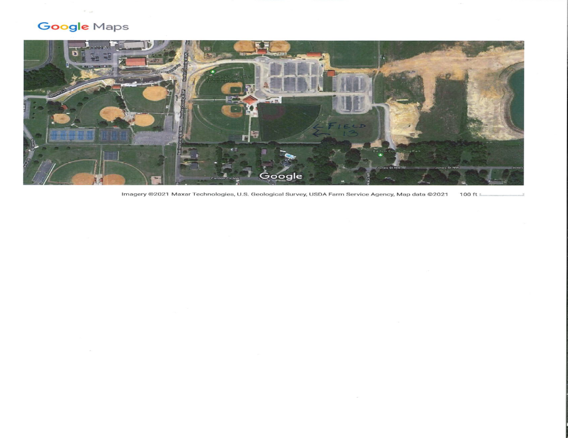

Field Type: Synthetic Turf
Field Dimensions : 70 Yards Long by 45 Yards Wide
Goal Area: 14 Yards Long by 35 Yards Wide
Goal Hight: 6 ½ feet High by 18 feet Wide
Penalty Mark: 10 Yards

