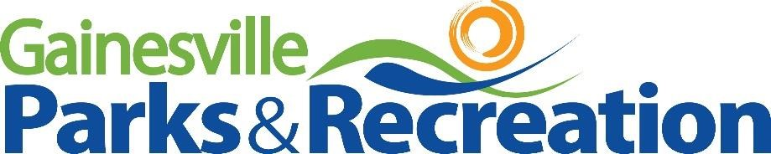

2021 GRPA Class A/B State Baseball Tournament 8U Boy’s Coach Pitch June 22-24

On behalf of Gainesville Parks and Recreation, I would like to welcome you to the City of Gainesville and Hall County. We are honored to have been selected by the Georgia Recreation and Park Association to host the 2021 GRPA 8U Boy’s Coach Pitch State Tournament. All games will be played at Lanier Point Athletic Complex, 1579 Lee Waldrip Drive NW, Gainesville, GA 30504.

Teams are required to check in with the tournament director at least one hour prior to their first game. Rosters will be checked and players identified at that time. Game officials will meet GHSA certifications.

The City of Gainesville features several hotels, restaurants, and shopping venues within minutes of the Lanier Point Athletic Complex. In addition, Lanier Point Athletic Complex provides an extensive concession list and a beautiful pavilion overlooking Lake Lanier.

Congratulations on representing your respective GRPA District. If Gainesville Parks and Recreation can aid you in any capacity, please reach out to us at 770-531-2680.

Sincerely,

Eason Spivey

Eason Spivey, Athletic Program Manager
Gainesville Parks and Recreation

2021 GRPA Class A/B State Baseball Tournament

Tournament Host: Gainesville Parks and Recreation

Tournament Site: Lanier Point Athletic Complex
1579 Lee Waldrip Drive NW Gainesville, GA 30504

Tournament Director: Eason Spivey, Athletic Program Manager
Email: espivey@gainesvillega.gov
Phone: 678-776-9714

Format: Double Elimination
Class A/B 8U Boy’s Coach Pitch
June 22-24

GRPA Rosters: Official GRPA rosters should be typed and signed by the agency director and be accompanied by each players birth records. All players must be present for roster check in one hour prior to their first game.

Entry Fee: Entry fee of $205.00 per team is due at roster check in. Please make checks payable to Gainesville Parks and Recreation.

Uniforms: Players must wear matching uniforms with factory applied numbers to the back of the jersey.

Conduct: GRPA and Gainesville Parks and Recreation strive
to provide an encouraging and fun filled environment for tournament participants. Profanity, degrading remarks, and intimidating actions directed at officials, players, coaches, or spectators are not allowed and may lead to removal from the event site.

Concessions: Gainesville Parks and Recreation will provide a fully stocked concession stand.

Admission: $5.00 per adult
Free for ages 17 and under

