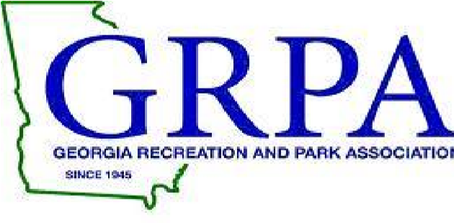
2017 GRPA STATE FOOTBALL PACKET
NORTH PLAY OFFS –December 2-3, 2017
CLASS A AND CLASS B
7-8 TACKLE; 9-10 TACKLE; 11-12 TACKLE

GAME SITE: CLASS B
CALHOUN HIGH SCHOOL
PHIL REEVE STADIUM
100 YELLOW JACKET DRIVE
CALHOUN, GEORGIA 30701

CONTACT INFORMATION: David Mitchell Kim Townsend
dmitchell@calnet-ga.net ktownsend@calnet-ga.net
Office: 706-629-0177 Office: 706-629-0177
Cell: 770-548-5031 Cell: 770-366-2939

ENTRY FEE: $150.00 (Make check payable to Calhoun Recreation Department)

ROSTERS: Coaches or Staff Representatives should bring their copy of their GRPA
Official Roster and birth verifications. If you are coming straight to
State all four copies of the roster are to be submitted upon arrival.
All rosters must be typed and in alphabetical order. All players must be
present at team roster check-in prior to their first game of the
tournament. Any player arriving after team check in MUST check in with
tournament staff prior to participating in tournament.

OFFICIALS: Northwest Georgia Football Officials Association – 4 approved or
certified officials per game.

JERSEYS: Governed by GRPA State Athletic Manual (See pages 152- 159)

AWARDS: Governed by GRPA State Athletic Manual.

ADMISSION: Adults: $5.00
Children: $2.00 – (5-18)
Senior Citizens – 55 and over - $2.00

TOURNAMENT BRACKETS: Brackets will be updated throughout tournament at www.grpa.org

LODGING/RESTAURANTS: Please visit www.Exploregordoncounty.com for lodging and restaurants.

