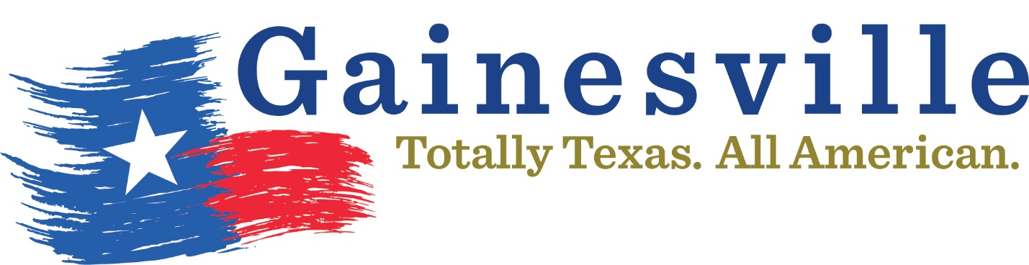
Revised July 17, 2019
The following individuals are ineligible to play in Gainesville Parks & Recreation sponsored activities for the foreseeable future.

Mitchell Malone – indefinite (SB)
Spencer Flint – indefinite (SB)
Gerald Pratt- indefinite (SB)
Kenny Spoon – indefinite (SB)
Kolby Kuykendall – indefinite (SB)
Jacob Blount – indefinite (SB)
Josh “Bubba” Lawson – indefinite (SB)
Jerome Franklin – indefinite (BB)
Jeremy Franklin – indefinite (BB)
DeShawn Franklin – Indefinite (BB)
Dezmond Sherrer- Indefinite (BB)
Payton Williams- Indefinite (BB)
Tursaula Hubbard- indefinite (Fan)

