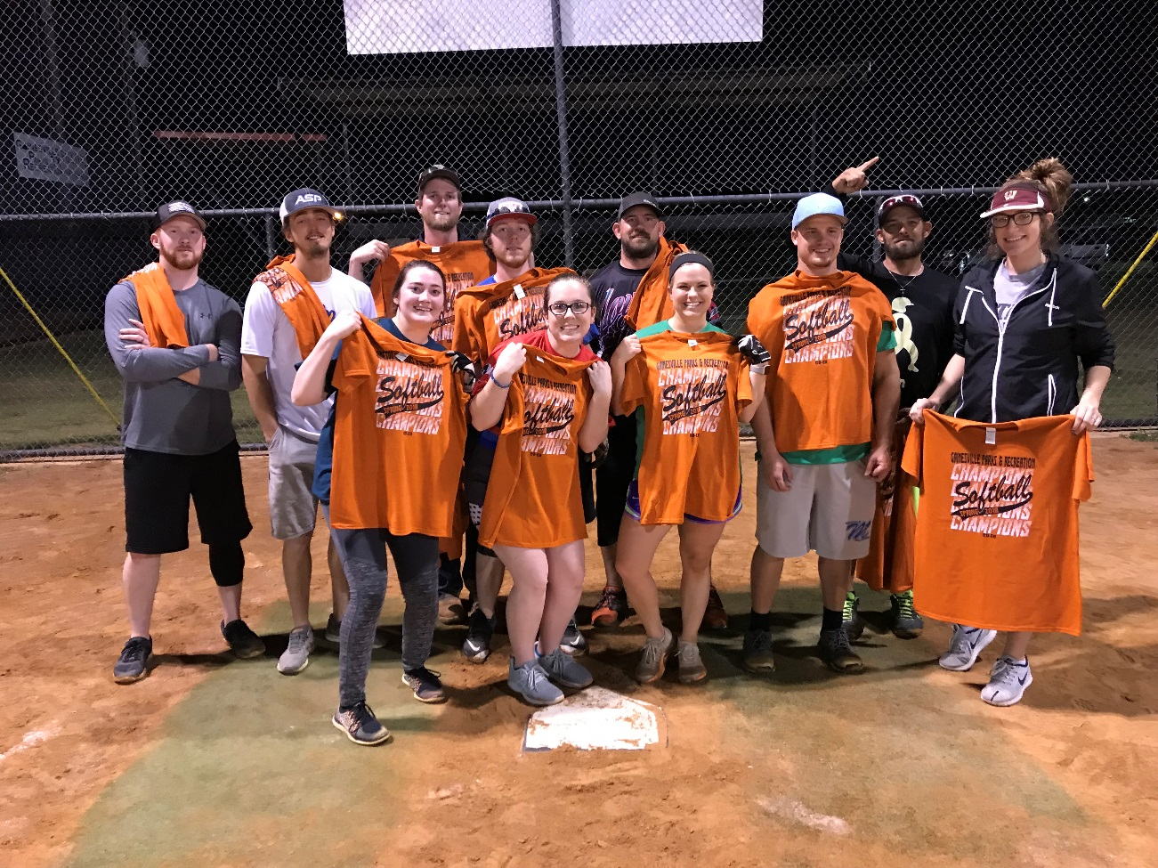
Sandlot All-Stars - Gainesville Parks and Rec Spring League Co-Ed Champions
Team Members: (Top Row) Alex Arrigoni, Cameron Snow, Trey Goldsmith, Nick Lowery, Kyle Bronson, & Bryan Schneider. (Bottom Row) Lorna Fothergill, Madison Caldwell, Krista Hitt, Chase Medler, & Stephanie Jones. Not Pictured Colten Sparkman.
On April 23, 2018, the Gainesville Parks and Recreation Co-Ed league held its championship tournament, made up of 4 teams. With the regular season being tilted toward 2 main teams, it was more a matter of who was going to upset them in the tournament. By the end of it all, it wound up as Leandra’s Team (1) and Sandlot All-Stars (2) in the championship game. The score ended up 5-21 in favor of Sandlot All-Stars.
Participating teams included: Leandra’s Team, Sandlot All-Stars, The Baker’s, and The Calabrese.
Upcoming league information can be found at www.quickscores.com/gainesville. Registration for all Summer I Adult Athletics will begin May 7, 2018 at the Gainesville Civic Center. For any additional questions pertaining to adult athletics please call 940-668-4530. Summer I Adult Athletics will consist of:
Softball: Co-Ed, Men’s Recreational, Men’s Competitive
Volleyball: Co-Ed Competitive, Co-ed/Church Recreational
Basketball: Men’s, Women’s

