2023 MWR Intramural Softball

USSSA Rule Book & By-Law Changes on Bats

2023 USSSA Slowpitch Softball Rule Book & By-Law
PAGE 10

RULE 2. EQUIPMENT SEC.2 C. 1.
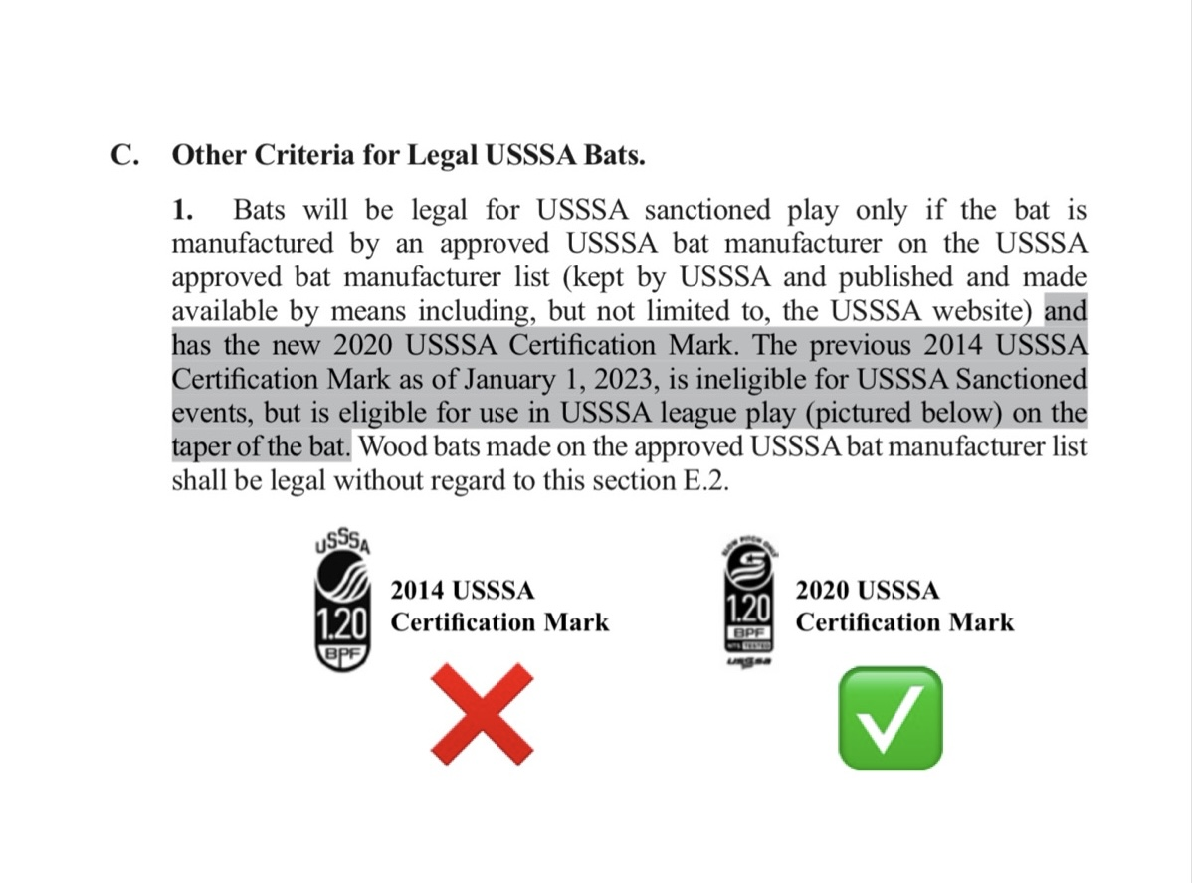
ALL Bats must have the new 2020 USSSA Certification Mark to be a legal bat to be used for league play.

If bats have only the 2014 USSSA Certification Mark or just ASA or USA Softball stamp, they are ILLEGAL to play with. ALL bats must be SLOWPITCH – no Fastpitch bats or bats with outdated stamps are permitted in league play.

