Farmington Soccer 2023 Rules & Regulations

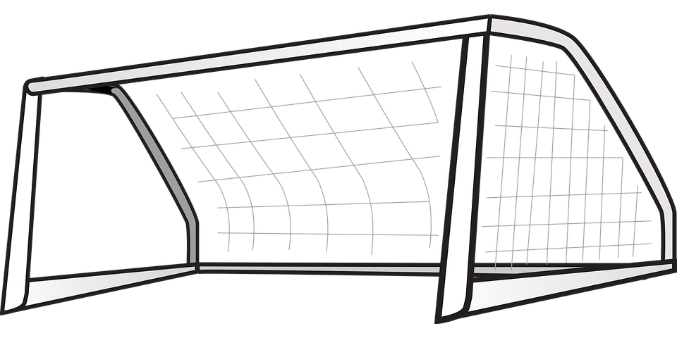

Match Conduct
- General Rules
- Coaches will be responsible for distributing and informing players and parents of schedules, rules, conduct, and any other information set forth by league coordinators.
- Practice times and locations are determined by coaches. (Open field space at Farmington parks may be available on a first come first serve basis. They cannot be reserved.)
- Treat schedules and other team related items would be at the discretion of coaches.
- Shin guards are mandatory.
- 3 year old- 6th Grade: Substitutions may be made at any stoppage in play
- 7th – 9th Grade: Free substitution on goal kicks and team with possession on throw-ins. Substitutes must be ready to go in when the whistle is blown. Substitutes need to receive okay from referee to enter the game.
- Coaches should focus on teaching skills and sportsmanship during practices and games.
- There will be a site supervisor at the field each night to assist with questions.

- Competition:
- All players attending the game must play at least 50% of the game
- For 2nd through 4th grade there will be one central official (two if staffing allows). For 5th -6th grade. There will be two central officials (three if staffing allows) for 7th -9th Grade there will be one center official and two sideline officials.
- We will play by NFHS (High School) rules with the following variations
- 3 year olds-1st Grade: Coaches will be the officials on the field to direct and guide players on soccer development and basic rules of play.
- 2nd Grade and Older: Coaches, officials and spectators shall not enter the field of play unless requested by the referee.
- This is a recreation league we will have a game with the players that show up for each team.
- Offside Rules: Only called in 5th & 6th Grade/7th – 9th Grade Rules

- Match Durations:
Matches shall be of two equal halves, not to exceed the following durations (no stoppage time). Half time periods shall be a minimum of 3 and a maximum of 5 minutes as regulated by the referee. Time will be kept by the Center Official. Practice and Game Start Times for Kindergarten and below will be signaled with a megaphone by the site supervisor.
Age Group | Max duration of half
3 year olds* | 10 minutes
Pre-K* | 10 minutes
Kindergarten** | 15 minutes
1st Grade | 20 minutes
2nd Grade | 20 minutes
3rd/4th Grade | 25 minutes
5th/6th Grade | 25 minutes
7th – 9th Grade | 25 minutes

*3 yr. - Pre-K: There will be a 30-minute practice starting at the scheduled game time. After the 30-minute practice, there will be a scrimmage against the team on the opposite side of the field with the coaches refereeing the game.
**Kindergarten: There will be a 20-minute practice starting at the scheduled game time. After the 20-minute practice, there will be a scrimmage against the team on the opposite side of the field with the coaches refereeing the game.

- Size of Ball
Age Group | Size
3 yr-2nd Grade | 3
3rd-6th Grade | 4
7th- 9th Grade | 5
Ball size for each age shall be as follows

- Field of play
The dimensions and marking of fields and goals shall be at the discretion of Farmington City coordinators.
 |  |  |  | Field Sizes by age group
 | 3 yr.- Pre K and Kinder | 1st/2nd Grade | 3rd/4th Grade |  | 5th/6th Grade & 7th -9th Grade
Length x Width (yards) | 35x25 | 35x25 | 65x45 |  | 80x55
Center Circle Radius (ft) | None | 21ft | 22ft |  | 23ft
Corner Arc (ft) | 3ft | 3ft | 3ft |  | 3ft
Goal Area (ft) | None | 10ftx20ft | 12ftx24ft |  | 15ftx47ft
Penalty Area (ft) | None | 18ftx36ft | 36ftx72ft |  | 42ftx108ft
Goal Line to penalty spot (ft) | None | None | None |  | 10
Penalty Spot to penalty arc (ft) | None | None | None |  | 8
Goal size (ft) | Yellow Pop up goals | 6ftx12ft | 7ft. |  | 7ft.

- Team Size
The following are the recommended team sizes:
Age Group | Players per team on field | Max no. of team members
3 year | 4 (No goalie) | 7
Pre-K | 5 (No Goalie) | 8
Kindergarten | 5 (No goalie) | 8
1st/2nd Grade | 6 (including goalie)_ | 8
3rd/4th Grade Boys | 7 (including goalie) | 10
3rd/4th Grade Girls | 7 (including goalie) | 10
5th/6th Grade | 8 (including goalie) | 11
7th – 9th Grade | 8 (including goalie) | 11

*3 year old – 2nd Grade: Coaches will only be allowed to designate their child and 1 others to be on their team.
*3rd Grade- 9th Grade: Coaches will only be allowed to designate their child and 2 others to be on their team.

- Penalties and Fouls
3 year old – 6th Grade
- All free kicks are indirect (An indirect kick must be touched by another player before it can go into the goal)
- Penalty kicks will only be for 5th-6th grade ages (A penalty kick results from a contact foul or hand ball by the defending team within the penalty area)
- If a player lifts one or both feet on a throw in or fails to throw the ball with both hands over the head the ball will be awarded to the opposing team
- A player cannot kick, trip, jump at, charge, strike, push, hold, or spit at an opponent. Bumping, leaning or going shoulder-to-shoulder while competing for a ball is not a foul until the hands or elbows come up.
- Deliberate heading is not allowed in any age division. If a player deliberately heads the ball in a game, an indirect free kick will be awarded to the opposing team where the player touched the ball with his/her head.
- A player cannot touch the ball twice in a row when putting the ball in play. If a player barely hits the ball and decides to take another kick at it, that is a two-touch. This also applies to throw-ins. A player cannot throw the ball in and then kick it.
7th – 9th Grade
- Slide Tackling: will not be allowed when another player is near the ball. Players must wear shin guards to play. (they are mandatory)
- There will be penalties for 7th -9th grade ages. (A penalty kick results from a contact foul or hand ball by the defending team within the penalty area)
- If a player receives a red card, the player will automatically be ejected from the game and the next scheduled game. Any player getting a red card for violent conduct will not participate in the next two scheduled games. Any player that receives two red cards in one season is automatically suspended for the rest of the season.
- If a player receives a yellow card, they are required to sit out for five minutes of game time. When a player is ejected for a red card or must sit out for a yellow card, their team may not send in a player to replace them, they must play shorthanded.

