EL PASO PARKS & RECREATION DEPT. YOUTH FOOTBALL RULES & REGULATIONS
2023 Spring Season

INTRODUCTION/REQUIREMENTS
NCAA Rules and Regulations will govern play for the El Paso Parks & Recreation youth football program. If the following rules interfere with NCAA, these rules will supersede those.

ORGANIZATION/TYPE OF LEAGUE
  - The El Paso Parks & Recreation will be the primary governing body and administrators of this program.
  - EPPARD will be using State of Texas, City or El Paso and UIL guidelines and safety procedures for COVID-19 precautions.
  - Football and Cheerleading Coaches will be required to pass a background check through the city of El Paso prior to getting their coaching badge. Background checks are $40.00 and will be good for two years. Coaches will still be required to purchase a City of El Paso sports ID for $5.00 once the background check has cleared.
  - Games will be played at the Eastside Sports Complex on Saturday’s and occasionally at Joey Barraza & Vino on Wednesdays.
  - All Football and Cheer athletes must have a current City of El Paso Parks and Recreation issued Youth ID card.
  - Youth Sports ID’s are $5.00 per player. Players must have ID’s before their first game for age verification. . Parents are required to take a parent training session at or read the Parent Education Program PowerPoint. Either training is $5.00 and only one parent/guardian is required to complete the training.
  - Once Schedule has been posted on quickscores.com/elpaso no refunds will be allowed.
  - Refunds will be given at a prorated amount if the season is canceled for Covid-19 reasons

FIELD RESERVATION POLICY:
All practices at any city park require a permit for certain reserved fields, times and privileges. Reservation permits can be obtained in person or over the phone at; Nations Tobin Sports Center, Armijo Recreation Center, Marty Robbins Recreation Center and Galatzan Recreation Center or Officer David Ortiz Sports Center.

PLAYER ELIGIBILITY
City of El Paso will be offering the following age Divisions:
  - Flag 5u
  - 7u
  - 9u
  - 11u
  - 13u

The age cut off for the spring season will be August 1st 2023. Whatever age they are on that day is the age bracket they will play on.
    - 7 years of age turning 8 years on or before Aug.01, 2023 must play 9u.
    - 9 years of age turning 10 years on or before Aug. 01, 2023 must play 11u
    - 11 years of age turning 12 years on or before Aug. 01, 2023 must play 13u.
    - 13 years of age turning 14 years on or before Aug.01, 2023 CANNOT PLAY 13u.

  - Player Youth ID’s can be done at any open recreation center Child athlete must be present and you must provide a form of age verification. The following will be the acceptable documentation for age verification:
    - Original (not a copy/not hospital version) State issued Birth Certificate
    - Original (not a copy/ not hospital version) Government issued Birth Certificate from another country
    - Court Paperwork (child’s name and date of birth must be present); or
    - Valid Military ID, Passport or State ID

    - Immigration Card (commonly referred to as a “Green Card”)
    - School issued demographic
  - Coaches must enter all football players on their virtual roster on quickscores.com prior to first game.
  - Coaches will verify each opposing player is certified electronically prior to each game.

PLAYING RULES
  - Clock management will be 8 minute quarters for every age division.
  - Intermission between halves will be a max of 10 minutes.
  - Each team is allotted 3 timeouts( TO) per half. All TO’s are 60 seconds (this includes inside the 2 minute warning).
  - On-field minimum of eligible players on the field to avoid forfeit is 7 for 5u flag, 11 for 7u-13u.
  - ONLY the first game of the day will allow a 10 minute grace period. All other games, game time is forfeit
  - For extra point attempts; A Run or Backward Pass will be 1 (one) point, a Forward Pass or Kick for XP will be 2 (two) points.
  - Mercy Rule: When a team has a 30+ point margin.
    - First Half: “Running Clock” will be used to finish the half. If team is still up by 30+ points at half, game will be called
    - Second Half: Losing team gets one possession and must score on that possession to bring the deficit back down to under 30 points or game is now final
  - Overtime: After the coin flip, the referee places the ball on the 25-yard line in the 1st OT. 15-yard line in the 2nd and 5-yard line in the 3rd. The offence takes over from there 1st down. Depending on the spot of the ball, additional first downs may be gained. During the 3rd OT teams must throw for the XP. Regardless if the offense scores or not, the team who was on defense now becomes the offense. If neither team scores, or both score the same amount of points, the whole process is repeated. Fumbles recovered or interceptions made by the defense CANNOT BE ADVANCED BUT DOES END THE OFFENSIVE SERIES. If the teams are still tie after three OT periods the game will remain tie.
  - Kickoffs:
    - 7u Standard Kickoffs will be done from the 50-yard line unless there was a penalty that modifies the placement of the ball. Safety Kickoffs will be done from the 35-yard line unless there was a penalty that modifies the placement of the ball.
    - 9u-13u Standard Kickoffs will be done from the 40-yard line unless there was a penalty that modifies the placement of the ball. Safety Kickoffs will be done from the 25-yard line unless there was a penalty that modifies the placement of the ball.
5u flag

- Game Play
  - Interceptions by the defense may be advanced for a touchdown during regulation play if the defender has flags on. A defensive score on an XP can be accomplished by an interception only and will be worth the value of the attempt as shown in the above table. If the defense commits a penalty while returning a ball and scores, no points will be award and the play is called dead; no do over.
  - “Last Man”: If there is no one between the ball carrier and the end zone (inside the defense’s 20-yard line) and the defensive player tackles, holds, pushes, strips or commits any other infraction that impedes the runner from scoring, the ball carrier will be award a score.
  - Quarterback Sneaks are not allowed if the QB takes the snap from under Center. The QB must start the play in “shot gun” formation (2 yards back from the Center) if they wish to run through the Center/’A Gap’ area. A QB under Center can run to any other spot on the line.
  - Center Sneaks are NOT allowed.
  - SNAPPING the ball can be done either the TRADITIONAL way through the Center’s legs or PITCH style where the Center stands sideways and tosses the ball to the Quarterback.
  - The offensive team may have NO MORE than four players in the backfield.
  - There are NO Kickoffs in Flag. The ball is placed on Offense’s 20-yard line; 1st and Zone to Go.

  - Flag IS REQUIRED to have at least one man on either side of the center to provide an “A” gap to assist in lining up the defense.
  - There are NO “fumbles” in Flag.
  - There are “muffs” in Flag, and they can only be recovered by the offense and only in certain circumstances.
- If the QB is under center and drops (muffs) the ball, the ball is considered DEAD at that spot and the play is over.
- If the QB is in “shotgun” formation and drops (muffs) the ball or the SNAP is bad, any of the offensive backfield players may pick it up and continue the play.
- If the Punter, in “shotgun” formation drops (muffs) the ball when taking it from the referee, they may pick it up and continue the play.
  - Ball Carriers cannot use their arms or hands to protect their flags from being pulled. The defensive player must have the opportunity to pull the ball carrier’s flags
  - Stiff-arming by the Ball Carrier is prohibited and will be penalized for Flag Guarding
  - The Ball Carrier cannot spin or hurdle to prevent a defensive player from pulling their flags and will be penalized as Flag Guarding. Exception: A player may leave their feet if there is a clear indication that they have done so to avoid a collision with another player.
  - The Ball Carrier MUST try to avoid contact with a defender in an established position. The Ball Carrier cannot lower their shoulder and contact the defender.
  - The Ball Carrier cannot dive to get a first down, touchdown or for any other reason.
  - Players are prohibited from pulling off the flags of players who are not the Ball Carrier to prevent them from gaining possession of the football and running with it.
  - The player having possession of the ball is down when they take a knee or fall, their flags are removed by an opponent or the flags inadvertently fall off (belt comes undone and part of the flag is touching the ground).
  - The defense CANNOT be lined up directly over Center in the “BOX” at the snap of the ball but can be lined up over Center outside the “BOX”.
  - Two coaches from each team is permitted on the field. The coaches will instruct the players and line them up. Once the QB starts his cadence all coaches must back away “outside their team’s formation”. This includes an excited coach running down the field being caught up in a formation while the play is live.
  - Overtime; The referees place the ball on the 25-yard line in the 1st OT and the 10-yard line in the 2nd and any subsequent OT periods (unless relocated by penalty). The offense takes over from there 1st down. During the 3rd and subsequent OT periods, teams do not have to go for a 2-point conversion like Tackle.
  - Downs and Lines to Gain:
- Each team will have four consecutive downs from the point on the field they take possession of the ball to advance over the next Zone Line (20/40 yard lines) or to score a touchdown. First downs are gained when the nose of the ball touches or passes a Zone Line.
- Once a team touches or passes the next Zone Line, it is 1st Down and Zone to Go. A team failing to move the ball to or past the next Zone Line will lose possession. The opposing team takes over at the point where the ball is declared dead and begins its series 1st Down and Zone to Go. The forward part of the ball touching any line will be the determining factor in determining a first down.
- When the offensive team is within the last Zone and has a first down, it will be “1st and Goal to Go”.
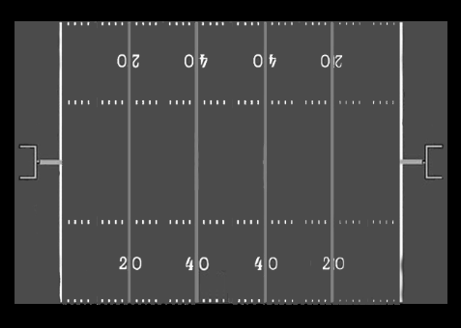

B: Blocking
- A Blocker must be on his feet at all times while blocking. All Lineman, except the Center, may not be in a 3-point stance or otherwise spring from a coiled or crouching start. Instead, they will simply stand at the line of scrimmage (2-point stance acceptable) and await the snap. The Center, though crouching, must first stand up before attempting to block a rusher
- Lineman may use their hands to block. The Lineman must have their arms straight out in front of them and may only make contact with the defensive player’s shoulders, arms and chest.
- Cross body, roll blocking, punch blocking, elbowing, knee blocking or hands to the head area is prohibited. Drive blocking (offensive player making legal contact with a defender but continually pushing them backwards; driving them away from the play) is prohibited
- Blocking will only be allowed in the BLOCKING ZONE.
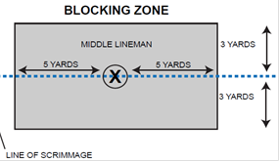

- Equipment
  - An “Approved Flag Set” is a 3-Flag Belt called “Triple Threat”. The flags are sewn onto the belt (not Velcro, Socket or Suction) and when pulled the complete belt comes off.
    - Flags are Vinyl coated polyester (no other material allowed)
    - Polyethylene clip (modifications to the clasp cannot be made)
    - Flags are to be no shorter than 12” and not narrower than 2 ¼”
  - Flag belts must be worn so that there is a flag on the right hip, left hip and behind the back.
  - All shirts must be tucked in.
  - The securing of flags to the body, waist, belt or tying a knot is prohibited
  - A team may play a game with only one legal flag on the Quarterback. What that means is that any player other than the Quarterback that receives possession of the ball will be considered immediately down where they take possession of the ball.
  - Soft shell helmets are required to be used during officially scheduled Flag games.
  - Flag players are prohibited from wearing towels.

7u
- Quarterback Sneaks are legal in ALL tackle age brackets (including (7U). Does not require the quarterback to take any steps backward before moving forward.
- Tykes ARE REQUIRED to have at least one man on either side of the center to provide an “A” gap to assist in lining up the defense. the offensive “A” gap cannot be any wider than 1 foot. Formations that do not comply will be penalized as Illegal Formation (LOS/5).
- A. To help the offensive line, the defense is limited to a max of five players in the “BOX” at the snap of the ball.

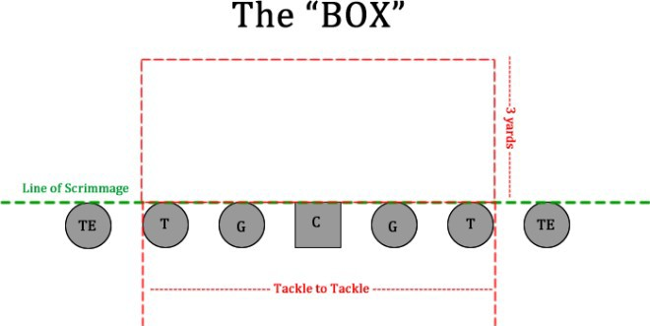
  - The defense CANNOT be lined up directly over Center in the “BOX” at the snap of the ball but can be lined up over Center outside the “BOX”
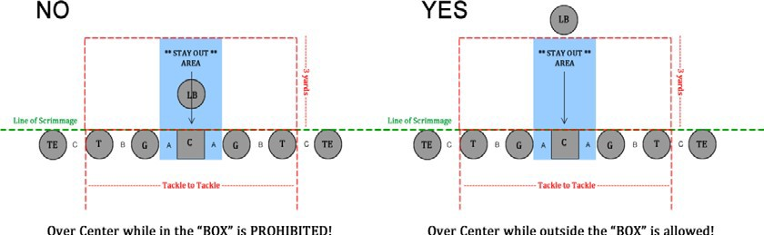
  - Center/Guard “A” Gap: The defense CANNOT be lined up in the Center/Guard “A” gap in the “BOX” at the snap of the ball but can be lined up in the “A” gap outside the “BOX”. Since the offense cannot make their “A” gap wider than 1 foot as stated in Article 2 above, lining up over the offensive Guards helps avoid being accidently caught in the “A” gap before the snap of the ball. Defensive Tackles may crash the “A” gaps at the snap of the ball.
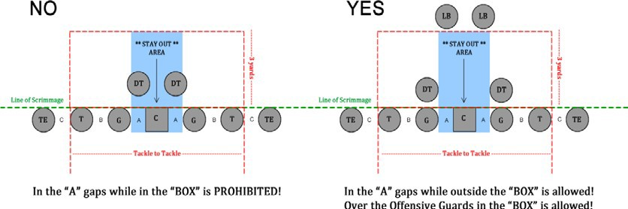
  - Defensive players outside the “BOX” may be lined up on the LOS (i.e. covering TE or WR).

  - Defensive players lined up in the “BOX” may drop back out of the “BOX” at any time. Vice Versa, if the defense has less than five players in the “BOX”, players may walk up into the “BOX” if the 5-player limit and where they are lined up at the snap of the ball is not violated.
  - If at the snap of the ball a team’s defensive players are violating the rules above, they will be penalized an Illegal Formation (LOS/5).
- The nose guard cannot line up directly over the center on the defensive line.
- 1 coach can be on the field for offense and defense.
- 2 coaches can be on the field for kickoff to help set up players, but 1 has to leave before the ball is kicked.
- Standard Kickoffs will be done from the 50-yard line unless there was a penalty that modifies the placement of the ball.
- Safety Kickoffs will be done from the 35-yard line unless there was a penalty that modifies the placement of the ball.

FIELD
- Punts (thrown not kicked)
- A Tyke’s punt is a thrown ball and therefore there are no “Fake” punts allowed. If a team fakes a punt, they will be penalized a Delay of Game
- On 4th down the offense MUST declare they are either “going to punt” or “are going for it”. Once the offense declares their intent, they cannot change their mind unless EITHER team calls for and is charged a time out.
- The offense must be in a legal formation and the players in proper stances. Movement by the offense is still penalized as normal. The punt is a timed down and the offense must deal with a Play Clock just as if it was a normal non-punting play or they will be penalized a Delay of Game
- Once the coach has placed all their players, they need to leave the field of play. If the coach is caught on the field, the coach will be penalized Interference assessed after the punt.
- The referee will pick up the ball and hold it out in front of the Punter. The Punter will call a cadence (any signal the offense uses to snap the ball) and the Punter will then take possession of the ball from the referee. Once the Punter has possession of the ball, the play becomes “live”. Live in this case means that the defense can rush, the ‘gunners’ can go down field and the team receiving the Punt can return it (run it back).
- If the ball is muffed it may be picked up and kicked (thrown). If the punter takes off running executing a ‘Fake’ Punt, they will penalize as Unsportsmanlike.

- The field will be 100 yards long with 10-yard end-zone for all age divisions.
- Parent(s) seated or standing must be 10 feet behind their team on the same side. Parents and spectators must be outside of the coaches’ box (20-yard line to the 20-yard line) or where told by City Staff, parent(s) not adhering to these markings will be required to leave.
- Only players and coaches for the scheduled game may be on the sideline.

TIME ELEMENTS
  - Official time and score will be kept by the officials on the field.
  - No reschedules are allowed once schedules have been released.
  - No special requests will be granted to accommodate other leagues.
  - Divisions will be based on appointed sports division staff.
  - If inclement weather cause the game to be stopped, a game will only be postponed if less than 3 quarters have been played. If a play has been run in the 3rd quarter, the game will be terminated and whomever was winning at that time, wins the game. If the game was tie, the game will remain tied.

EQUIPMENT:
  - All players will wear a visible mouth piece at all times. Mouth piece does not have to be attached to helmet.
  - No tint, smoked face shields, sun glasses or prescribed metal framed glasses will be allowed. Prescribed Sports framed glasses will be allowed. We must be able to see player’s eyes clearly for safety. NO Exceptions, NO appeals
and NO special request. Only exception would be medical glasses provided with a doctor’s waiver that should be submitted prior to first game.
**Tinted visors will ONLY be allowed with a valid doctor’s note. Coaches must present note to the staff and a special decal will be placed on the helmet of the player who has been approved by staff to wear a tinted visor**
  - Players do not have to have certain numbers by position.
  - Duplicate numbers are allowed as long as both numbers are not on the field at the same time.
  - All jerseys must be numbered 00 through 99. Any number preceded by zero (‘0’) (except double zero ‘00’) is prohibited. A single zero (‘0’) is allowed.
  - Numbers MUST be clearly visible and must match jersey number input on QuickScores.
  - Footballs will be provided by City Staff. The following are the ball size requirements for each division;
    - (5U) Wilson K2
    - (7U) Wilson K2
    - (9U) Wilson TDJ
    - (11U) Wilson TDJ
    - (13U) Wilson TDY

ILLEGAL PLAYERS:
  - If an illegal player is discovered on any roster, the head coach, player, and the parents will be subject to appropriate disciplinary action as deemed by the Youth Football Coordinator. If found, anyone having knowledge of the player, will be subject to disciplinary action and will be subject to the penalty matrix from the City of El Paso.
  - Any game(s) in which an illegal player participates/participated will be forfeited. NO EXCEPTIONS.

IMPORTANT NCAA RULES:
  - Targeting:
    - No player shall target and initiate contact against an opponent with the crown (top) of his helmet.
    - No player shall target and initiate contact to the head or neck area of a defenseless opponent with the helmet, forearm, hand, fist, elbow or shoulder.
  - Blindside Blocking:
    - Blindside blocks are now illegal. These blocks are defined as an open field block against an opponent that is initiated from outside the opponent's field of vision, or otherwise in such a manner that the opponent cannot reasonably defend himself against the block. (An exception is when the runner or receiver is in the act of attempting to make a catch.)
    - No player shall deliver a blindside block by attacking an opponent with forcible contact. The penalty is 15 yards, applied by rule. Note: the blindside block can be with targeting. It would not be two separate penalties in this case, but one.

  - Chop Block (Low/High): A Chop Block is a high-low or low-high combination block by any two players against an opponent (not the runner) anywhere on the field, with or without a delay between contacts; the “low” component is at the opponent’s thigh or below. This is illegal and will be penalized as (EOP/15) + automatic 1st Down (if committed by the defense).

CHEERLEADERS
  - Cheerleaders will be positioned outside the end zone closest to their team or positioned by site supervisor.
  - Cheerleading performances will be a max of 4 minutes at half time per team, this includes set up and breakdown time.
  - All Cheerleading coaches must go through a background check and obtain a City of El Paso coaching ID.
  - Cheerleaders will need a City of El Paso youth ID.
  - Cheerleaders will have an end of season cheer competition on the last weekend of football.

COACHES
  - Coaches for the teams shall be adults interested in the promotion of sportsmanship and teamwork. All coaches must be certified through El Paso Parks & Recreation. Any head coach who knowingly allows an individual to coach that is not certified will be held accountable.
  - All coaches MUST BE IN DRESS CODE and must wear their City of El Paso coaching ID card and be visible at all times.
    - Coaches out of dress code will NOT be allowed to coach at all (this includes from behind the PARENT LINE or CHAIN CREW).
  - There will be a maximum of seven (7) coaches allowed in the coach’s box. Coaches, board members, athletic trainers, support staff and team photographer (no water boys will be allowed) will be part of the 7. There will be no switching of coaches’ through-out the game. Coaches who start the game must finish the game.
  - All coaches’ must have a cleared BACKGROUND CHECK and coaching ID badge.
  - Home team will provide volunteers for the chain/down crew. All volunteers MUST be adults. No minors are allowed to assist with chains/down markers.
  - Coaches will maintain control over players, parents, and spectators in all circumstances, including disputes on the field. Game officials will discuss disputes on the field with the head coach only, during timeouts and between quarters. Players and parents are not to question a referee’s judgment call or rulings.
  - Teams are responsible for verifying the leagues game scheduled days and times on www.quickscores.com/elpaso and inform their League Organizer and fellow team members of an error(s) if found. The League/Tournament Organizer will correct the error(s) and make new schedules and inform the other teams of the revision.
  - One hired photographers will be permit per team and will need a city issued Vendor ID badge in order to record or photograph.

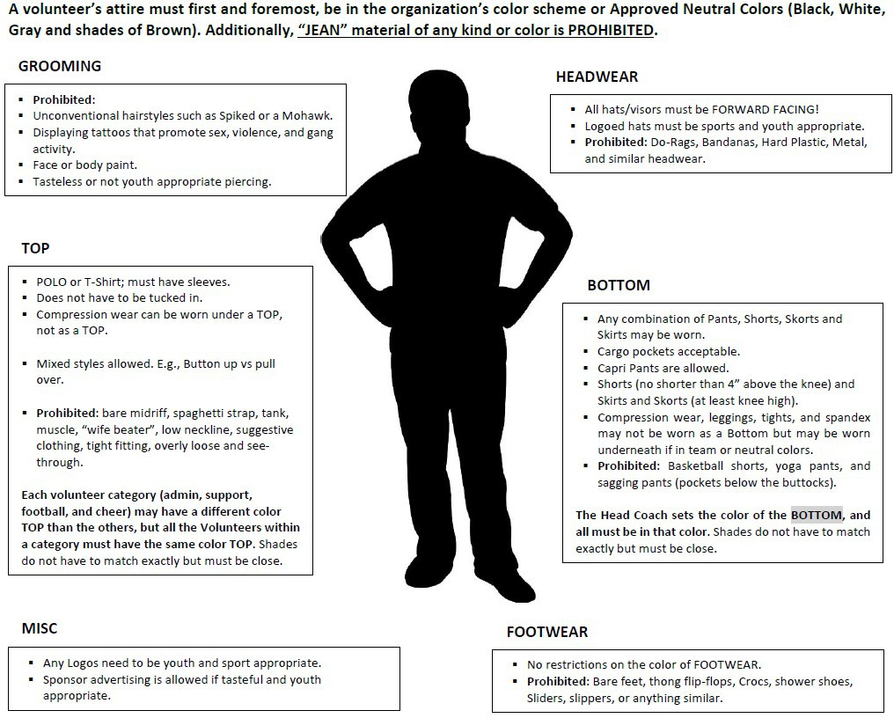
  - All coaches on the sidelines must follow the TYFA dress code.

CONDUCT OF COACHES, PLAYERS AND SPECTATORS
  - Unsportsmanlike conduct directed toward any league official, game official, player, coach and/or spectator will not be tolerated.
  - No team player(s), team staff, spectator(s), or `manager(s) will “CLEAR THE BENCH.” Clear the Bench, is defined as leaving your team area adjacent to the playing area or leaving the spectator area. Leaving the bench to break up a fight is considered a violation of this rule.

    - Only coaches, players and authorized persons will be allowed in designated team areas. Coaches will be expected to enforce this rule. Parks and Rec. staff are authorized to stop the game until said area is cleared or termination of the game will take effect.
    - Player(s) who have been ejected/disqualified by an official may stay on the sideline and may NOT re-enter the game. They must remove their helmet and shoulder pads if they wish to remain on the sideline.
    - Disrespect of any kind toward staff, officials, and opposing players/teams will NOT be tolerated. Anyone being disrespectful to the aforementioned groups may be ejected from the complex for the remainder of the day.
    - Ejected persons will have only 2-minutes to leave the complex completely. Failure to leave in the allotted time will result in a team forfeit
    - Out-of-Sight and Out-of-Sound will be in effect
    - Derogatory comments, gestures towards players, opposing team, officials, and staff will not be tolerated.
    - Physical violence will not be tolerated.
    - Any coach, parent, or spectator who follows/harasses an official after their game has concluded will result in a team forfeit and the team may be subject to further discipline at the staff’s discretion.
    - In the event a head coach is ejected, an assistant coach may be appointed and must indicate to the white hat official on their field that they will be replacing the ejected head coach.

YOUTH SPORTS COACHING / TEAM STAFF POLICY
  - All coaches must sign a El Paso Texas Parks and Recreation Coaches Code of Conduct form and a City of El Paso Coach’s Registration Form.
  - Head coach must sign the City of El Paso Parks and Recreation COVID-19 screening checklist prior to ALL games.
  - The health and safety of each participant is priority to The City of El Paso, should there be a serious outbreak such as COVID-19, M-pox, etc. it is the coaches responsibility to report it to a staff member.
  - A coach representing each team must attend a mandatory coaches meeting prior to each season.
  - All coaches/team staff are responsible for the maintenance and cleanliness of the facility/fields being used. All team areas are to be left clean, and all team materials are to be picked up after each practice or game. Failure to maintain facility/field could result in suspension, loss of that facility/field or fine.
  - All coaches/team staff 17 years and older must sign and complete a “Background Check Consent & Release Form" for a criminal background check. (This form must be updated every two years.)

DISCIPLINARY INFRACTION:
If at any time benches clear during a physical altercation, the entire team is subject to disciplinary action. If members of the team and/or spectators enter the field of play even if to separate/stop the altercation they are subject to penalty. For all other disciplinary infractions, please refer to Administration Guideline 201

Participants suspended from a Park, or Parks and Recreation facility may not return until their suspension has expired.
Appeal Ineligible Actions:
Suspension or trespass actions taken by staff as a result of rule infraction or behavior management policy violation areable to be appealed to the Parks and Recreation Advisory Board through the Grievance Subcommittee. There are some actions however, that are ineligible for appeal:

- Infractions that occur during city league play-off games.
- Infractions that occur during league tournament play.
- Immediate ejection or removal from a facility or program at the time of the incident.
- Failure to meet standards as a result of a background screening.

GAME OFFICIALS:
Game officials will be assigned by organizations contracted by the City Parks & Recreation and must attend an official’s clinic prior to each season.

PLAYOFFS:
NO PLAYOFFS in the spring. Division champs will be determined by a win-loss record. In the case of a tie the following will be used as a tie breaker:
  - Head-to-head
  - Head-to-head point differential

  - Total points

AWARDS:
  - Team trophy and Shirts will be awarded to the 1st place teams in each division.

XI. FEES
- Registration fees will be for a 6 game season.
  - $350.00 for 5u
  - $450.00 for 7u
  - $450.00 for 9u
  - $450.00 for 11u
  - $450.00 for 13u

IMPORTANT DATES:

- Mandatory in-person coaches meeting will be on Thursday March23, 2023 @ 6:30pm at the Officer David Ortiz Recreation Center

- Deadline to register and have ALL FEES paid up in full is Thursday March 23, 2023 @ 9:00 pm. NO EXCEPTIONS!!!

- Kickoff week will be at the East Side Sports Complex on Monday April 10 ^{th}, 2023

- Roster Lock Date: April 17, 2023

- Local Cheer Competition

EL PASO YOUTH FOOTBALL and CHEER CONTACT INFO:
Admin | City Cell # | Email Address
Ruben Martinez | (915) 588-0427 | martinezrx1@elpasotexas.gov
Jannie Villasana | (915) 979-5828 | VillasanaJA@elpasotexas.gov

