Eastwood Baseball league
Code of conduct

Players
The code of conduct requires that players exhibit exemplary behavior during Little League activities. Players must respect umpires, coaches, managers and other players and demonstrate good sportsmanship. Eastwood league prohibits the use of profanity and fighting during league play. If a player breaks the code of conduct he will be immediately removed from the game.

Parents
The code charges parents with demonstrating exemplary behavior at all times during Eastwood League activities. Parents should remember the volunteer-status of board members, coaches and managers and respect all officials and players. Eastwood League asks that parents help to keep playing fields safe and clean. Parents agree to refrain from using tobacco, alcohol or drugs in or around Eastwood League functions. Parents found to be in violation will be barred from league.

Managers and Coaches
Eastwood League requires managers and coaches to consistently present a professional image, which includes appearance and behavior, during all league activities. The code of conduct calls for league officials to display enthusiasm, respect, honesty and fair play. Managers and coaches must follow all league game rules, encourage appropriate behavior by players and fans, maintain a safe game environment and consider the physical and emotional well-being of players above all else. Managers and coaches agree not to use tobacco, drugs or alcohol while involved in league activities. If a spectator is ejected on your team the head coach will also be ejected. You will have a maximum of 2 minutes after that time the game will be forfeited by violating team. 0 tolerance on cursing this will be cause for immediate ejection and forfeit of game.

Spectators
Eastwood League, publishes a code of conduct for parents, coaches and spectators to manage the environment in which Little Leaguers play. The code prohibits unsportsmanlike conduct, disrespect of League officials, unofficial coaching and verbal abuse of players, such as ridicule and booing. 0 tolerance on cursing this will be cause for immediate ejection and forfeit of game.
Violation of the Eastwood Little League’s code of conduct results in ejection from the game and could lead to season, game forfeiture by the offending team. If a spectator is ejected on your team the head coach will also be ejected. You will have a maximum of 2 minutes after that time the game will be forfeited by violating team.

Any coach that is ejected from a game must pay a league fee of $50 for reinstatement, if a coach is ejected a total of 3 times in one season that coach will be barred from any future Eastwood league games.

Protest
Each league shall adopt rules governing procedure for protesting a game, when a manager claims that an umpire’s decision is in violation of these rules. No protest shall ever be permitted on judgment decisions by the umpire. In all protested games, the decision of the League President shall be final. Even if it is held that the protested decision violated the rules, no replay of the game will be ordered unless in the opinion of the League President the violation adversely affected the protesting team’s chances of winning the game.
Whenever a manager protests a game because of alleged misapplication of the rules the protest will not be recognized unless the umpires are notified at the time the play under protest occurs and before the next pitch, play or attempted play.

All protest will require a deposit of $50, if the protest stands the game will resume play at the time of protest. If your protest is not upheld the protesting coach will lose the deposit and the final game results will prevail.

We are following el Paso county plex rules, the league president will have 24 hrs to decide the outcome of the protest and will give an explanation to the protesting coach only.

Teams and Organizations
All organizations within eastwood league will need to have coaching coverage. It is up to the team to make sure a coach is available for all games. No accommodations will be provided for organizations and there will be no exceptions. There is no grace period for coaches to arrive at a game because they are coaching another game within organization.

Forfeits
(a) A game may be forfeited to the opposing team when a team:
(1) Fails to appear upon the field, or being upon the field, refuses to start play within five minutes after the umpire -in-chief has called “Play” at the appointed hour for beginning the game, unless such delayed appearance is, in the umpire-in-chief’s judgment, unavoidable;
(2) Employs tactics palpably designed to delay or shorten the game;
(3) Refuses to continue play during a game unless the game has been suspended or terminated by the umpire-in-chief;
(4) Fails to resume play, after a suspension, within one minute after the umpire-in-chief has called “Play;”
(5) After warning by the umpire, willfully and persistently violates any rules of the game;
(6) Fails to obey within a reasonable time the umpire’s order for removal of a player from the game;
(7) Fails to appear for the second game of a doubleheader within thirty minutes after the close of the first game unless the umpire-in-chief of the first game shall have extended the time of the intermission.
(b) A game shall be forfeited to the opposing team when a team is unable or refuses to place players on the field.
(c) If the umpire-in-chief declares a game forfeited he shall transmit a written report to the League President within 24 hours thereafter, but failure of such transmittal shall not affect the forfeiture.
Any teams that are in danger of forfeit due to not having enough players must contact the league for assistance. Forfeiting team will be charged the umpires fees associated with that game by division. Please remember that umpires are paid scheduled in advanced.

Teams that have 2 or more forfeits will need to meet with league to determine if a resolution can be reached. If no resolution can be reached, team will be removed from schedule.

- Home team will be the official score book
- Courtesy runners are allowed for pitchers and catchers (for baseball only).
- Metal cleats can be used in 13/14u division only
- No Id=No Play, no exceptions. Digital copies are accepted
- Players must have at least 4 season games in order to play in playoffs.
- Eastwood league will provide 2 game balls per game. USSSA DOL-A balls.
- We will follow USSSA bat rules, all bats for age divisions 14u and younger must be stamped with new USSSA 1.15 BPF or BBCOR .50. All wood bats are safe to swing. For 13/14u split division a Max drop 5 will be adopted. -3 are encouraged as this will be the bat used in Middle school divisions.
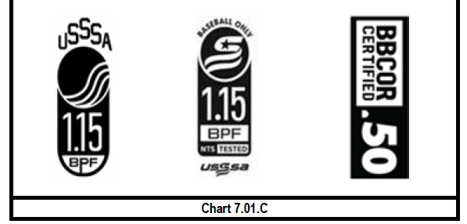
- Curve balls are allowed in all baseball divisions.
- Any player that appears to have suffered a concussion or injury will need to be taken out of the game and taken to his primary care physician. Player will not be able to return to play if he does not clear his injury with his doctor. Any head injuries should be reported to league staff to discuss concussion protocol.

- Eastwood league would like to remind participants that it is not affiliated in any way to the City of El Paso Parks and recreation.

Please send all comments, inquiries, and complaints to eastwoodleague915@gmail.com.
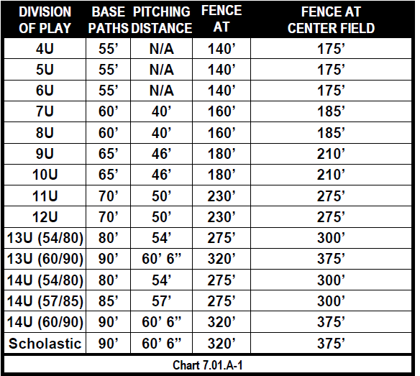
- Inclement weather
Directors will postpone games in 30 minute intervals, if weather does not permit play, Eastwood league will adopt USSSA inclement weather protocols and best out of three coin flip will determine win or loss. Games will not be rescheduled due to field availability.

