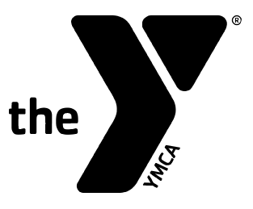
YMCA Soccer- Ages 9-11 Rules
Playing Time At the YMCA, we aim for all players to have equal playtime and learn the game. Coaches should ensure every player gets equal time on the field. Players who miss practice can still play in games, but regular practice attendance is encouraged.
Number of Players Games are played 7 on 7, including a goalkeeper. If a team is short on players, they may borrow from the opposing team to field enough players.
Equipment Players must wear a MLS GO soccer jersey, shoes, socks, shorts or pants, and shin guards. Only soft rubber cleats are allowed.
Field Requirements
- Field size: 60 yards by 40 yards (may vary)
- Goal size: 6’x12’ (or close)
- Markings: midfield line, 10-yard radius center circle, four 2-yard radius corner arcs, goal area lines (6 yards from posts), penalty area (14 yards from posts), and a 10-yard penalty mark
Ball Size
- Size 4
Games
- Start with a coin flip or odd/even for kickoff choice.
- Two 20-minute halves with a 5-minute halftime.
- Clock stops only for timeouts. Each team gets 2 one-minute timeouts per half (no carryovers). No overtime.
Substitutions Allowed at halftime, for injuries, timeouts, throw-ins, and non-advantage situations.

Game Rules
- Kick-offs, free kicks, throw-ins, goal kicks and corner kicks are used to start or restart play.
- Kick-ins and/or dribble-ins are recommended as restarts when the ball has gone out over the sidelines.
- If field markings are absent, goal kicks and corner kicks should be taken in the general vicinity of the respective goal or corner.
- If used, all free kicks are indirect.
- Opponents should be 10 feet away from the ball on all restarts.
- No penalty kicks.
- No offsides.
- Game may not start or continue if there are less than 5 players on a team.
- No punts or drop kicks are allowed by the goalkeeper.
- All other laws of the game should be followed.

Build-Out Line
- The build-out line should be 5-7 yards from the goal line.
- Prior to a goal kick, the opposing team must move behind the build-out line.
- Once the opposing team is behind the build-out line, play can restart.
- After the ball is put into play, the opposing team can cross the build-out line and play resumes as normal.
- Quick restarts: Ideally, the player taking the goal kick will wait to put the ball into play once all opponents are past the build out line. However, the player can put the ball into play sooner, but he or she does so accepting the positioning of the opponents and the consequences of how play resumes.
- If a player from the opposing team crosses the build-out line before the ball is put into play, the goal kick is retaken.
Headers: Coaches should not teach heading the ball and should discourage its use in games and practices.
Additional YMCA Rules
- Coaches and participants recite the YMCA Youth Sports pledge before the game.
- Opposing teams, parents, and coaches should shake hands after each game.

