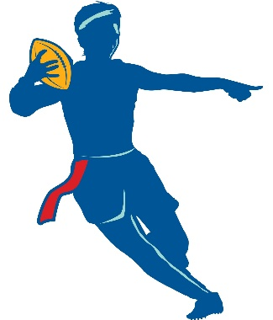
BOYS & GIRLS CLUB OF DENISON ATHLETICS

BOYS & GIRLS CLUB OF DENISON FLAG FOOTBALL
2K17 REGISTRATION
Name of Player:
Age: DOB: Grade: (Circle One) Boy or Girl
Parents/Guardians Name:
Address: School Attending:
Primary Cell Phone: Secondary Phone:
Email:
Shirt Size: YS YM YL YXL AS AM AL (Circle one) Football # (List 3 Different #’s)
Emergency Contact: Address: Phone #
How many years of football played? 0 1 2 3+ (Circle one)
Has your child participated in a Boys & Girls Club Event? YES or NO (Circle one)
REGISTRATION FEE $40
*Additional $20 Club Registration for Non Club Members*(The $20 membership is good for a calendar year)
(INCLUDES JERSEY, AWARDS, GAMES, OFFICIALS, AFTERPARTY!)
Call 903/465/9008 for questions or information or Email Ron @Director@bgcdenison.org or JJ @ JHughes2011@yahoo.com
ALL GAMES WILL BE ON SATURDAYS
Registration Permission Form
The Boys&Girls Club of Denison nor any individual or organization assumes aby responsibility for damage, injury, or other problems, which arise directly or indirectly from anyone’s participation or involvement in anyway with this event/program. Having read and understood these conditions, the undersigned agree to participate in this event.
Furthermore
I, am the parent/legal guardian of , who participates in a Boys&Girls Club of Denison program. I understand that from time to time the Club or its agents may photograph or for promotional purposes only (non-commercial purposes) and do herby waive any and all claims for compensation to me or to my child for such photograph or videotapes. This grant and waiver shall be effective until withdrawn by me in writing and delivered to Boys&Girls Club of Denison Administration.
**STAFF MEMBER**
Initial & Date after payment received

If you are interested in being a coach and can pass background check please check the box.

