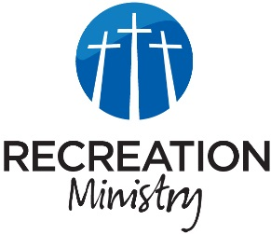
Bellevue Recreation Ministry
K-5th grade Devotional
August 24, 2024

The Lord saves you and me
Main Point
God saves the Israelites through Moses and God saves us through his Son Jesus
Sports
- Has it been difficult for you to learn how to throw and catch a ball
- Have you listened and paid attention to your coach’s guidance
- Is it now a little easier to throw and catch
Life
- I bet everyone on the team has disobeyed their coach/parents at one time
- What was the result of this disobedience
Application Verse
“When the people of Israel saw the mighty power that the LORD had unleashed against the Egyptians, they were filled with awe before him. They put their faith in the LORD and in his servant Moses."
Truth
- God works even in our disobedience
- He saved the Israelites even though they were disobedient
- Jesus saves us even though we have been been sinful and disobedient
- This season we are going to talk about what it means to be obedient and to have a relationship with Christ
Pray
- Pray for your players to know what it means
- Pray that they would understand more about who God is and how much he loves them.

