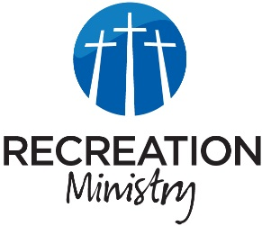
Bellevue Recreation Ministry
K-8th Grade Devotional
[Select Date] April 22, 2023

Jesus Gives His Great Commission
Main Point
Jesus wants us to build relationships with people and tell them of His Good News!
Sports :
- In any sport, is it important to get to know your teammates and coaches? (Why?)
- Yes, it’s important to get know your team not only to know them better, but to build friendships as well!
Life :
- What about in your lives? Do you have friendships at school? Church?
- For many of us, we all have good friendships in our lives! And for some of us we may have friends who don’t have a relationship with Jesus.
- Today we are going to be talking about what God called His disciples to do!
Application Verse :
“Go, therefore, and make disciples of all nations, baptizing them in the name of the Father and of the Son and of the Holy Spirit, teaching them to observe everything I have commanded you. And remember, I am with you always, to the end of the age.”
Matthew‬ 28:19-20‬ ‬‬‬‬‬‬‬‬‬‬‬‬‬‬‬‬
‬‬‬‬‬‬‬‬
Truth :
- God challenged His disciples to go out and tell others about Him!
- That’s not only a challenge for them, it’s a challenge for us! For those who have a relationship with Jesus we should tell our friends and others of the Good News!
- Who can you tell about Jesus today?
Pray :
- Prayer requests
- Pray for those who do not have a relationship with Jesus

