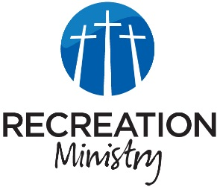
Bellevue Recreation Ministry
K-5th grade Devotional
September 10-12, 2024

Mustard Seed
Main Point
We have an incredible power only accessible through Jesus if only we have the power to obtain it.
Sports
- What would it feel like to be able to hit a home run every time? To have that power? That ability?
- Do you know anyone with that kind of power? An athlete? A celebrity? Your coach?
- Even the most skilled in the world can’t hold a 100% success rate.
Life
- What about pulling off something a little easier? Like the ability to lift a car or even move a mountain.
- You might be questioning the ease of these feats, but I assure you these accomplishments are in your ability.
- We just lack the one thing that helps us get it done: FAITH.
Application Verse
Matthew 17:20 “Because of your little faith, He told them. “For is assure you: If you have faith the size of a mustard seed, you will tell this mountain, ‘Move from here to there’, and it will move. Nothing will be impossible for you”.
- Our faith is a catalyst for power that is only attainable through faith in God.
- We don’t run into physical mountains every day, but we have our metaphorical share. (ex. tests, responsibilities, stress, relationships, etc.)
- The things that keep us from immediately turning to God first. They’re not bound to be the hurdles they serve as. They don’t have power over us, God gives us power over them.
- What mountains are there in your life that you need moved?
- What is stopping you from possessing the faith to move these mountains?
Pray
- Pray for your players to identify the mountains in your life.
- Pray for your players to find the faith to move those mountains themselves.

