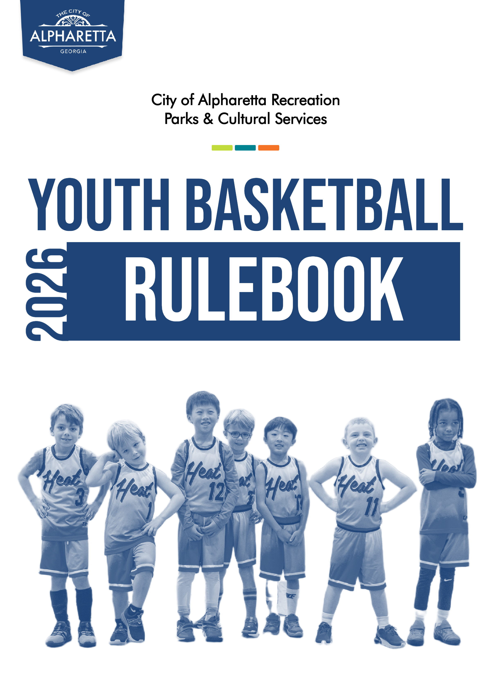

TABLE OF CONTENTS

LEAGUE ORGANIZATION…………………………………………………….………. 2
Tampering………………………………………………………………………. 2
COACHING…………………………………………………………………………….. 2
UNIFORMS………………………………………………………………………...…… 3
PARTICIPATION………………………………………………………………………… 3
GAMEPLAY……………………………………………………………………………... 3
Players/Lineups…………………………………………………………………. 3
Time………………………………………………………….…………………. 3
Overtime………………………………………………………………………… 4
Goal Height……….……………………………………………………………. 4
Ball Size………………………………………………………….……………… 4
Free Throw Line…………………………………………………………………. 4
Three Point Shot………………………………………………………………… 4
Full Court Press………………………………………………………………… 4
Ball Stealing…………………………………………………………………… 4
Double Teaming/Trapping………………………….………………………… 4
Fast Breaks…………………………………………………………………….. 5
Mercy Rule…………………………………………………………………….. 5
Fouls………..…………………………………………………………………… 5
Technical Fouls…………………………………………………………………. 5
CONDUCT…………………………………………………………………………….. 5
BENCH ETTIQUETTE…………………………………………………………………… 5
MISCELLANEOUS……………………………………………………………………… 6
Blood Rule…………………………………………………………..………… 6
CONTACT INFORMATION…………………………………………………………… 6
LOCATIONS……………………………………………………………………………. 7


- LEAGUE ORGANIZATION:
  - The governing body of this league will be Alpharetta Recreation, Parks & Cultural Services (ARPCS).
  - ARPCS reserves the right to edit, remove, change, or add rules at any time.
  - The league will abide by Georgia High School Association (GHSA) rules unless superseded by ARPCS rules.
  - All participants must register online to be eligible to participate.
    - Participants register based on grade level (K-12).
    - Leagues will be formed based on grade level. Grade levels may be combined if necessary.
    - Once a team is established, each player will remain on that team. ARPCS athletics staff will attempt to place brothers/sisters in the same age group on the same team, if requested.
  - All players are asked to attend evaluations in order for coaches to draft teams as evenly as possible with regard to participants’ individual skill level.
  - TAMPERING
    - Any attempt by a coach or parent to move a player/players between teams may be punishable by the immediate dismissal of a coach or player from this program.

- COACHING
  - Each team is managed by a volunteer coach. To volunteer, give our team a call at 678-297-6130 or email us at athleticprograms.ga.us.
    - Coaches are eligible for a full reimbursement of their children’s registration fees at the end of the Youth Basketball season.
  - League administrators will communicate important information to player parents as needed, but coaches are expected to facilitate communication within their team(s).
  - Coaches who cannot fulfill their volunteer commitment, including conduct violations, may be removed from their position at any time by ARPCS.

- UNIFORMS:
  - Only league provided uniforms (jersey and shorts) may be worn. Players not dressed in the proper uniform will not be allowed to enter the game.
    - Players may wear substitute shorts provided that they do not have pockets or belt loops.
    - An athletic shirt may be worn as a substitute jersey upon request in scenarios where a player does not have a jersey.
      - Substitute jerseys must be approved by league staff and must not bear a team logo worn by an opposing team.
      - Substitute jerseys may not contain numbers.
      - Substitute jerseys are required to match the color of the player’s team.
        - Substitute jerseys must match the color of the player’s team, specifically to home-away designation.
  - Jerseys must be tucked in while players are on the court.
  - It is required that all players remove all jewelry (rings, necklaces, earrings, etc.) before participating in any game.
    - Referees have the authority to require that such jewelry be removed before a player can participate.
    - Jewelry may not be covered; it must be removed.
    - Contact ARPCS staff regarding any special medical or religious jewelry (bracelets, necklaces etc.) that cannot be removed.
  - Sneakers with a non-marking sole must be worn; no boots or street shoes will be allowed. Players will not be allowed to play in stockings or bare feet.

- PARTICIPATION:
  - Coaches are asked to make every effort to ensure that all players get equal playing time. Each participant should play at least ½ of every game.
  - Players must report to the scorer’s table before entering the game.

- GAMEPLAY:
  - PLAYERS/LINEUPS
    - A team must have at least four players present at game time, or a forfeit will result. At the scheduled game time, if each team has at least four players, the game will begin.
    - If a team starts a game with four players, late-arriving teammates may enter during any dead ball. Once the game begins, a team must maintain a minimum of four players, or the game will be declared a forfeit.
  - TIME
    - Games will consist of 8-minute quarters. There will be 1 minute between quarters and a halftime.
      - Halftime breaks are typically 5 minutes in length, but may be shortened or lengthened in certain scenarios, such as in injury scenarios, or where a game has started late.
    - The game clock will run continuously throughout the game except for timeouts. During the last 2 minutes of the 2nd and 4th quarters, the clock will stop in accordance with GHSA rules.
    - Teams get 4 timeouts per game which may be used at any time during regulation.
    - OVERTIME:
      - During regular season games, if regulation time ends with a tie, one 2-minute overtime period will be played. The game clock will run the same as the last 2 minutes of regulation time. If the game remains tied after the 2-minute overtime period, the game will be scored as a tie.
      - In post-season games, 2-minute overtime periods will be played until a winner is determined.
      - Teams have 1 timeout per overtime period. Timeouts do not carry over to additional overtime periods.
  - GOAL HEIGHT
    - 3rd grade and under will use an 8’ goal.
    - 4th and 5th grade will use a 9’ goal.
    - 6th grade and up will use a 10’ goal
  - BALL SIZE
    - 3rd grade and under will use a 27.5” ball.
    - 4th and 5th grade will use a 28.5” ball.
    - 6th grade and up boys will use a 29.5” ball. 6th grade and up girls will use a 28.5” ball.
  - FREE THROW LINE
    - 5th grade and under will use a 12’ free throw line. 6th grade and up will use a regulation free throw line.
  - THREE POINT SHOT
    - Three-point shots will be allowed for grades 4 and up.
    - For grades K-3, all shots will count as 2 points.
  - FULL COURT PRESS
    - Full court press is not allowed K-3rd grade.
    - Full court press is allowed for 4th grade and up as long as long as the pressing team’s lead is less than 10 points.
  - BALL STEALING
    - For K-3rd grade, a defensive player may only steal the ball if the ball handler is both dribbling and moving. The ball may not be stolen if the ball handler has stopped dribbling.
    - When the ball handler is inside the paint, the defense may steal the ball whether the ball handler is dribbling or not.
  - DOUBLE TEAMING/TRAPPING
    - For K-3rd grade, double teaming is not allowed except for inside the paint.
  - FAST BREAKS
    - For K-3rd grade, fast breaks are allowed as long as the offensive team’s lead is less than 10 points.
    - For 4th grade and up, fast breaks are allowed regardless of the score.
  - MERCY RULE
    - If a team is leading by 20 points or more within the last 2 minutes of a game, the clock will run continuously with the exception of timeouts.
If a team is leading by 30 points or more within the last 5 minutes of a game, the game will be stopped and considered complete.
  - FOULS
    - TECHNICAL FOULS
      - All technical fouls will result in two free throws for the opposing team, plus possession of the ball.
      - Any player or coach that receives two technical fouls will be ejected.
        - Anyone who receives two technical fouls in one game will be suspended for the following game. (See Rule 5.4.2)
      - Three technical fouls on one team will result in a forfeit for that game.
      - Anyone sitting with a team is considered part of the team and can be issued a technical foul.
      - Any individual player issued four technical fouls in one season is subject to expulsion from league activities for the remainder of the season.

- CONDUCT
  - Any player, coach or spectator acting in a discourteous way toward an official, scorekeeper, ARPCS staff member, player, coach or spectator will be subject to a one-week suspension from all ARPCS youth basketball activities.
    - A player, coach or spectator who receives two such suspensions will be banned from competition for the remainder of the season.
  - Any player, coach, or spectator who participates in a fight will be suspended indefinitely.
  - Profanity of any kind will result in ejection from the game, regardless of where or whom it is directed. This rule applies to players, coaches, assistant coaches and spectators.
  - If a player, coach, or spectator is ejected from the gym, they must vacate the facility immediately.
    - Refusal to vacate may result in a forfeit by the offending team.
    - Any player, coach or spectator ejected from a game will be required to serve a one game suspension for the team’s next scheduled game.

- BENCH ETIQUETTE
  - Only two eligible coaches may be present on the bench during a game.
    - Only one coach may be allowed to stand during active gameplay.
    - Eligible coaches have registered with league staff and have completed the required background check form, or have otherwise been cleared by league staff.
      - If there is no assistant coach listed, the head coach may designate an assistant coach for each game. The head coach must inform the scorekeeper who the assistant coach will be.
  - Those not participating in the game as a player or coach must stay off the playing floor.
  - Coaches are not allowed to play music or use any device to amplify speech during active gameplay.

- MISCELLANEOUS
  - Hard casts and splints will not be permitted on the playing court. Any player with a cast or splint will not be allowed to play.

  - BLOOD RULE
    - The ARPCS youth basketball league will adhere by the National Federation of State High School Association “Blood Rule,” as follows:
      - If a player is bleeding, the referee will call an official's timeout. A substitute player must replace the affected player.
      - The bleeding must be stopped, and the wound covered before the player is allowed to return to the court.
      - If any part of the player’s uniform is saturated with blood, that uniform part must be replaced before the player can return to the game.
      - Referee’s discretion will determine if a “bleeding situation” has been sufficiently managed to allow a player’s return to the court.

- CONTACT INFORMATION

Athletics Coordinator
ALAN SANDERS, CPRP, CYSA | asanders@alpharetta.ga.us
678-297-6172

Athletics Coordinator
JAYDAN MACON, CPRP, CYSA | jmacon@alpharetta.ga.us
678-297-6152

Athletics Supervisor
TYLER SPINNENWEBER, CPRP, CYSA | tspinnenweber@alpharetta.ga.us
678-297-6163

Athletics Offices
WILLS PARK RECREATION CENTER | athleticprograms@alpharetta.ga.us
678-297-6130

City of Alpharetta Website
www.alpharetta.ga.us

City of Alpharetta Athletics Website
www.quickscores.com/alpharetta

- LOCATIONS

WILLS PARK RECREATION CENTER
11925 Wills Rd., Alpharetta, GA 30009

ALPHARETTA COMMUNITY CENTER
175 Roswell St, Alpharetta, GA 30009

CRABAPPLE GOVERNMENT CENTER
12624 Broadwell Rd, Alpharetta, GA 30004



