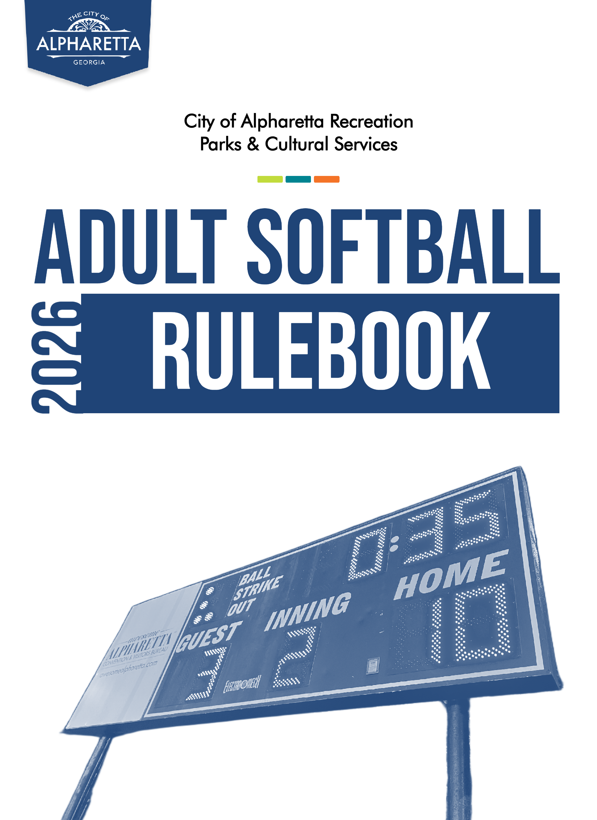
TABLE OF CONTENTS

GENERAL……………………………………………………………………….…………. 2
General Information………………………………………………………………. 2
Forfeitures…………………………………………………………………………..2
Postseason Tournament…………………………………………………………… 3
Registration and Fees……………………………………………………………... 3
PLAYER ELIGIBILITY…………………………………………………………………...…… 4
Rosters ……………………………………………………………………………... 4
Substitute Players……………………………………………………………......... 4
TEAM SPONSORSHIPS…………………………………………………………………… 5
GAMEPLAY………………………………………………………………………………... 5
Players/Lineups……………………………………………………………………. 5
Game Clock……………………………………………………………………….. 5
Courtesy Runner…………………………………………………………………… 6
Mercy Rule…………………………………………………………………………. 6
Home Run Limits…………………………………………………………………… 6
Flip Flop Rule………………………………………………………………………. 6
Safety Base………………………………………………………………………… 6
Pitching Screens…………………………………………………………………… 7
JERSEYS……………………………………………………………………………………. 7
EQUIPMENT……………………………………………………………………………….. 8
Guidelines…………………………………………………………………………. 8 USSSA-Approved Equipment…………………………………………………….. 8
Balls…………………………………………………………………………………8
Bats………………………………………………………………………………… 8
Cleats………………………………………………………………………………. 9
COED SPECIFIC RULES…………………………………………………………………… 9
Batting………………………………………………………………………………9
Fielding…………………………………………………………………………….. 10
CONDUCT………………………………………………………………………………… 10
MISCELLANEOUS………………………………………………………………………….11
FIELD USAGE AND PRACTICES…………………………………………………………..11
CONTACT INFORMATION………………………………………………………………. 12
LOCATIONS………………………………………………………………………………. 12
YOUTH SOFTBALL AND YOUTH BASEBALL……………………………………………..13
- GENERAL:

  - GENERAL INFORMATION
    - The governing body of this league will be Alpharetta Recreation, Parks & Cultural Services (ARPCS).
    - ARPCS reserves the right to edit, remove, change, or add rules at any time.
    - The league will abide by USSSA rules unless superseded by ARPCS rules.
    - A season will consist of 10 regular season games, weather and time permitting. The highest performing teams in each league will enter a postseason, single elimination tournament, weather and time permitting.
    - Games will be scheduled to begin as early as early as 6:30 PM and as late as 9:30 PM.
    - Actual game start-times may be delayed due to weather, grace periods for teams to field a team in order to avoid forfeit, extra innings due to tied games, and other extenuating circumstances.
    - Teams must provide a team name prior to the creation of the season schedule.
    - ARPCS reserves the right to reject a team name on the basis that it is deemed inappropriate.
    - All City of Alpharetta program participants are expected to adhere to park rules and City ordinances.

For a complete, updated list of the City of Alpharetta’s Adult Softball programs, as well as additional information, please email the City of Alpharetta Athletics offices at athleticprograms@alpharetta.ga.us.

  - FORFEITURES
    - Teams are responsible to provide adequate prior notice to league management in the event that their team cannot play a given game.
      - Teams that give over 24 hours of notice are eligible to have their game rescheduled, provided that their scheduled opposing team does not first accept their forfeit, and there is space to do so in the remaining season schedule.
        - Playoff games are not eligible to be rescheduled.
      - Teams are not eligible to receive a refund of their team fees in the event that a game is forfeited, per the City of Alpharetta’s refund policy.
    - Teams are subject to team withdrawal following three forfeited games in one season regardless of context.
    - Teams are subject to team withdrawal following two forfeited games in one season without prior notice given to their league’s administrator.
    - In cases where a team forfeits a double header, teams are not penalized for not providing prior notice to league administrators.
      - Both games, however, will count towards their three-game forfeiture limit.
    - Players on the roster for a withdrawn team are not eligible to register a team for an Adult League program season which follows a season in which their team has been forcibly withdrawn.
      - Players are still welcome to play, provided that they register to play for other teams.
  - POSTSEASON TOURNAMENT:
    - The highest-performing teams are invited to participate in a single-elimination tournament following the conclusion of the regular season.
    - Seeding for the postseason tournament is determined by a team’s overall record, with tiebreakers determined by average run differential and/or head-to-head wins.
    - In the instance that a league season is abbreviated, or the league is large enough that it does not allow for each team to play every other team at least once, playoff seeding will be determined by win percentage (win%), with tiebreakers determined by average run differential (arDiff).
      - Otherwise, playoff seeding will be determined by overall wins, with tiebreakers determined by head-to-head wins.
  - REGISTRATION AND FEES
    - Teams can register for any upcoming season by going to the City of Alpharetta’s website, www.alpharetta.ga.us/recreation.
      - The City of Alpharetta currently offers both team-based registration and free agency registration.
        - The City of Alpharetta does not charge players who register as free agents; however, teams may require that you pay a portion of the team’s split fees for items like equipment or jerseys.
        - Registering as a free agent does not guarantee that you will be placed on a team each season and is based on team needs.
      - For a complete breakdown of fees charged by the City of Alpharetta for athletic leagues and other programs, please refer to the program coordinator or visit the City of Alpharetta’s website.
      - At the end of the registration period, a league coordinator will reach out to your team with more information about the upcoming season, which includes an updated rulebook, team registration pages, and a season schedule.
        - Once your team receives your team registration page, you can begin adding players to your roster.
          - All team managers (the individual responsible for registering your team and receiving league communications) must also register to be included on a team’s roster if they intend to play during the season.

- PLAYER ELIGIBILITY:
  - Players must be at least 18 years of age to participate.
  - ROSTERS:
    - All players must be registered online for their specific team in order to be eligible to participate on said team. Online player registration serves as each team’s roster.
    - As of the Summer 2024 season, sponsored teams may no longer provide a carbon copy of their team’s roster. All players must register online via the City of Alpharetta website. (See Rule 3 – TEAM SPONSORSHIPS for more information.)
    - Rosters are frozen halfway through the season, as determined by the league coordinator. Players may no longer register to play for the season following this date.
      - Teams may be granted a temporary re-opening of their roster based on hardship conditions. All requests must be made to the league coordinator.
    - A player may not be on the roster of two teams in the same league.
    - A player may not be on the roster of a C League team and an E League team in the same season.
    - Teams may have up to 20 players on their roster.
    - Players may not be released from one team’s roster in order to join another team’s roster after either team’s roster is locked. (See Rule 2.2.3 for more information.)
    - A team found using an ineligible player in a game will forfeit said game. A game may be called a forfeit after its completion if it is later determined that a team was using an ineligible player.
  - SUBSTITUTE PLAYERS:
    - A team may use substitute players if the following criteria are met:
      - The player must be registered to play on another team in the ARPCS Adult Softball league for the current season.
      - Prior to the start of the game, the coach of the team requesting to use a substitute player(s) must request permission from the opposing team’s head coach in the presence of the home plate umpire.
        - The opposing team may deny the request of the use of substitute players without reason even if it results in the requesting team forfeiting.
        - A team found using substitute players without permission from the opposing team may forfeit that game.

- TEAM SPONSORSHIPS
  - Teams may be sponsored by an outside party.
  - Teams sponsored by an Alpharetta-based organization may be eligible to have their team’s nonresident roster fees waived.
  - Teams sponsored by an Alpharetta-based organization may be eligible to have their team’s sponsor highlighted on the City of Alpharetta athletics website.
  - Teams sponsored by an organization outside of the City of Alpharetta are not eligible for ARPCS team sponsorship benefits.
  - Teams must submit a City Athletics Sponsorship Form to the league coordinator before they are eligible for team sponsorship benefits.

- GAMEPLAY
  - PLAYERS/LINEUPS: Lineup cards must be submitted to the home plate umpire prior to the beginning of each game.
  - A team must be able to field 8 players to complete a game.
    - A team may start a game with 7 players; however, the team must have at least 8 players before 30 minutes have expired on the game clock or the game will be ruled a forfeit.
    - If a team has at least 7 players present, they must begin play.
  - For the first game of the night on a given field, there will be a 10-minute start-time grace period for teams to field 7 players.
    - The 10-minute grace period will not be subtracted from the game clock.
  - Once a game has started, a team may add any additional eligible players to the bottom of their lineup as those players arrive.
  - If a team has more than 10 players on their lineup, all players must bat, and all players may be freely substituted in the field at the start of each inning.
  - If a player must leave or come out of a game for any reason (ejection, injury, time conflict, etc.), an out will be called the next time that player comes up in the batting order. Any subsequent at bats by that player will be skipped free of an out being called.
  - Senior (55+) league games will be played using 65ft of distance between bases.
  - GAME CLOCK: All regular season games will have a 60-minute game clock. There is no game clock in postseason championship games.
    - A 5-minute countdown clock will be set prior to each game. When the countdown clock expires, the 60-minute game clock will be set and started.
      - If a game ends early, the countdown clock will be set to coincide with the next game’s scheduled start time. If a game ends late the countdown clock will still be set to 5 minutes.
      - Teams of games that have just ended should exit the field and dugout area promptly to allow the next game’s teams to enter.
    - Unless a game is tied, another inning will not begin after time has expired.
      - If there is any time left after the third out of the bottom of an inning is called, another inning will be played.
    - In the event of a tied game after time is expired, one extra inning will be played. Games that remain tied after one extra inning has been completed will be scored as such.
      - The postseason tournament championship game will be played untimed until a winner is determined.
    - A game that has completed the 4th inning and must be stopped for any reason including weather or lighting failure will be considered complete.
      - The score recorded will be that of the last completed inning.
      - If the home team is winning after the top of the 4th inning, the game will also be considered complete.
    - A game stopped prior to completion of the 4th inning will be rescheduled and replayed as a new game.
  - COURTESY RUNNER: One courtesy runner will be allowed per inning to run for another player on base. The courtesy runner does not have to be the last player in a team’s batting order to have been called out.
    - In Coed leagues a male courtesy runner may not run for a female on base.
  - Batters begin their at bat with a 1 ball, 1 strike count.
  - MERCY RULE: For all leagues, games will be called if a team is winning by:
    - 20 runs after 3 innings
    - 15 runs after 4 innings
    - 10 runs after 5 innings

  - HOMERUN LIMITS:
    - C League is allowed 5 homeruns. After a team has reached 5 homeruns and the opposing team has reached 4 homeruns, the one-up rule will apply.
    - The D and E Leagues are allowed 3 homeruns. After a team has reached 3 homeruns and the opposing team has reached 2 homeruns, the one-up rule will apply.
    - For Coed leagues, the one up-rule will apply.
      - One-up rule: A team may not hit more than one more homerun than the opposing team has hit.
    - Senior (55+) leagues are allowed 5 homeruns before the one-up rule will apply.
      - A homerun hit exceeding the home run limit will be called an out.
  - FLIP FLOP RULE: With under 5 minutes remaining on the game clock, if the home team is losing at the end of an inning, home and visiting teams will “flip.” The home team will clear the bases and bat again as the visiting team.
    - If another inning is completed and the new home team (original visitor) is now losing, the teams will flip back.
  - SAFETY BASE: A safety base will be used at first base.
    - If a batter is running to first and there is a play at first, the runner must use/tag the orange half of the base and the fielder making the play at first must use/tag the white part of the base.
    - If a fielder blocks the orange part of the base when a runner is advancing to first, the runner will be awarded first base.
    - After a ball is dead and time is called, a runner on first must use the white half of the safety base. Failure to do so will be viewed as the runner being off base, result in the runner being called out.
  - PITCHING SCREENS: Protective pitching screens will be used on the field.
    - Screens must be placed in front of and parallel to the pitching rubber.
      - The left or right side of the screen frame must be within range of the 24” pitching rubber.
      - The screen frame must be no more than 3 feet in front of the pitching rubber.
    - During their warmup at the beginning of the top or bottom of each inning, a pitcher may adjust the placement of the screen within the aforementioned range.
      - Once the first pitch of the top or bottom of an inning is thrown, the placement of the screen should not be adjusted in order to avoid a delay of game penalty.
      - The screen may not be moved during a live ball in order to remove it as an obstruction to a play.
      - Screen placement may be adjusted if there is a change in pitchers in the middle of an inning.
    - A batted ball that hits any part of the screen, including the base and wheels, will be called a foul ball.
      - During gameplay, a ball that makes contact with the screen will remain a live ball unless the ball becomes lodged within or under the screen.
      - If a live ball becomes lodged within or under the screen, the player closest to the ball should raise both hands in the air, indicating so to the umpire.
          - Umpires will call time/dead ball. Any runners that are between bases will advance to the next base.
            - A runner who has run through first base and is in foul territory is not considered to be between bases.

- JERSEYS: Players on a team must wear matching jerseys with non-duplicating numbers.
  - Teams will be allowed a one-week grace period to obtain official jerseys at the beginning of the season.
  - Numbers may not be drawn or taped on.
  - A team must obtain permission from the recreation department to field a player(s) without an official jersey.
    - Exceptions may be made for substitute players. (See Rule 2.3 – SUBSTITUTE PLAYERS for more information.)
  - If a team cannot field at least 8 players with official jerseys, the game may be called a forfeit.

- EQUIPMENT:
  - GUIDELINES
    - All equipment used in-game must be approved for use by USSSA and ARPCS for slowpitch softball.
    - Specifications for league-approved equipment are outlined within this document. Please refer to your league’s coordinator with any questions about which equipment is league-eligible.
  - USSSA-APPROVED EQUIPMENT
    - A list of current approved manufacturers for USSSA slowpitch equipment can be found on the USSSA website.
      - https://usssa.com/slowpitch/slowpitch-licensed-softball-bat-ball-manufacturers
  - BALLS:
    - Teams supply their own game balls.
    - Balls must be official USSSA stamped, 12 inch, yellow, slowpitch softballs.
      - “Stadium” and “Senior” balls are not allowed.
    - Balls must be in new to good condition as determined by recreation staff or officiating umpires.

For more information about league-approved equipment, please email the league coordinator, or email the City of Alpharetta Athletics offices at athleticprograms@alpharetta.ga.us.

  - BATS:
    - Teams supply their own bats.
    - Eligible bats must be marked with the 2020 USSSA Certification Mark on the taper of the bat.
      - USSSA has outlawed the 2014 USSSA Certification Mark as of January 1st, 2023.
        - Bats with the 2014 USSSA Certification Mark are no longer eligible for ARPCS Adult Softball gameplay as of the Fall 2023 Season.
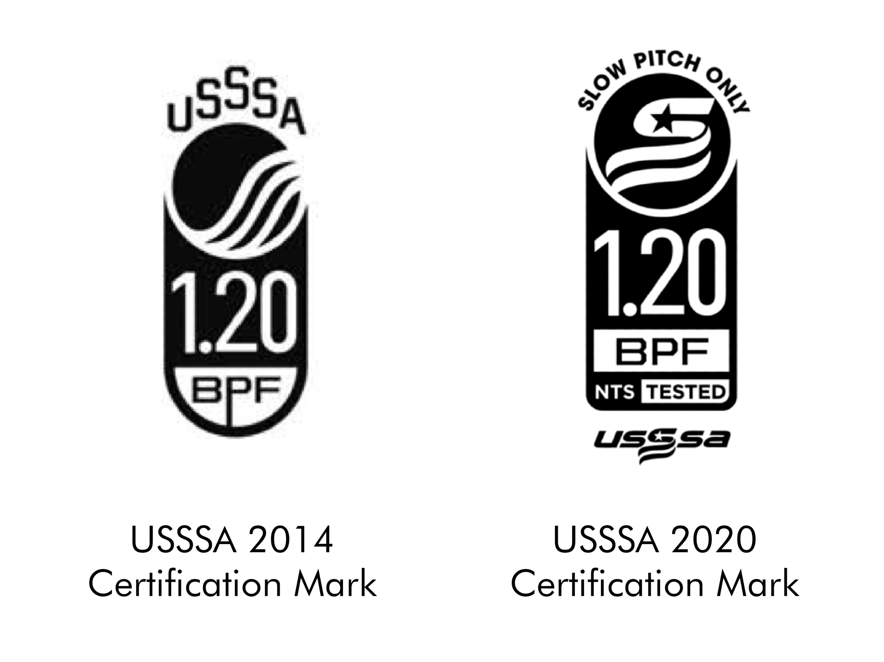
    - All bats must be compression tested by an ARPCS staff member and marked with an ARPCS sticker proving they have passed testing for each season.
      - Bats must register at or above 240lbs of compression at the thickest point in the barrel of the bat to be league eligible.
      - Bats must be tested by an ARPCS staff member before they are eligible to be used in gameplay during the season and must be retested before they are eligible to be used in postseason tournament gameplay.
      - All bats must be tested seasonally, without exceptions for bats tested the previous season.
    - All bats used in senior (55+) league play must comply with the same bat rules established in this document. USSSA 2014 certification mark bats are strictly prohibited.
    - Wood bats are not allowed, as of the Spring 2024 season.
    - Use of any equipment that is found to have been tampered with is subject to penalties including player suspension, forfeiture of games, or other penalties at the discretion of ARCPS staff.
      - All bats used in a game must be checked in with home plate umpires prior to the start of each game. Checked-in bats are inspected both for their USSSA Certification Mark and City of Alpharetta stamp.
        - Amended May 13, 2024.
      - Teams are given access to bat holder racks provided by ARPCS. These are to be placed on the fence interior on each field near each team’s dugout by ARPCS Staff.
        - Each team is allowed to use up to 10 bats per game.
        - All bats must be “checked in” ahead of the beginning of each game by placing them on the team’s designated bat rack.
          - In cases of a double header, teams may substitute their teams’ allotted bats between games, but may not otherwise change which bats they intend to use during a game. All bat substitutions must be made aware to the home plate umpire prior to the beginning of the game.
    - All teams may request an official inspection of any suspicious equipment during any dead ball period.

For more information about league-approved equipment, please email the league coordinator, or email the City of Alpharetta Athletics offices at athleticprograms@alpharetta.ga.us.

  - CLEATS:
    - Metal cleats or metal tipped cleats are not allowed.

- COED SPECIFIC RULES:
  - BATTING:
    - At no time may there be more males than females in the field (unless otherwise agreed upon by both teams prior to the start of the game with the umpires present).
    - Two female players may bat back-to-back. Two male players may bat back-to-back, but an out must be taken between batters. (Unless otherwise agreed upon by both teams prior to the start of the game with the umpires present).
    - If a male batter is walked, he advances to 2nd base.
      - If a male player is walked with 2 outs, the next female batter has the option of batting or taking a walk and advancing to 1st base.
      - If a male batter is walked with less than 2 outs, the next female batter must bat.
  - FEILDING:
    - There must be 1 female at either the pitching or catching position.
    - There may be any combination of 2 female players at the 1st, 2nd, shortstop, and 3rd base positions.
    - There may be any combination of 2 female players in the outfield.
    - There is a 200 ft. line in the outfield that outfielders must remain behind when a female is at bat until a ball is hit. Failure to do so will result in the female batter taking 1st base.
    - Infielders must remain behind the baseline and in front of the outfield grass when a female batter is at bat until a ball is hit. Failure to do so will result in the female batter taking 1st base.
- CONDUCT:
  - All City of Alpharetta athletic program participants must abide by park and facility rules while within City of Alpharetta grounds.
  - Players and spectators must behave respectfully towards opponents, other spectators, officials and ARPCS staff.
  - Profanity and unsportsmanlike conduct are not permitted.
  - Alcohol and tobacco are not permitted in the park.
  - Any discussion or challenge to a call by an umpire or explanation of a rule should take place only between a head coach and an umpire or ARPCS staff.
    - Any formal petitions to rulings, game outcomes, etc. must be made by the team’s manager to a league coordinator or an on-duty ARPCS staff member.
  - Any umpire or ARPCS staff may eject any player or spectator from the park at their discretion at any time.
    - An ejected player or spectator must leave the park immediately. Failure to do so may result in a forfeit.
    - Any player ejected from the park will receive a minimum suspension from the park during hours of league play for one week of gameplay.
      - If an ejected player plays on multiple teams, that player will not participate in any games that fall within their week suspension.
      - A break in scheduled games due to a holiday such as spring break will not count as a week of gameplay.
    - The ejected player may not be present in the park on the night of their team’s next game.
      - In the case of a double header, the second game played in the same night of a double header will not serve as the team’s next game.
    - Further suspension up to and including a lifetime banishment from the park may be determined by the recreation department on a case-by-case basis.

- MISCELLANEOUS
  - The City of Alpharetta keeps several first aid supplies, including adhesive bandages and ice packs on-hand at North Park. First Aid supplies are available upon request with an ARPCS staff member.
    - For serious injuries, participants are encouraged to notify an on-duty ARPCS staff member, and call emergency services.
    - ARPCS’ part-time athletics staff members are not certified in first aid, but can help provide first aid materials upon request.
  - In the event that an AED is needed, an AED is available in the North Park Quad building inside the storage closet.
  - In the event that a fire extinguisher is needed, one is mounted to the wall on the inside of the North Park Quad building stairwell leading to the upstairs office.

- FIELD USAGE AND PRACTICES
  - The City of Alpharetta is proud to provide softball fields at North Park.
  - The City of Alpharetta allows registered softball teams to reserve space to hold practices in 2-hour blocks throughout an Adult Softball season without reservation fees, provided that field space is available.
    - All field reservation requests can be made through the league’s administrator.
  - Fields can be rented through the City of Alpharetta’s Athletics Office.

- CONTACT INFORMATION

Athletics Coordinator, Adult Softball League Coordinator
ALAN SANDERS, CPRP, CYSA | asanders@alpharetta.ga.us | 678-297-6172

Athletics Supervisor
TYLER SPINNENWEBER, CPRP, CYSA | tspinnenweber@alpharetta.ga.us | 678-297-6163

Athletics Offices
WILLS PARK RECREATION CENTER | athleticprograms@alpharetta.ga.us | 678-297-6130

City of Alpharetta Website
www.alpharetta.ga.us

City of Alpharetta Athletics Website
www.quickscores.com/alpharetta

- LOCATIONS

NORTH PARK – Adult Softball Fields
13450 Cogburn Rd., Alpharetta, GA 30004

WILLS PARK RECREATION CENTER – City of Alpharetta Athletics Office
11925 Wills Rd., Alpharetta, GA 30009

- YOUTH SOFTBALL AND YOUTH BASEBALL

Youth Softball is provided to the Alpharetta community by the parents and volunteers of the Alpharetta Youth Softball Association. For more information about this program, including updated contact information, please visit the Alpharetta Youth Softball Association website at https://alpharettayouthsoftballassociation.teamsnapsites.com/.
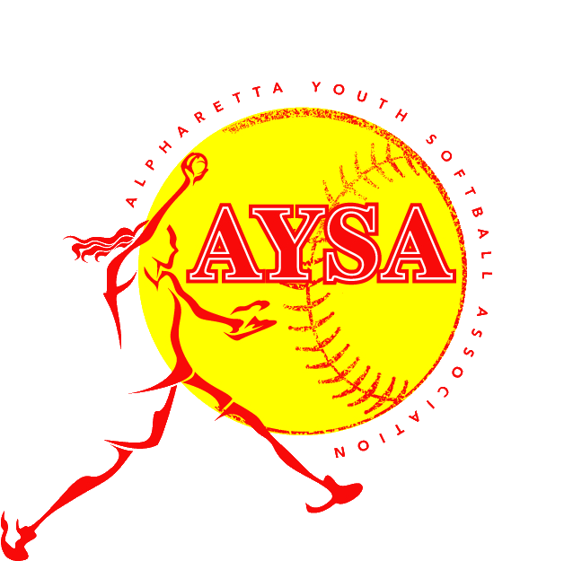

Youth Baseball is provided to the Alpharetta community by the parents and volunteers of the Alpharetta Youth Baseball Association. For more information about this program, including updated contact information, please visit the Alpharetta Youth Baseball Association website at https://alpharettayouthsoftballassociation.teamsnapsites.com/.
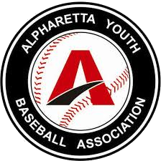

The City of Alpharetta Recreation Parks & Cultural Services Department is proud to provide youth, teen, and adult sports programs. For a complete listing of athletics programs for everyone, please visit our Athletics website, www.quickscores.com/alpharetta.



