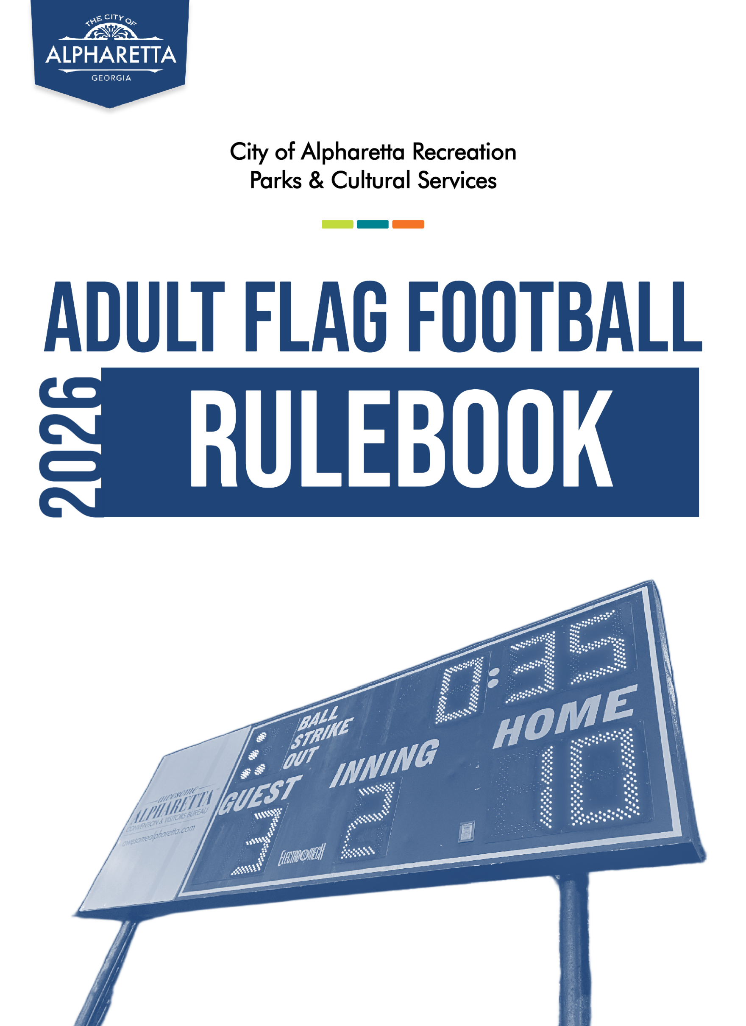
TABLE OF CONTENTS

LEAGUE ORGANIZATION ………………………….……………………….…………. 3
PLAYER ELIGIBILITY…………………………………………………………………...…… 3
Rosters ……………………………………………………………………………... 3
Substitute Players……………………………………………………………......... 3
GAMEPLAY………………………………………………………………………………... 4
TEAM SPONSORSHIPS…………………………………………………………………… 4
JERSEYS…………………………………………………………………………………….4
EQUIPMENT……………………………………………………………………………….. 4
Balls……………………………………………………………………………… 4
Uniforms ………………………………………………………………………… 5
Flags ……………………………………………………………………………. 5
Misc Equipment …………………………………………………………………. 5
CONDUCT………………………………………………………………………………… 6
CONTACT INFORMATION………………………………………………………………. 6
LOCATIONS………………………………………………………………………………. 7

- LEAGUE ORGANIZATION:
  - The governing body of this league will be Alpharetta Recreation, Parks & Cultural Services (ARPCS).
  - ARPCS reserves the right to edit, remove, change, or add rules at any time.
  - The league will abide by NIRSA Flag Football rules unless superseded by ARPCS rules.
  - A season will consist of 6 regular season games, weather and time permitting. The top 6 teams in each league will enter a post-season, single elimination tournament, weather and time permitting.
  - Games will be scheduled to begin as early as early as 6:30PM and as late as 8:30PM.
    - Actual game start-times may be delayed due to weather, grace periods for teams to field a team in order to avoid forfeit, extra innings due to tied games, and other extenuating circumstances.

- PLAYER ELIGIBILITY:
  - Players must be at least 18 years of age to participate.
  - Rosters: All players must be registered online for their specific team in order to be eligible to participate on said team. Online player registration serves as each team’s roster.
    - Rosters will be locked after the second week of the season, or as deemed by the league coordinator, and teams may not add any new players to their roster.
    - A player may not be on the roster of two teams in the same league.
    - Teams may have up to 20 players on their roster.
    - Teams must have a minimum of 7 players on their roster.
    - Players may not be released from one team’s roster in order to join another team’s roster after either team’s roster is locked. (See rule 2.2.1)
  - A team found using an ineligible player in a game will forfeit said game. A game may be called a forfeit after its completion if it is later determined that a team was using an ineligible player.
  - Substitute Players: A team may use substitute players if the following criteria are met:
    - The player must be registered to play on another team in the ARPCS Adult Flag Football League for the current season.
    - Prior to the start of the game, the coach of the team requesting to use a substitute player(s) must request permission from the opposing team’s head coach in the presence of a referee.
      - The opposing team may deny the request of the use of substitute players without reason even if it results in the requesting team forfeiting.
      - A team found using substitute players without permission from the opposing team may forfeit that game.

- GAMEPLAY
  - Please refer to the NIRSA Flag Football Rulebook for more information regarding specific on-field rules, game terminology, or penalties not specifically outlined by the ARPCS rulebook.
  - Players/Lineups:
    - A team mist be able to field 6 players to complete a game.
      - A team may start a game with 5 players; however, the team must have at least 6 players present before half of the game clock has lapsed or the game will be ruled a forfeit.
      - A team must begin play if 5 players are present.
    - For the first game of the night on a specific field, a team may be given a 10-minute grace period to allow for more players to arrive.
      - If the grace period is granted, the 10 minutes will be subtracted from the game clock during the first half.
  - All games are played in 20-minute halves with a 3-minute halftime.
  - Games are played on a continuous clock, with clock stoppages in the last 2 minutes of each half.
  - ARPCS Flag Football does not currently adhere to NIRSA rules pertaining to Co-Rec play. All games adhere to NIRSA rules for “male” gameplay.

- TEAM SPONSORSHIPS
  - Teams may be sponsored by an outside party.
  - Teams sponsored by an Alpharetta-based organization may be eligible to have their team’s nonresident roster fees waived.
  - Teams sponsored by an Alpharetta-based organization may be eligible to have their team’s sponsor highlighted on the City of Alpharetta athletics website.
  - Teams sponsored by an organization outside of the City of Alpharetta are not eligible for ARPCS team sponsorship benefits.
  - Teams must submit a City Athletics Sponsorship Form to the league coordinator before they are eligible for team sponsorship benefits.

- EQUIPMENT
  - Balls: Game balls will be provided by ARPCS staff.
    - All game balls will have a standard length of 11 inches, with a width of 7 inches, and a diameter of 21 inches when fully inflated.
    - Teams can request that a referee examine the game ball prior to or during gameplay during a “dead ball” period.
      - Teams have the right to petition league-ineligible equipment.
        - Use of any equipment that is found to have been tampered with before or after their approval by league staff can lead to penalties including player suspension, forfeiture of games, or other penalties at the discretion of ARCPS staff.

  - Uniforms
    - Teams are required to provide matching team jerseys with non-duplicating numbers.
      - Team jerseys are NOT required for the Spring 2024 season. ARPCS will be providing athletic pennies for the Spring 2024 season.
        - All borrowed equipment must be returned to an official or ARPCS staff member at the end of gameplay.
      - Numbers may not be drawn or taped onto jerseys.
    - Teams must be granted an exception by ARPCS league staff in order to field a player that does not meet jersey requirements.
    - A game may be called a forfeit in the event that a team cannot field a minimum of players with matching jerseys.
      - Exceptions may be made for substitute players. See substitute player rule.
    - Cleats:
      - Teams are required to wear cleats during gameplay.
      - Metal cleats or metal tipped cleat are not allowed.
    - Flags
      - Flag belts will be provided by ARPCS through the Spring 2024 season.
        - All flag belts must be returned to a staff member or official at the end of gameplay.
      - Flag belts must be worn at all times during gameplay.
      - Belts must be properly fastened and not loose.
      - Jerseys may not be covering any portion of the flag belt at any time.
    - Miscellaneous Equipment
      - Exceptions may be made for additional equipment, such as protective or adaptive equipment, provided that it does not provide a unique strategic advantage to a player or team.
      - Headgear is not allowed to be worn during gameplay, with the exception of “soft material” headgear (i.e., beanies, bandanas, headbands)
      - Mouthguards are recommended for all players but are not specifically required by ARPCS rules.
      - Approved gloves may be worn.
      - Materials which may be applied to make provide an additional advantage (i.e., Stick-Um™) are considered illegal equipment and are penalized either by penalty yardage or disqualification, at the discretion of referees and league staff.
      - Sunglasses may not be worn during gameplay.
        - Exceptions are granted for sunglasses with prescription lenses.
        - Form-fitting goggles may be worn.
      - Jewelry is strictly prohibited during gameplay.
      - Pants with beltloops are strictly prohibited during gameplay.

For a comprehensive list of league-eligible equipment or recommended vendors, please contact athleticprograms@alpharetta.ga.us

- CONDUCT:
  - Players and spectators must behave respectfully towards opponents, other spectators, officials and ARPCS staff.
  - Profanity and unsportsmanlike conduct are not permitted.
  - Alcohol and tobacco are not permitted in the park.
  - Any discussion or challenge to a call by an umpire or explanation of a rule should take place only between a head coach and an umpire or ARPCS staff.
  - Any umpire or ARPCS staff may eject any player or spectator from the park at their discretion at any time.
    - An ejected player or spectator must leave the park immediately. Failure to do so may result in a forfeit.
    - Any player ejected from the park will receive a minimum suspension from the park during hours of league play for one week of gameplay.
      - If an ejected player plays on multiple teams, that player will not participate in any games that fall within their week suspension.
      - A break in scheduled games due to a holiday such as spring break will not count as a week of gameplay.
    - The ejected player may not be present in the park on the night of their team’s next game.
      - In the case of a double header, the second game played in the same night of a double header will not serve as the team’s next game.
    - Further suspension up to and including a lifetime banishment from the park may be determined by the recreation department on a case-by-case basis.

- CONTACT INFORMATION

Athletics Coordinator
ALAN SANDERS, CPRP, CYSA | asanders@alpharetta.ga.us | 678-297-6172

Athletics Coordinator
JAYDAN MACON, CPRP, CYSA | jmacon@alpharetta.ga.us | 678-297-6152

Athletics Supervisor
TYLER SPINNENWEBER, CPRP, CYSA | tspinnenweber@alpharetta.ga.us | 678-297-6163

Athletics Offices
WILLS PARK RECREATION CENTER | athleticprograms@alpharetta.ga.us | 678-297-6130

City of Alpharetta Website
www.alpharetta.ga.us

City of Alpharetta Athletics Website
www.quickscores.com/alpharetta

- LOCATIONS

NORTH PARK – Adult Softball Fields
13450 Cogburn Rd., Alpharetta, GA 30004

WILLS PARK RECREATION CENTER – City of Alpharetta Athletics Office
11925 Wills Rd., Alpharetta, GA 30009

The City of Alpharetta Recreation Parks & Cultural Services Department is proud to provide youth, teen, and adult sports programs. For a complete listing of athletics programs for everyone, please visit our Athletics website, www.quickscores.com/alpharetta.

