WES JOHNSON
USSSA AREA DIRECTOR
503 BOYCE
ALAMOGORDO, NM 88310
HOME: 575-491-0364 CELL: 575-921-9262
E-MAIL : alamousssa@q.com
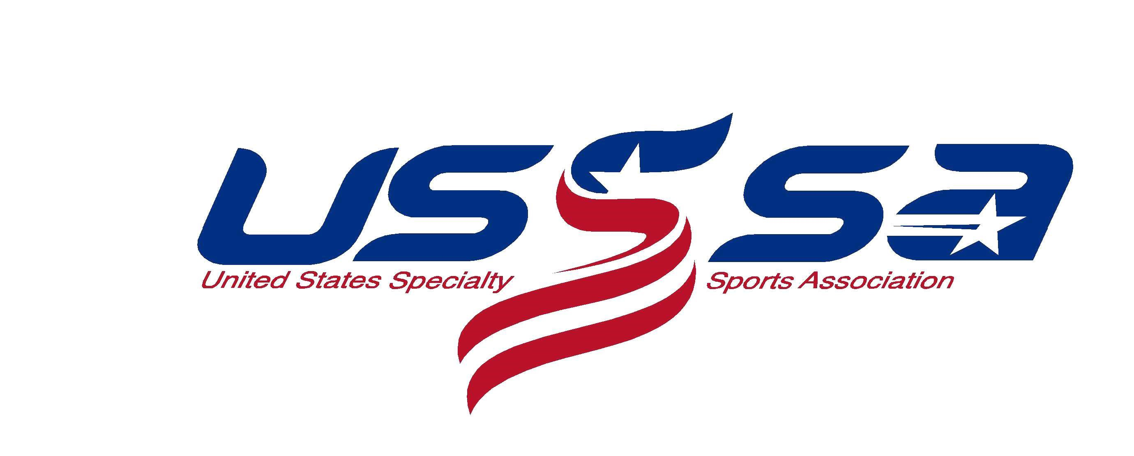
To Whom It May Concern:
The Alamogordo Softball Association has formed it’s 2023 Alamogordo USSSA Softball League. The league fees will be $300.00 per Team. This covers all cost for the League play.
- Use of Field Fees ( Paid to City)
- Use of Lights (Paid to City)
- City Liability Insurance ( City Requires This)
- Southwest Umpire Association for Officials
- USSSA Sanction Fees
- All Trophies and Awards
- On-Line Scheduling fee
- And all other fees that are not listed.
All Sponsor checks can be made out to: Wes Johnson Alamo USSSA
Wes Johnson

Area USSSA Director

