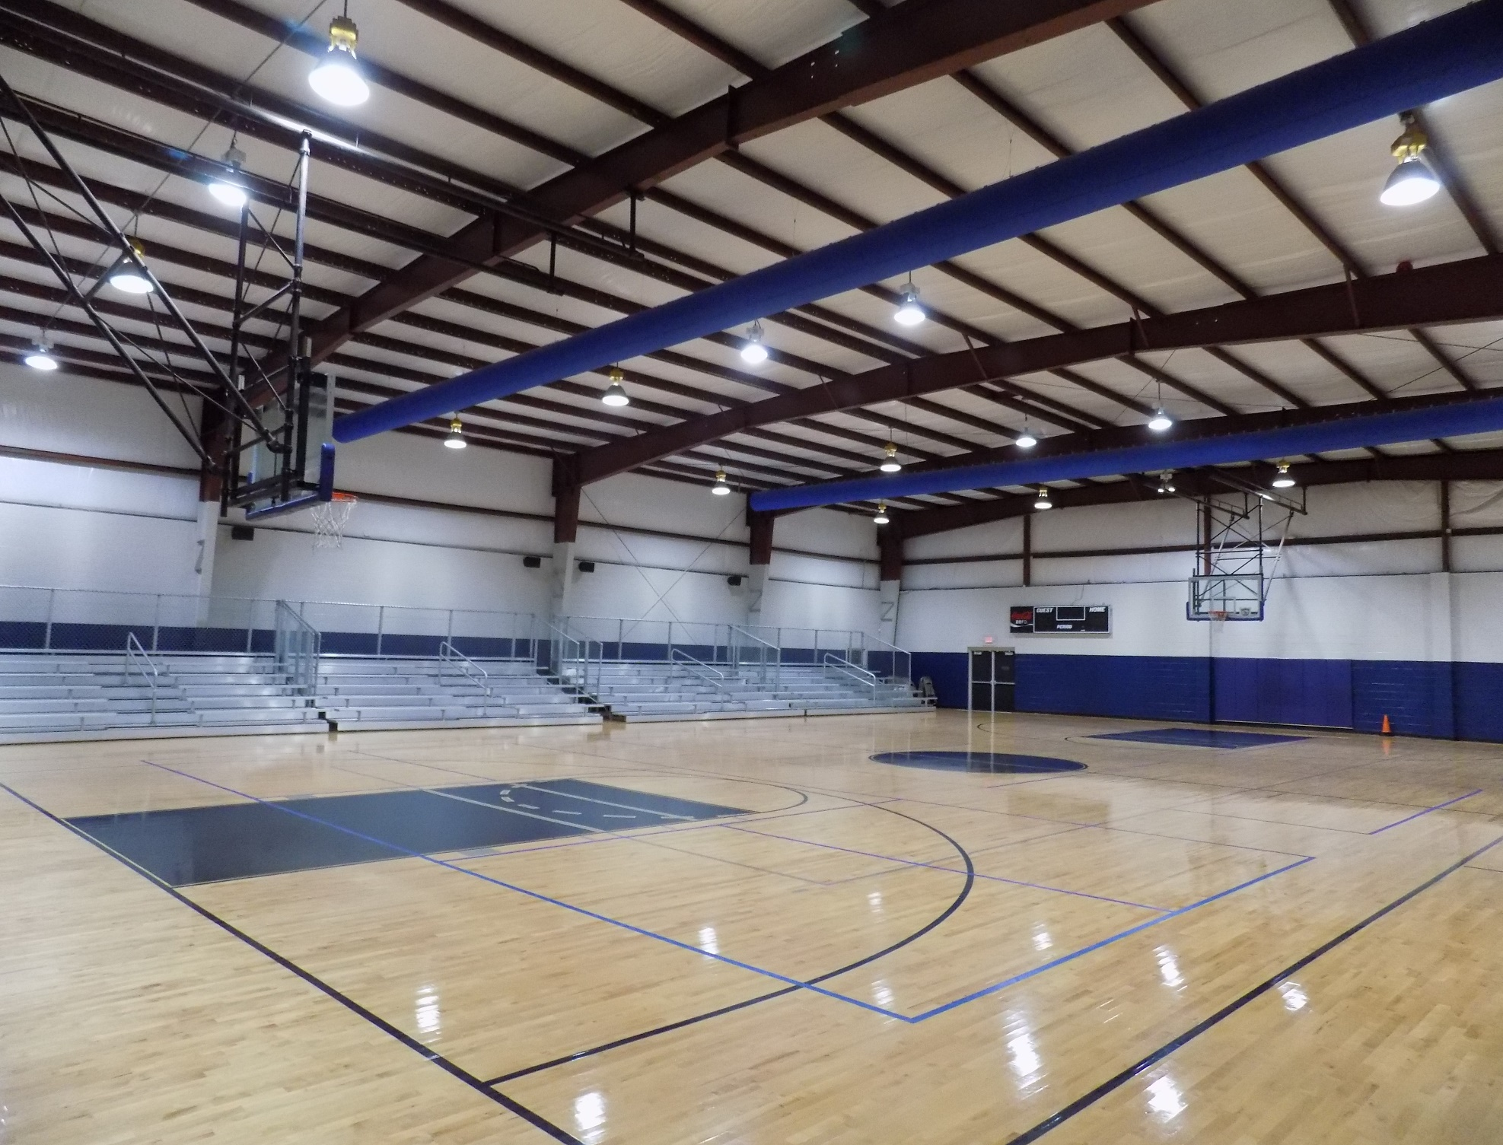

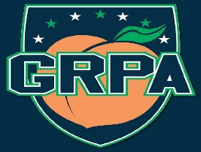
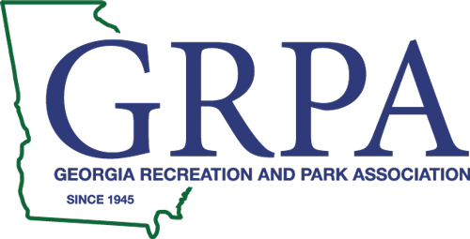
GRPA STATE BASKETBALL TOURNAMENT
MITE BOYS

Hosted By:
March  3-4, 2023 | 12 & Under Girls | Fairmont Gym

Dear Basketball Team:

On behalf of Spalding County and the Spalding County Leisure Services Department, I would like to welcome each team and its fans to the 2023 G.R.P.A. State 12 & Under Girls Basketball Tournament at Fairmont Gym.

If we can be of any assistance to your team, please let us know. For your information, alcoholic beverages are not allowed inside the gyms or on facility grounds, including the parking lots. For your safety, there will be a law enforcement officer on duty.

Good luck to all of you!

Sincerely,

SPALDING COUNTY LEISURE SERVICES DEPARTMENT

Robby Milner
Program Manager

RM/pb

Enclosures

2023 GRPA 12 & UNDER GIRLS
STATE BASKETBALL TOURNAMENT
MARCH 3 & 4, 2023
GRIFFIN, GEORGIA

Gym Location: Fairmont Gym.

Entry Fee: Pool Play/Single Elimination Tournament: 205.00 Make check payable to:
SPALDING CO. PKS & REC CERTIFICATION

Officials: Two (2) G.H.S.A. approved officials will be used at all games.

Awards: Team trophies awarded to first and second place, and individual awards for first and second place.

Rules: G.R.P.A. Manual, pages 66-69 and G.H.S.A. (2022 Manual)

Coaches: No more than 3 coaches.

Uniforms: Uniforms shall consist of a team shirt or jersey with numbers on the front and back, identical in style and color with other members of the same team. The under shirt must be the same color if used and shall not have frayed or ragged edges. Players cannot play unless they meet the uniform requirements.

Uniform Numbers: 1-5, 10-15, 20-25, 30-35, 40-45, and 50-55. The numbers 0 and 00 cannot be used on the same team.

Forfeit: Game time is forfeit time.

Admission Fee: There will be a charge of $5.00 for adults and $3.00 for 55 and over and for youth 6-17 years old. 5 and under is free.

Concession: A concession will be available at gym.

********* Recreation staff members are admitted free with a maximum of two coaches per team.

Security: Griffin Police Officers and Spalding County Sheriff’s Department Deputies will provide security.

Tournament
Director: Robby Milner
Cell: 678-572-8133
Office: 770-467-4755
Email: rmilner@spaldingcounty.com

Recreation Assistant: Promise Travers
Office: 770-467-4750
Email: ptravers@spaldingcounty.com

2023 GRPA STATE 12 & UNDER GIRLS
BASKETBALL TOURNAMENT
MARCH 3-4, 2023
GRIFFIN, GEORGIA

Coach’s Agenda

- Tournament will be governed by the current rules and regulations of the GHSA Constitution and GRPA Athletic Manual.

- Game time will be forfeit time. There will be NO GRACE PERIOD.

- Good sportsmanship is expected from all players, coaches, and spectators. Please remember that you are not only representing your team you play for but your recreation department as well. Any negative cheering or hollering may result in a warning and/or removal from the site, whether it is for or against your team.

- Any player or coach ejected from a game for unsportsmanlike conduct will be suspended for one game, in addition to the game from which ejected.

- Make sure you read the bracket carefully for your next game time.

If you have further instructions or questions, please feel free to contact the Tournament Director or Recreation Assistant.

Robby Milner
Cell: 678-572-8133
Office: 770-467-4750

Spalding County Hotels and Local Restaurants 2023

Hotels:

Holiday Inn Express & Suites
1361 N Expressway
Griffin, Ga 30223
678-408-6693

Country Inn & Suites by Radisson
1900 N. Expressway
Griffin, Ga 30223
770-228-9799

Baymont by Wyndham
2007 N. Expressway
Griffin, Ga 30223
770-504-6121

Comfort Inn & Suites
1906 N. Expressway
Griffin, Ga 30223
770-233-4747

Local Restaurants:

Angelo’s Mediterranean Restaurant Slices Pizza
Corner Café Happy Daze
Fish Tales Seafood Restaurant J Henry’s Restaurant
Margo’s Mediterranean Cuisine Georgia Potato Factory
Southern Pit Bar-B-Q

Chain Restaurants and Fast food in Griffin, Ga:

Chain Restaurants and Fast Food:
Longhorn O’Charley’s Restaurant & Bar
Truett’s Grill (Chick-fil-A) I-HOP
El Charro Mexican Restaurant La Parrilla Mexican Restaurant
Marco’s Pizza Pizza Hut
Zaxby’s American Pie

Looking for Fast Food restaurants? McDonald’s, Arby’s, Hardee’s, Dunkin’ Donuts, Starbuck’s, etc. are also conveniently located.

Directions to Fairmont Community Center Gym
Griffin, GA
Fairmont Community Center Gym
From Interstate 1-75 use the right two lanes to take exit 235 towards US-19/US-
41/Griffin/Jonesboro. Continue on to Tara Blvd for 11.3 Miles, you will pass a KFC on your right in 4.7 miles and will continue on US-19 S/US-41 S for 9.8 miles. You then will pass Atlanta speed way as you will continue on US-19 S/ US-41. After 4.3 miles you will then reach the city limit of griffin and turn left on Vineyard Road for 0.3 miles. Continue on Dobbins Mill Road for 1.4 miles and then turn right on N Hill Street. Continue straight on North Hill Street for 1.4 miles then turn left onto Lynn Lane for 0.1 miles, then turn right on Pool Road. In 285ft you will turn left onto Blanton Ave and your destination will be on the left 241 Blanton Ave Griffin, Ga 30223.
Fairmont Community Center Gym
Coming South on Interstate 16 W take ramp to Macon/interstate 95. Continue on 1-16 W for 205 miles to Butts County. Take the exit on to 1-75 N toward Atlanta, take exit 205 for GA-16 toward Griffin/Jackson. Turn Left onto GA-16 W pass by the dollar general on the right in 9.7 miles. Turn right onto S 6th St, in 0.3 miles turn right on North 6th Street which you will turn a slight right and it becomes Blanton street and your destination will be on your left 2241 Blanton Ave

241 Blanton Ave
Griffin, Ga 30223

