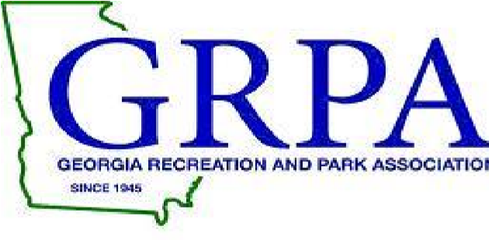
2018 GRPA STATE BASKETBALL PACKET
Basketball State Tournament
March 2-3, 2018
CLASS A 8U Girls and 10U Girls

GAME SITE: Edwards Park Community Center
115 Edwards Park
Dalton, Ga 30721

CONTACT INFORMATION: Ryan Hollingsworth
rhollingsworth@whitfieldcountyga.com
Office: 706-226-8341
Cell: 706-671-9882

ENTRY FEE: $200.00 (Make check payable to Whitfield County)

ROSTERS: Coaches or Staff Representatives should bring their copy of their GRPA
Official Roster and birth verifications. If you are coming straight to
State all four copies of the roster are to be submitted upon arrival.
All rosters must be typed and in alphabetical order. All players must be
present at team roster check-in prior to their first game of the
tournament. Any player arriving after team check in MUST check in with
tournament staff prior to participating in tournament.

OFFICIALS: GHSA High School Officials – 2-3 approved officials per a game

JERSEYS: Governed by GRPA State Athletic Manual (See pages 72-75)

AWARDS: Governed by GRPA State Athletic Manual.

ADMISSION: Adults: $5.00
Children: $2.00 – (5-18)
Senior Citizens – 55 and over - $2.00

TOURNAMENT BRACKETS: Brackets will be updated throughout tournament at www.grpa.org

LODGING/RESTAURANTS: Please visit visitdaltonga.com for lodging and restaurants.

