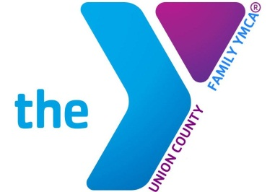
MINI CAMPS

Member-Non Member DATE MINI CAMP TIME

$60-$75 June 10-14 Fishing Camp (3rd- 6th grade) 9am – 12pm
$50-65 June 17-21 Cooking Camp (1st – 6th grade) 9am – 11am
$40-$55 June 17-21 Tennis Camp (5th – 8th grade) 9am – 11am
$40-$55 June 24-28 Tennis Camp (1st – 4th grade) 9am – 11am
$60-$75 July 8-12 Golf Camp (1st – 4th grade) 9am – 11am
$60-$75 July 15-19 Golf Camp (5th – 8th grade) 9am – 11am
$60-$75 Gymnastics Camp (K – 18 years) 5:30pm – 7:30pm
$60-$75 Gymnastics Camp (K – 18 years) 5:30pm – 7:30pm
$40-$55 July 22-26 Volleyball Camp (2nd – 8th grade) 9am – 11am
$40-$55 July29-Aug2 Basketball Camp (K – 6th grade) 9am – 11am $40-$55 August5-9 Soccer Camp (K – 6th grade) 9am – 11am

