Rio Grande Showdown Hotel Rates
March 31-April 2, 2017
**ASK FOR THE “Rio Grande Showdown rate”**
Click on Hotel
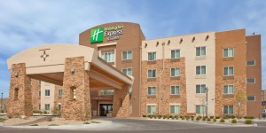
Holiday Inn Express & Suites
2142 Telshor Court
575-522-0700
Las Cruces North
$93 plus tax
Staybridge Suites
2651 Northrise Drive
Las Cruces, NM 88011
575-521-7999
$109 plus tax.
Hotel Encanto de Las Cruces
705 S. Telshor Blvd
Las Cruces, NM 88011
575-532-4252
$99 plus tax for up to four persons.

Fairfield Inn by Marriott
2101 Summit Ct.
Las Cruces,NM 88011
575-522-6840
$95 plus tax.

TownePlace Suites by Marriott
2143 Telshor Court
Las Cruces NM 88011
575-532-6500
$95 plus tax

La Quinta Inn Mesilla Valley
790 Avenida De Mesilla
Las Cruces, NM 88005
575-524-0331
$64.80 plus tax.
La Quinta Organ Mtn
1500 Hickory Dr.
Las Cruces NM, 88005
575.523.0100
$70 plus tax.

Motel 6 Telshor
2120 Summit Ct
Las Cruces, NM 88011
575-525-2055
$47.99 plus tax.

