PDN Online registration Step by Step Guide:
In order to take advantage of online registration, and make it an easy experience for everyone, please follow the recommendations provided to be used as a guide in the process of PDN online registration using Got Soccer. If you are registering an existing players, meaning this player played previously with you and this player is currently on your list of players on your team account, then there is no need to create an new Got soccer account for this player, the coach can easily retrieve and provide the Got Soccer Account login information. No need to create a new account for existing players this will only create a duplicate record, and which creates more work because this will need to be cleaned up later by PDN office personnel.

Coaches need to take care of steps 1-5.
- Coaches identify the players on your team who are interested in registering on-line. Retrieve your players existing account information from your Got Soccer team account.
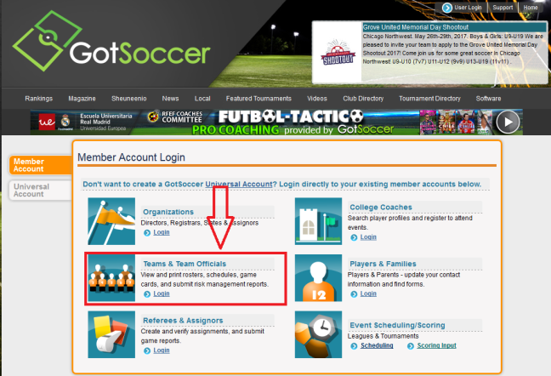

- Click on your Roster option and view your list of players. This is same place you go to upload your player’s photo.
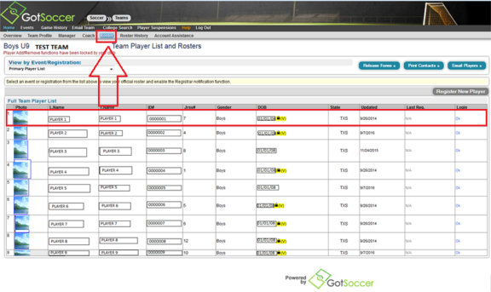

- Click on the player interested in online registration. Once you have your player’s profile up.
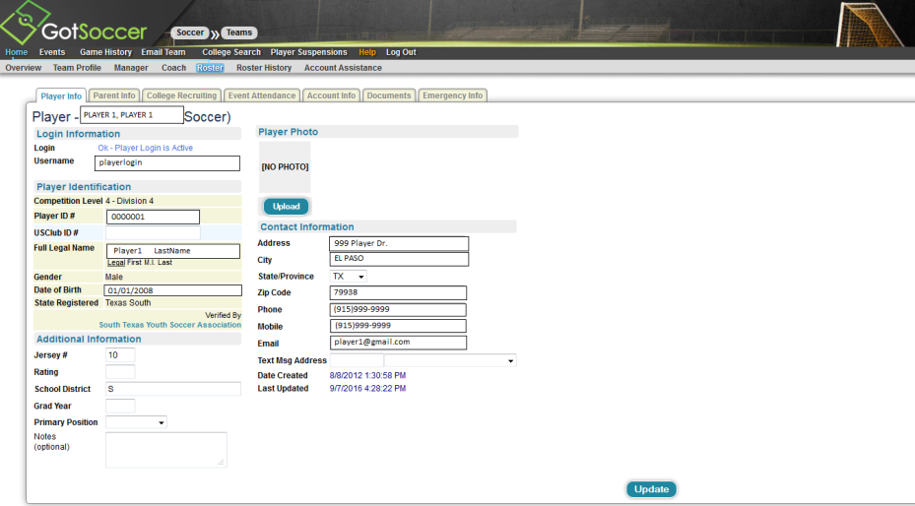

- Click on the Account Info tab. You can set or reset the password here.
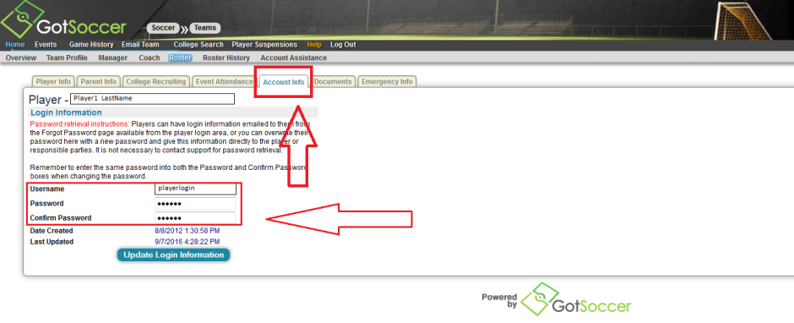
- Provide the Username, and Password to your Player’s Parent and the following link to register online. Parents should be able to take over from here going forward.
https://www.gotsport.com/asp/application/reg/?ProgramID=55703&Type=PLAYER
UserName: (Player’s Got Soccer Username)
Password: (Player’s Got Soccer Password)
--------------------------------------------------------------------------------------------------------------------------------------------------------------------------------------------
Parents can take care of steps 6-13.
- Please choose the appropriate login option, and login with your child’s login information. Team coach should provide this for all players that are not new to the team.
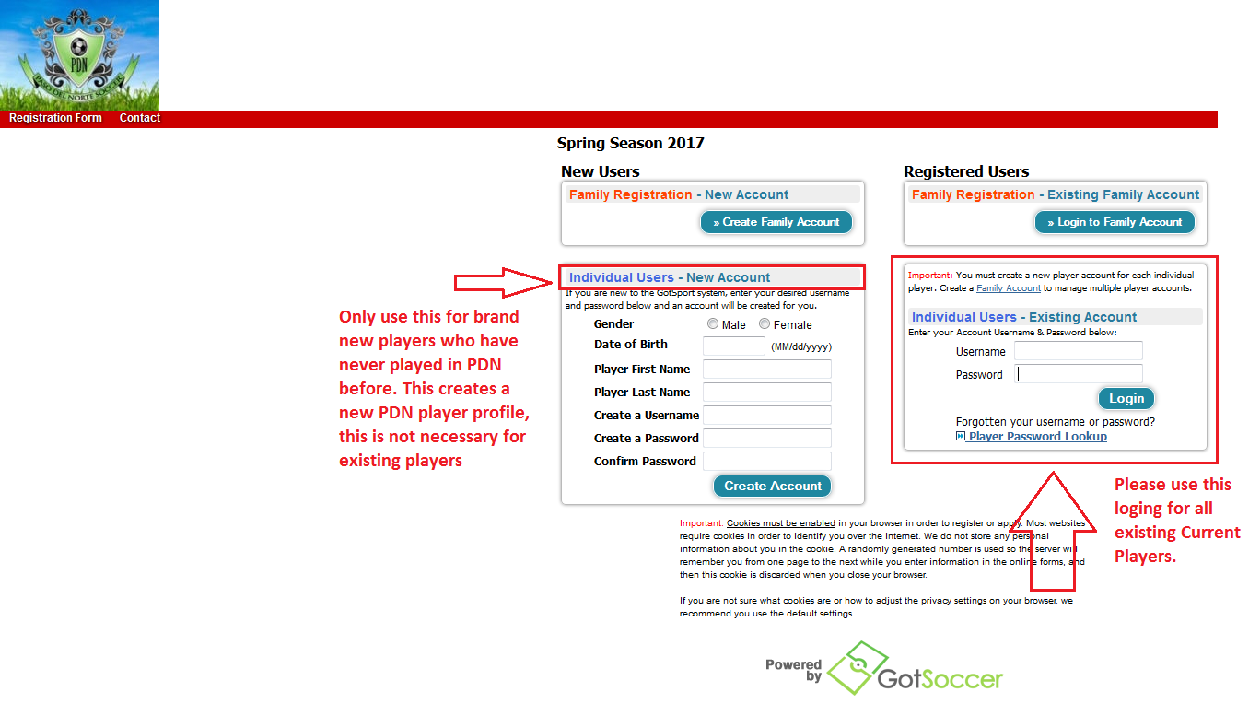

- Parents please fill out form below after successful login, and click Continue.
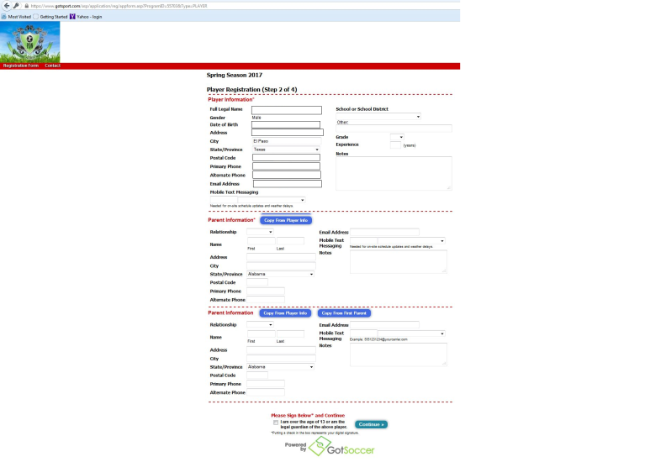
- Please enter PDN Team Name your child plays with, and the name of coach for this team. Click continue
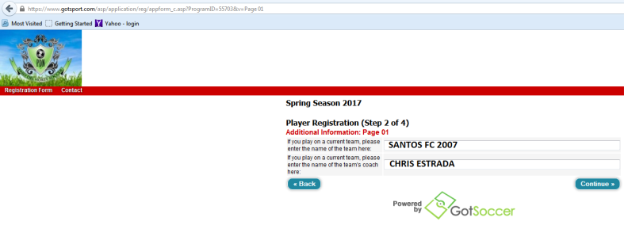
- Please enter Medical Information and click Continue.
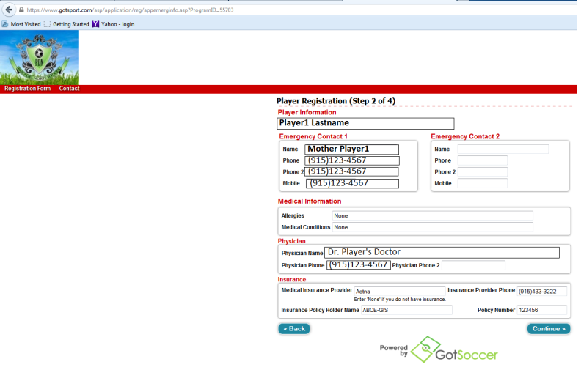

- Please select Spring Registration Fee and click Continue
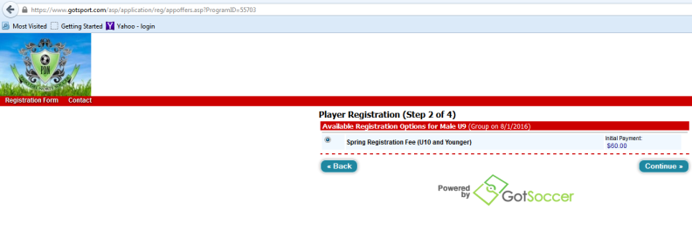
- In the Pay by Credit Card section click to Continue.
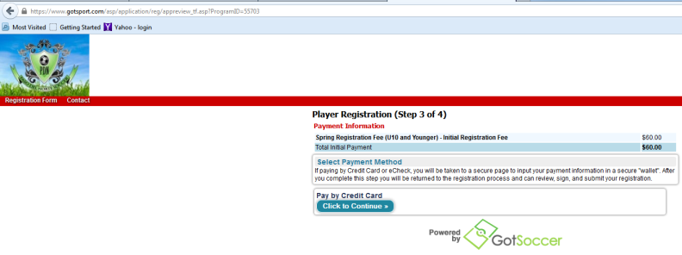
- Complete Credit Card Payment information, and click submit.
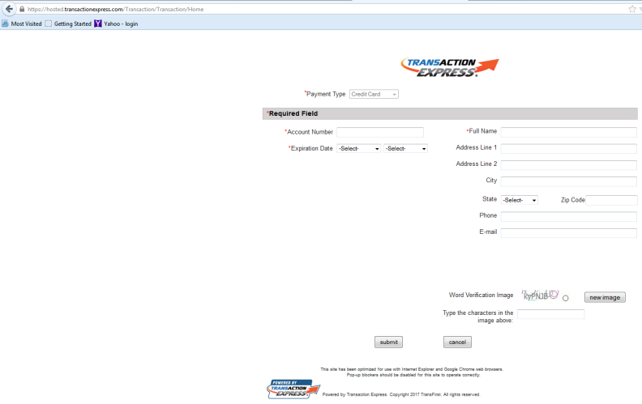

- After submitting your payment information, you will receive a successful message on the screen. You will also receive a confirmation email, confirming your online registration, and Registration# confirming your registration submission.
