2016 GRPA Open Coed Equalizer
State Softball Tournament
June 11 – 12
Augusta, GA

Team Entry Fee: $275.00
(3-Game Guarantee)
(*Checks are to be made payable to Augusta Recreation, Parks & Facilities Department or ARPFD)

#playAUGUSTA

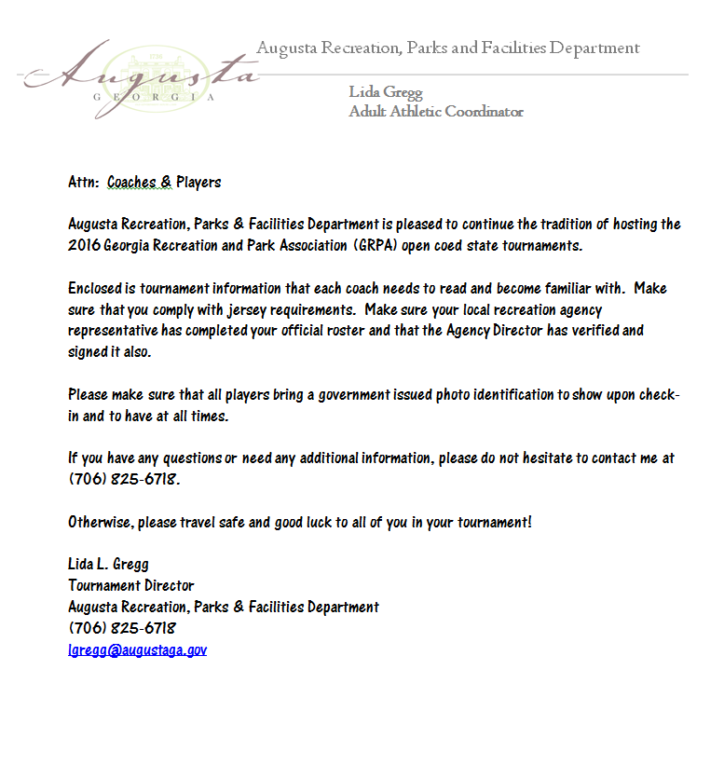
2016 GRPA Open Coed Equalizer
State Softball Tournament
Augusta, GA
June 11 - 12

Coach’s Meeting Agenda
- Tournament will be governed by the current rules and regulations of the Amateur Softball Association (ASA), along with GRPA eligibility guidelines found in the GRPA Athletic Manual. See your local agency for those guidelines.
- Balls will be provided. (.52/.300 ASA approved)
- All bats must be ASA approved and will be inspected and tested for compression.
- Game time is forfeit time! There is NO grace period.
- The tournament director will not converse with any coach in reference to any protest. Only designated recreation staff members are allowed to protest. There will be a $25.00 protest fee for rule interpretation and a $25.00 protest fee per player for player eligibility.
- Good sportsmanship is expected from all players, coaches and spectators. Please remember that you are not only representing the team you play for but your recreation department as well. Any negative cheering or hollering may result in a warning and/or removal from the site, whether it is for or against your team.
- Any player or coach ejected from a game for unsportsmanlike conduct will be suspended for one game, in addition to the game from which he was ejected.
- Home team will be determined by the flip of a coin prior to each game except for the championship game. The undefeated team will automatically be the HOME team, as per the GRPA Athletic Manual. The flip of a coin will determine the HOME team if there is an “IF” game.
- Jerseys should be alike in color and have factory, non-duplicating numbers on the back. There are no exceptions.
- Please make sure you have completed a team contact telephone number form in case of any changes to the schedule. Also, please make note of the telephone numbers listed below in case you need to contact any local staff members for any information.

Lida Gregg (706) 825-6718
Tournament Director

Bobby Martin (706) 836-7560
Athletic Manager

Check-In Procedure

Each player must check-in and present a valid government issued form of identification that includes a photo. Players must be prepared to show this identification prior to each game.

If a player does not have his ID then the player does NOT play. No exceptions!

Acceptable Forms of Identification Include:

Valid Driver’s License
State Issued ID Card
Military ID Card
Passport
Department of Immigrations & Naturalization Card
Notarized Correctional Institution Records

No ID…No PLAY!!!

2016 GRPA Adult Open Coed Equalizer
Contact Information Form
Team Name: _______________________________________________
Coach: ___________________________________________________
Address: _________________________________________________
City: _____________________________________ State: _________
Cell Phone: ________________________________________________
Motel Where Team Is Staying: ___________________________________
Number of Rooms Reserved: ____________________________________
Number of Nights Reserved: ____________________________________
Please list the name(s) of the people in which the rooms are reserved:
________________________________________________
________________________________________________
________________________________________________
________________________________________________
________________________________________________
________________________________________________
Thank you for your participation!

2016 Motel Recommendations

Baymont Inn Baymont Inn
2905 Riverwest Drive 629 NW Frontage Road
(706) 733-5900 (706) 855-6060

Candlewood Suites Comfort Suites
1080 Claussen Road 2911 Riverwest Drive
Betty Carter (706) 733-3300 (706) 434-2540

Courtyard by Marriott Doubletree
1045 Stevens Creek Road 2651 Perimeter Parkway
Jackie Drummond (706) 737-3737 Elizabeth Kennedy (706) 855-9414

Hilton Garden Inn Holiday Inn
1065 Stevens Creek Road 2511 Gordon Highway
(706) 739-9990 (706) 737-2300

Residence Inn Quality Inn
1116 Marks Church Road 4073 Jimmie Dyess Parkway
Augusta, GA 30909 Augusta, GA 30909
(706) 288-1900 (706) 855-2088

Sheraton of Augusta
1069 Stevens Creek Road
(706) 288-2202

Directions to Diamond Lakes Regional Park from Highway 1
To: Diamond Lakes Community Center
Travel north on Highway 1 to Tobacco Road. Take the Tobacco Road ramp and turn slight right on to Tobacco Road. Travel approximately 2.7 miles to Windsor Spring Road. Turn right on to Windsor Spring Road and travel approximately 1 ½ miles. Diamond Lakes Regional Park will be on your right. Turn in to the park and the community center is on your right. (706) 826-1370
Directions to Diamond Lakes Regional Park from Highway 25
To: Diamond Lakes Community Center
Travel north on Highway 25 to Tobacco Road. Turn left on to Tobacco Road. Travel approximately 3 miles to Windsor Spring Road. Turn left on to Windsor Spring Road and travel approximately 1 ½ miles. Diamond Lakes Regional Park will be on your right. Turn in to the park and the community center is on your right. (706) 826-1370
Directions to Diamond Lakes Regional Park from Interstate 20

To: Diamond Lakes Community Center
Travel east on Interstate 20 to Bobby Jones Expressway (I-520) Exit 196A. Travel on Bobby Jones Expressway to the Windsor Spring Road Exit 7. Merge right on to Windsor Spring Road and travel approximately 5 ½ miles. Diamond Lakes Regional Park will be on your right. Turn in to the park and the community center is on your right. (706) 826-1370

