Week 1: Dribbling
Stage | Activity Description | Diagram | Coaching Points
Activity 1  5-10 min | Body Part Dribble: (Dribbling, movement, agility and coordination)  All players will be dribbling a soccer ball. The coach will call out a body part. (Right foot, left elbow, right knee) Players will stop the ball as quickly as they can with that body part.  Coach: Vary the body parts. Rate that you call out parts. Vary speed of dribbling. Encourage kids to use a variety of surface areas on the foot to dribble the ball. (Inside, outside, and sole of foot) | 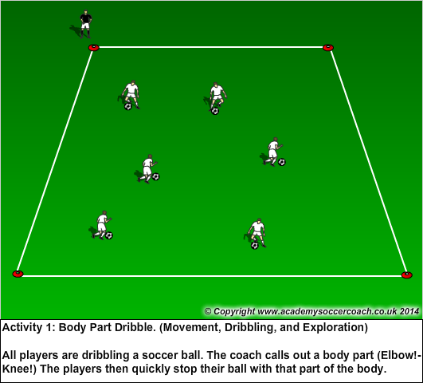 | - Inside and outside of the foot.  - Small taps when dribbling ball.  - Keep ball close.  - Change of pace.  - Encourage kids to keep head up.  - Quickly have kids stop ball then right back up to dribble
Activity 2  10 min | Red Light/Green Light: (Dribbling, change of speed, focus, and head up)  Line kids up on an end line of a 15W x 20L yard grid. Coach stands on the opposite end line of grid. Coach will yell out either Red light, Yellow light, and Green light. Red light means stop ball with foot. Yellow light means dribble slowly, and green light means dribble fast.  Variations: Use hand signals to signify when to stop, dribble slowly, or fast. Example: Hands on head means stop, fingers on nose means dribble slow, and hands on hips mean dribble fast. | 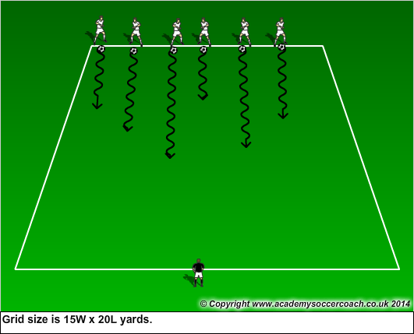 | - Keep ball close and under control.  - Head up.  - Encourage using inside and outside of foot.  - Arms out a little for balance.  - Inside and outside should be used to dribble slow.  - Outside of foot should be used to dribble fast.
Activity 3  10min | Dribble Tag: (Dribbling, changing direction and speed, and getting head up)  All the players have a ball and are freely dribbling around the grid. The coach then yells out a player’s name and the kids quickly try and dribble their ball and tag the kids name who was called as he or she tries to dribble away while not getting tagged. | 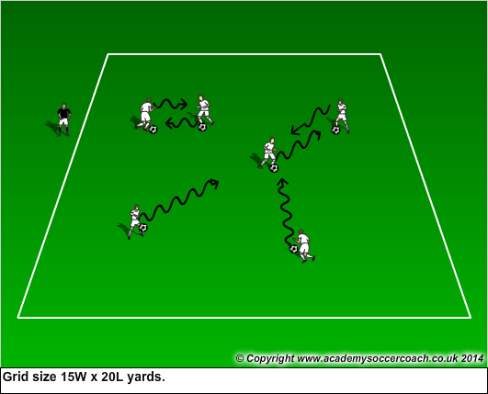 | - Head up.  - Encourage players to explode into open space.  - Change directions.  - Encourage players to use each foot.
Activity 4  15-20 min | Scrimmage: (3v3 or 4v4 depending on numbers. Game play) | 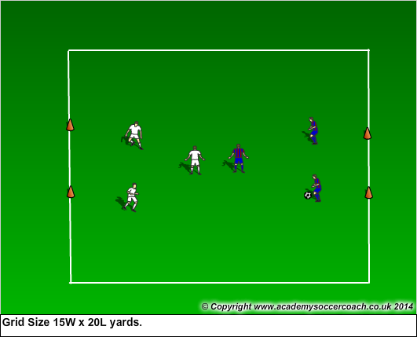 | - Don’t over coach. Let kids play.
Week 2 Stage | Activity Description: Dribbling | Diagram | Coaching Points
Activity 1  5-10min | 4 Surfaces:  Each player has a ball. Have the players explore and use the 4 surface areas of the foot. (Inside, outside, laces, and sole)  Sequence Dribble:  - Inside, outside, laces.  - Outside, inside, sole.  - Inside, outside, sole, laces. | 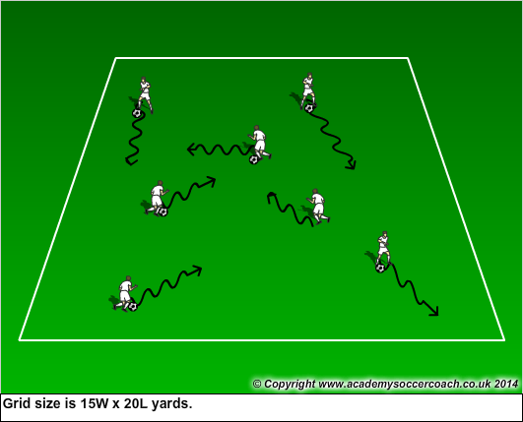 | - Encourage inside, outside, laces and sole of the foot.  - Give kids chances to change their speed while dribbling.  - Encourage kids to keep head up and change direction.
Activity 2 | Traffic Jam:  Players dribble their soccer balls trying not to crash with any other player. Every time a player is in front on another player they should say “Beep” to get him/her out of the way.  Coach can give a ticket to any players that crash. After 3 crashes, he or she much to 10 foundation touches to get back into traffic.  Variation:  Coach becomes the ambulance and runs around the field and the cars must quickly get out the coaches way. | 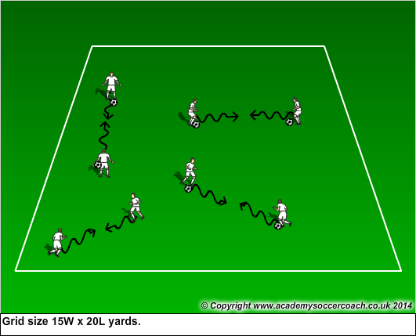 | - Kids have to keep their head up to see other dribblers.  - Challenge kids to use both feet to change direction.  - Encourage players to explore using the 4 surface areas to avoid traffic.  - Encourage players to explode when being pressured by ambulance.
Activity 3 | Freeze Tag:  The coach is the Mr. or Mrs. Freeze. They move around the grid and try to tag the players who are dribbling a ball. When Mr. or Mrs. Freeze tags a player the player then must hold their ball above their head with their legs spread apart. To unfreeze a player another player must pass the soccer ball through the frozen players legs.  Variations: Designate a couple players to be Mr. or Mrs. Freeze | 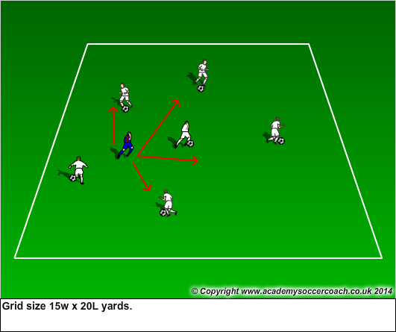 | - Focus on Head up.  - Encourage players to keep ball close to foot.  - Players should exhibit change of direction and change of pace.
Activity 4 | Scrimmage: 3v3 or 4v4 Multi goal game. | 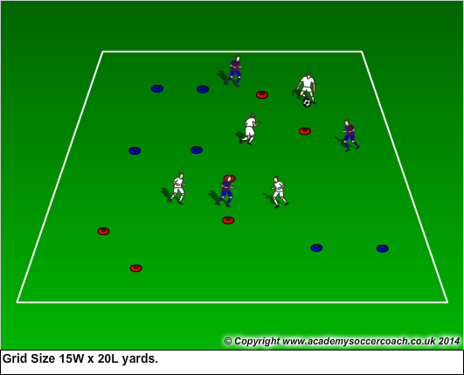 | - Look to switch the point of attack.  - Let the kids play.

Stage  week 3 | Activity Description | Diagram | Coaching Points
Activity 1  5-10 min | Dribble Tag: Tag without getting tagged.  All players have a ball and are dribbling. Players try to tag a player while dribbling and try not to get tagged back.  Variations: Players can only dribble with a certain foot or a certain part of foot.  Players can only try and tag coach who is dribbling a ball. |  | - Keep head up and on a swivel.  - Encourage kids to change direction and speed.  - Have players explore using different parts of foot to dribble ball.  - Players need to be explosive to prevent themselves from getting tagged back
Activity 2  10min | Snake: In a 15W x 20L yard grid all players will have a ball except 2 players. The 2 players without a ball will link arms and become the snake. The snake works together to tag the player with the balls. If a player is tagged they lock arms with the snake and the snake now becomes bigger.  The snake should be no more than 4 players big.  Coach: For fun have the snake hiss. | 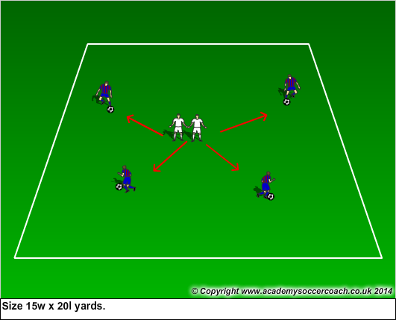 | - Keep head up an on a swivel.  - Players should look for open space to dribble into.  - Turn to avoid pressure.  - Keep ball close to body.  - Be prepared to explode into open space.
Activity 3  10min | River Pirates: Keep the same grid size as above. If the game is to easy make the grid smaller if it is to hard make grid bigger.  Players all stand one river bank with a ball. The coach is the middle of the grid and is the river pirate. On the coaches signal the players try to dribble their soccer ball from one river bank to the other river bank without the river pirate stealing the ball. If the players make it to the bank they are safe; If the river pirate steals the ball the player becomes a river pirate. Variations: Have a player start as the river pirate. | 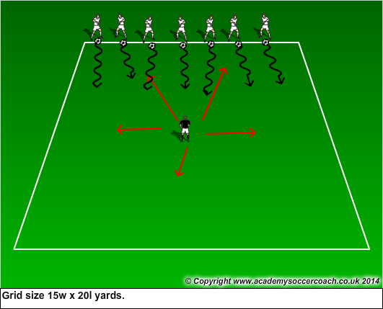 | - Encourage players to keep ball close by dribbling. They will want to just kick it and run.  - Head up and on swivel.  - Players should be trying to use both feet.  - Encourage players to use their outside of foot to dribble at speed.  - Players should be encouraged to cut the ball.
Activity 4  15-20min | Scrimmage: 3v3 or 4v4 . Grid size 15w x 20l yards. |  | - Let them play.  - Encourage transitioning.

Stage  Week 4 | Activity Description | Diagram | Coaching Points
Activity 1  5-10min | Shapes: In a 20W x 25L yard grid, make 3 shapes with cones. (Triangle, Square, and Diamond)  Players will dribble around grid freely. Coach will then call out a shape. Players will see how quickly they can dribble and stop their ball inside the shape.  Variations: Coach gives instructions to dribble around shape, through shape, or dribble to multiple shapes. | 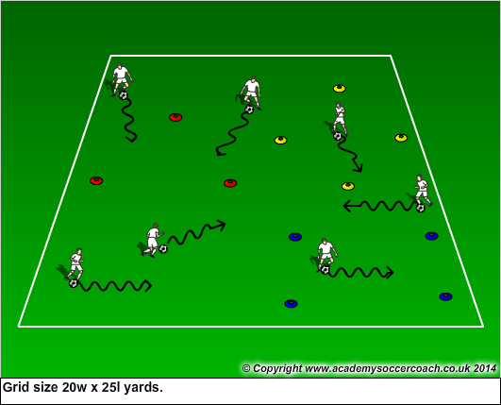 | - Encourage competition. See you can get there fastest.  - Encourage keeping head up when dribbling.  - Keep ball close and under control.  - Have players dribble in a pattern. (Inside/outside of foot.
Activity 2  10min | Cone Jungle: Take cones from above activity and randomly spread them out in the grid.  All players should have a ball and should be dribbling freely within the grid.  On coaches signal he/she will call out the following:  - Turn. Players dribble at a cone and quickly turn away from cone.  - Fake. Players dribble at a cone and give a fake. Let them be creative.  - Around. Players dribble as quickly around a cone. | 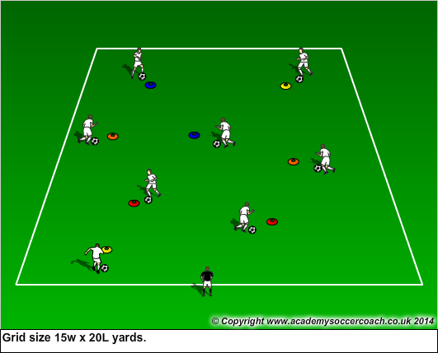 | - Encourage kids to be brave and try dribble close to cone.  - Keep ball close to body and under control.  - Have players use both feet to dribble their ball.  - Have players explore using a variety of surface areas of their foot.  - Fakes: Cut(Inside and outside of foot) Body fake.
Activity 3  10min | Raiders and Defenders: Split the grid in half. In one half of the grid set up multiple balls on the disc cones. The balls represent special statues. Within the grid assign two defenders to protect the statutes. The defenders can use their feet, body, or hands to block the raiders balls from knocking over the statues.  At the coaches signal the raiders invade the defenders zone by dribbling the soccer balls. They a time limit of 1-2 minutes to try and knock over all the statues by passing their ball hitting the statues(balls) off the cones. If they can knock them all over in the allotted amount of time they are winners. If they do not then the defenders are the winners.  Switch up defenders so that everyone gets a turn. | 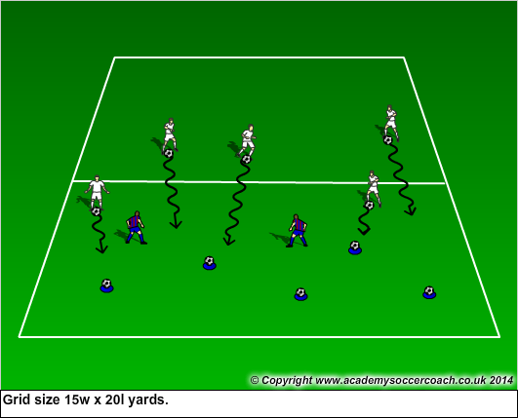 | - Defenders should be in athletic position.  - Dribblers should have head up to see which statues are open.  - Encourage players to use cut moves to change direction.  - Praise defenders for being aggressive and blocking balls.  - When passing encourage them to use inside of foot.
Activity 4  15-20min | Scrimmage: Gate game. Set up cones so that they make 3 x 3yd gate. Every time a player from a team dribbles through or kicks a ball through a gate their team scores a point. |  | - Let them play.  - Praise good aggressive play on offense and defense.  - Encourage competition.

Stage  Week 5 | Activity Description | Diagram | Coaching Points
Activity 1  5-10min | Soccer Marbles: Every kid has their ball and they dribble around the grid and try to pass their soccer into another players soccer ball. Every time they hit a ball it is worth a point.  Variation: Have one or two kids walk around grid and players try to pass ball hit them. Every time they get them it is worth a point. | 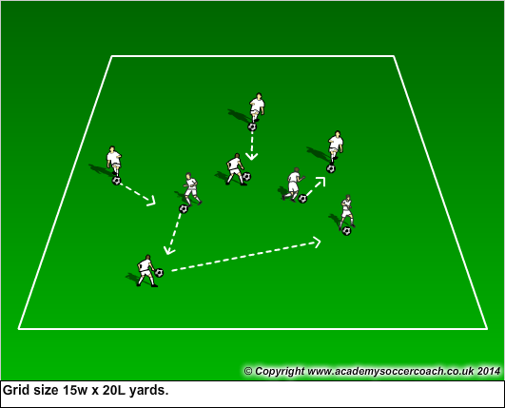 | - Have players try and pass with the inside and outside of their foot.  - Quick pass should be emphasized over long passes.  - Players should strike the ball over the midline to keep ball on ground.  - Use words like step hit to describe a good pass.
Activity 2  10min | Orbs: Players line up on end line (edge of the galaxy) without a ball. The coach or a player starts in the middle of the grid with a ball. On the coaches signal the players without a ball (space ships) try to run across the grid to the other end line without having the coach or player (The Orbs) hit them with a ball. If they make to the end line they are safe and should stop. If they get hit they become an Orb. | 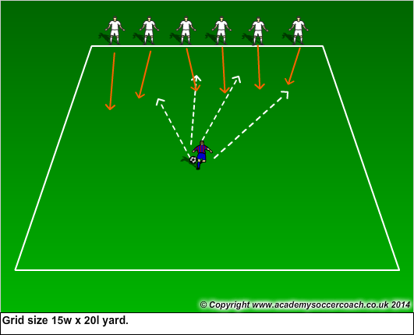 | - Players should look to make cuts. Emphasize changing direction. Cutting off outside leg.  - When passing encourage them to use inside and outside of foot.  - Step into passes to make them firmer.  - Players need to strike over the midline of ball to keep it down.
Activity 3  10min | Top gun: In same grid line players up on end line without a ball. They are the fighter jets and their goal is to become a Top Gun Pilot. The coach will line up balls on the sideline of the grid. On the coaches signal (Fly!!!) the players will try to run from one end line to the other end line without getting hit by the ball being passed across the grid. If the player gets hit with the ball they go to the outside and become a gunner.  Variations: Have gunner work on passing with non-dominant foot. Players could roll the ball with hand instead of passing with foot. | 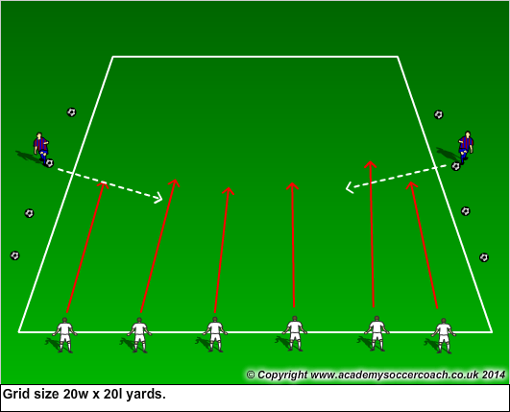 | - Keep head up and look for incoming passes.  - Step into passes to create power.  - Encourage proper technique by having kids pass with inside of foot.  - Use the term Step, hit. To describe pass. Step with not kicking leg, hit with dominant foot.
Activity 4  15-20min | Scrimmage: Play a game of 3v3, or 4v4. Score by kicking ball in goal or by making a pass to a teammate. |  | - Let them play  - Praise good passes
Stage  Week 6 | Activity Description | Diagram | Coaching Points
Activity 1  5-10min | Bandits:  Select 1 or 2 players to be the bandit. The bandit does not have a ball. All the rest of the players have a ball that they are dribbling. The bandit tries to steal the balls and kick it out of the grid. If a player ball is kicked out of the grid they do 6 foundation touches and they are back in the game. | 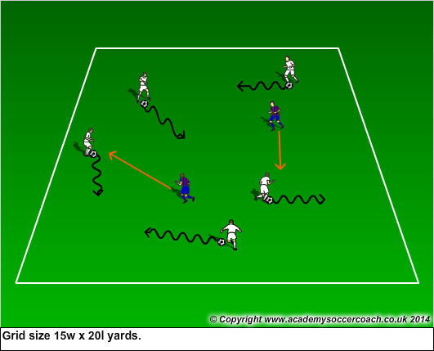 | - Encourage bandits to be aggressive.  - Dribblers need to keep head up.  - Encourage shielding of the ball.  - Players should exhibit change of direction and speed.
Activity 2  10min | Super heroes and Super Villains:  Split group into to equal sized teams. On each team 2 kids will have a ball and 2 kids will not have a ball. The goal of the game is to see which team can have the most balls at the end of the time limit set by the coach.  Try to do 1-2 games. Team with the most balls at their feet wins. Losing teams does a fun exercise like start jacks. Switch team names. | 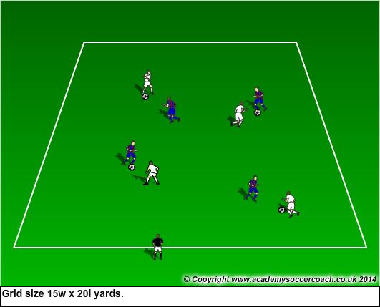 | - Head up and on swivel.  - Encourage shielding the ball with their body.  - Players should exhibit change of direction and speed.  - Encourage kids to be aggressive and tackle the ball away with their feet.
Activity 3  10min | Numbers game: In your same teams as above give each player a number (1-however many you have) Each team should have one player who #1, #2, #3, #etc.  Coach will have one team A on one side of him/her and Team B on the other side of him/her. Teams should line up shoulder to shoulder in numerical order.  When coach yells out, “#1” only the #1 will run out from each team and they will play in a 1v1 situation to cone goals or goals. If coach calls out the #2 only the #2s go out. You can all out multiple #s to create 1v1, 2v2, 3v3 situations. Good to use pennies in this activity. | 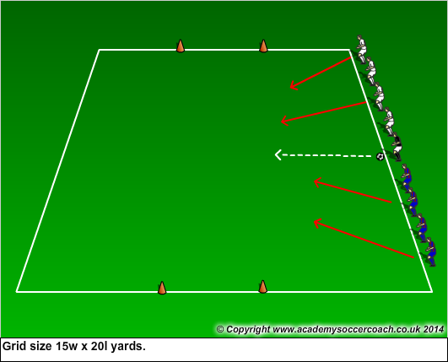 | - Kids should explode out into the field of play.  - Compliment kids when they attack and shoot early.  - Encourage kids to be aggressive and get in front of player to steal the ball.  - Compliment nice moves.  - Encourage competiveness.
Activity 4  15-20min | Scrimmage:  Game of 3v3 or 4v4. |  | - Let them play.  - Encourage nice plays.

Stage  Week 7 | Activity Description | Diagram | Coaching Points
Activity 1  5-10min | Magic Kingdoms: Make a 15W x 30L yard grid, divided into 4 rectangles, name each of the quadrants a different kingdom. All players will start out dribbling in a kingdom. When the coach calls out a different kingdom the players will try to dribble as quickly as they can to that kingdom.  Variations: Have kids to a certain dribbling technique in each kingdom.  - Magic Mountain- One foot only  - Enchanted Castle-Outside of foot only.  - Candyland- Inside/outside of foot.  - Fireworld- Sole of foot only. | 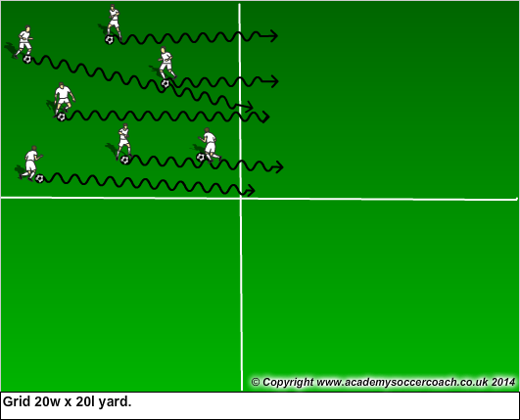 | - Keep ball close to your foot. Small touches.  - When dribbling to another kingdom uses explosive touches.  - Head up and on a swivel.  - Have players use a variety of surface areas of their foot.
Activity 2  10min | Sharks and Minnows:  In same grid as above have 1-2 players start out as sharks. The minnows are at one end of the grid with their soccer balls. When the Sharks say “Swim fishy, Swim” the minnows try to dribble to the other end of the grid without having the soccer kick away their ball. If a shark gets the minnows ball out of the grid the minnow then becomes a shark. The game continues until there is only 1 minnow left. | 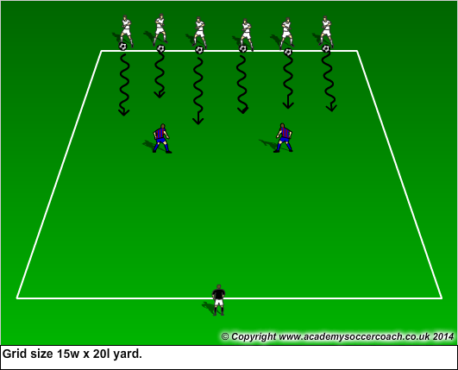 | - Head up and on a swivel.  - Look to unbalance defender with a fake.  - Explosive touches to get by defender.  - Keep ball close to foot.  - Be aggressive.
Activity 3  10min | Knock out:  All players have a ball in the same grid as above. All players are dribbling throughout the grid. Players are trying to keep their ball while knocking someone else ball out of the grid.  If a player’s ball gets knocked out of the grid he or she should do some sort of skill task before re-entering the grid.  Example: 5 ball taps, foundation touches, juggles | 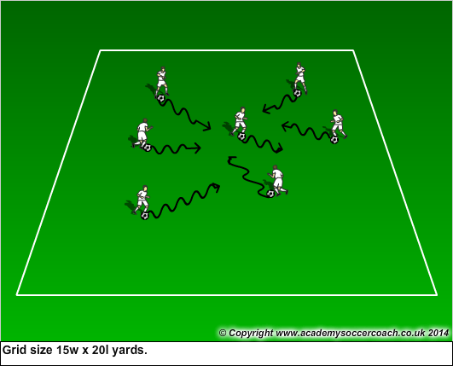 | - Use body to shield ball.  - Take risks and be aggressive.  - Keep head up and on a swivel.  - Look to turn and explode from pressure.
Activity 4  15-20 min | Scrimmage:  3v3 or 4v4 four goal game. | 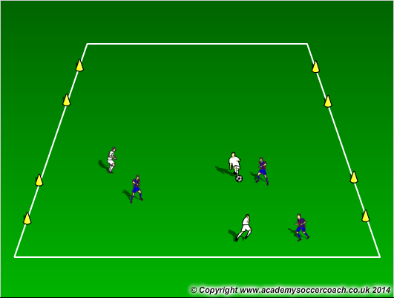 | - Do not over coach. Let them play.  - Encourage switching point of attack.  - Praise good plays!

Stage  Week 8 | Activity Description | Diagram | Coaching Points
Activity 1  5-10min | Paint the Field:  All players will dribble their in a 15W x 20L yard grid pretending that is a paintbrush and wherever it rolls it is painting the field. The player will try to paint as much of the area as possible in the time allotted.  Variations: Have kids paint their name or different shapes. Have them use each foot and different surface areas to paint. | 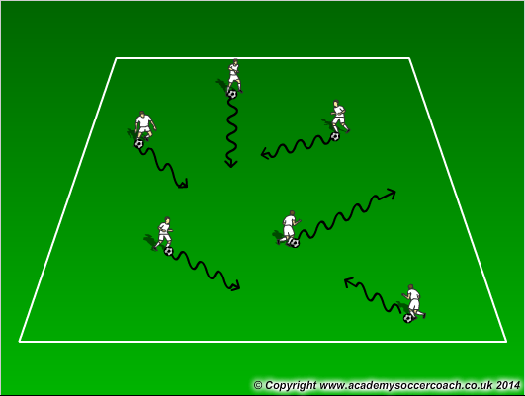 | - See if the players are exploring the whole field.  - Encourage kids to use each foot and different surface areas of their foot.  - Encourage kids to keep their head up to avoid running into other players.
Activity 2  10min | Soccer Marbles:  Each player will have a ball and dribble around the field. Players will try and pass their ball into another persons ball or hit their legs. Every time they hit the ball or legs they get a point.  Variation: Coach or other players walk around grid and the dribblers can only try and get them with their ball. They get a point every time they get the targets. |  | - Players need to have their head up.  - Encourage players to use the inside of their foot to pass the ball.  - Make quick short passes.
Activity 3  10min | Angry Birds:  Select two players to be the Angry Birds. They will dribble around and try to tag any player without the ball with either their hand or by passing the ball. Once they have tagged a runner, he or she becomes an Angry Bird and will go to get a ball and join the hunt.  Variation: They can only use the outside of their foot to make a pass. | 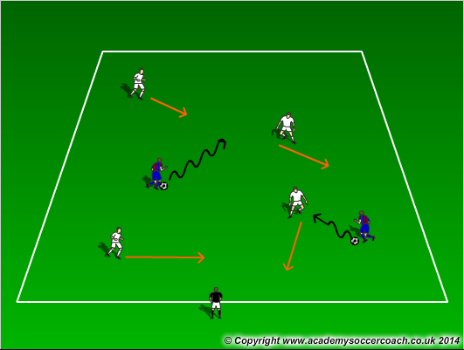 | - Players will need to keep their head up an on swivel.  - Encourage explosive dribbling.  - Players should be using both the feet and a variety of surface areas to dribble the ball.
Activity 4  15-20min | Scrimmage:  3v3 or 4v4. |  | - Let the kids play.  - Don’t over coach.  - Praise good plays.

