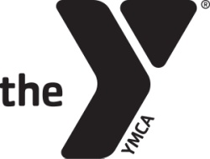

Coaches Requirement Links

Coaches Background Check
https://eforms.ymcaokc.org/lincdoc/openform/default/ymcaokc/Volunteer_BGC

Concussions Training
http://www.cdc.gov/concussion/HeadsUp/Training/

