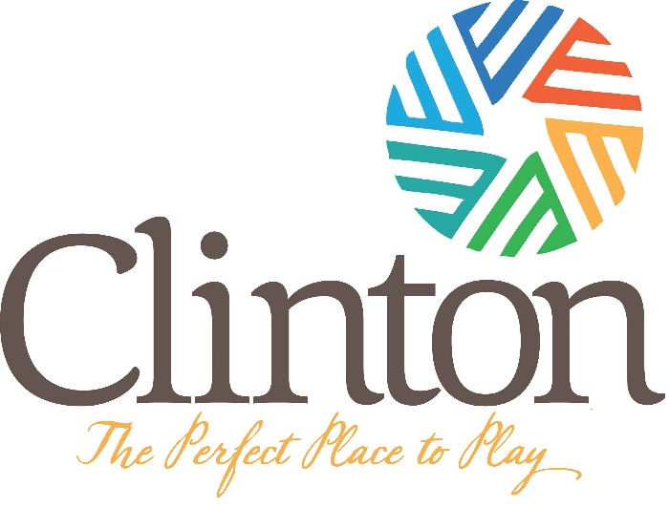
All-Star Player/Parent Agreement
- I pledge to support, cooperate, and work in every way to promote and support the All-Star Teams of the Clinton Recreation Department.
- I pledge to be respectful to all officials (game, league, district and state), even in the expression of disagreement.
- I do agree to adhere to the principals of good sportsmanship and the rules and regulations as defined by the Clinton Recreation Department and Dixie Youth Baseball.
- I agree that I will support the post-season player’s and coach’s selection process. I further acknowledge the playing time on an All-Star team is not mandatory and is the coach’s decision.
- I understand that a player may be removed from a team by the Recreation Department as a result of disciplinary problems.
- I understand that I am responsible for the cost of my child’s uniform. (See below).
- I understand that if my child quits before the All-Star season is completed without valid reason (i.e.: injury, etc.) he/she will not be eligible to play All-Stars the following season.
- I understand there will only be one tryout date and that my child must be present and this form turned in before the tryout date. Forms will not be accepted at the tryout.
- I have read, understand and agree with the purpose of this team, the selection process, the funding requirements and the other rules concerning participation on this team.

Player’s Signature: _____________________________________ Date:____________
Parents’ Signature: _____________________________________ Date:____________
Uniform Cost: $40
The cost for All-Stars will cover a jersey, hat, and socks. Parents are responsible for providing white baseball pants and a black belt. Players have to match when they play in any Dixie Youth Baseball Tournament. Also, players will be required to wear a helmet with a facemask. Helmets will be provided to the team with a facemask, but if you want your child to wear their own helmet, it must have a facemask.
All-Star Tryout Application
Age Group (check one)

COACH-PITCH (8U) MINORS (10U)

MAJORS (12U)

PLAYER’S NAME:___________________________________________ DOB:__________________
PARENT’S NAME: _____________________________________________________________________
EMAIL: _____________________________________________________________________________
ADDRESS: ___________________________________________________________________________
TELEPHONE: (H)__________________ (W)____________________ (C)_______________________
SHIRT SIZE: YS YM YL AS AM AL AXL
REGULAR SEASON TEAM: ______________________________________________________________
REGULAR SEASON COACH: _____________________________________________________________
IF YOU MAKE AN ALL-STAR TEAM, YOU WILL BE REQUIRED TO PROVIDE A COPY OF YOUR BIRTH CERTIFICATE
WAIVER
We the parents of the above named applicant, do herby give our approval for her participation on the JCAA All-Star Softball teams. We agree to participate under the rules and regulations of the JCAA. We assume the risks and hazards associated and incidental to such activities including transportation to and from such activities. We do hereby in consideration for her acceptance as a member of and being permitted to participate on the team; waive, release, absolve and agree to hold harmless any part of the coaching staff, and their organizers, sponsors and supervisors from any claim arising out of injury to our child.
Parents’ Signature: ________________________________________ Date:_____________
TRYOUT DATE
Coach-Pitch – June 2nd at 6pm Field 4
Minor League – June 8th at 6pm Field 4
Major League – June 9th at 6pm Field 6

**All applications must be received at the Royal Lane Main Office by 12pm the day of the tryout. No applications will be accepted after this time.**

